Workload Analysis of Physician Assistants in Pediatric Surgery Department

Final Report

Submitted to:

Christina Lower MS PA-C, Lead PA, UMHS
Corrie Pennington-Block, Staff Specialist, UMHS
Professor Mark Van Oyen, IOE 481 Instructor
Mary G. Duck, UM Hospital Liaison

Prepared By:

IOE 481 Team 3
Steven Ball (stevball@umich.edu)
Nolan Hopkinson (nolanhop@umich.edu)
Evan Stein (elstein@umich.edu)
Carali Van Otteren (vanottcm@umich.edu)

April 22, 2014

TABLE OF CONTENTS

Executive Summary 4
Background 4
Methods 4
Findings 5
Conclusions 6
Recommendations 6

Introduction 7

Background 7
Key Issues 7
Goals and Objectives 7
Project Scope 8

Methods 8
Literature Search 8
Orientation Shadowing 8
Interviews 8
Time Study 8
Task Breakdown 9
Industrial Engineering Tools 9

Findings 9
Literature Search Results 9
Orientation Shadowing Results 9
Interview Results 9
Time Study Results 10
Task Breakdown Results 11
Industrial Engineering Tools Used 13
Conclusions and Recommendations 17

Appendix A: Pareto Chart Task Breakdowns by Category in the ICU
Appendix B: Pareto Chart Task Breakdowns by Time Block in the ICU
Appendix C: Pareto Chart Task Breakdowns by Category in the GCU

LIST OF FIGURES AND TABLES

Figure 1: Pareto Chart of ICU Tasks in an Average Day 10
Figure 2: Pareto Chart of General Care Tasks in an Average Day 11
Figure 3: Pareto Chart of ICU Tasks by Category in an Average Day 12
Figure 4: Pareto Chart of General Care Tasks by Category in an Average Day 13
Figure 5: Yamazumi Chart of the ICU on an Average Day 14
Figure 6: Pareto Chart of ICU Tasks in the Afternoon Work Time Block 14
Figure 7: Yamazumi Chart of the General Care Unit on an Average Day 15
Figure 8: Pareto Chart of General Care Tasks in the Morning Work Time Block 16
Figure 9: Pareto Chart of General Care Tasks in the Afternoon Work Time Block 16
Figure 10: Historical Data on Patient Volumes 17
Figure 11: Pareto Chart of ICU Task Breakdown within Patient Documentation A1
Figure 12: Pareto Chart of ICU Task Breakdown within Waste A1
Figure 13: Pareto Chart of ICU Task Breakdown within Patient Care A2
Figure 14: Pareto Chart of ICU Tasks in the Work Rounds Time Block B1
Figure 15: Pareto Chart of ICU Tasks in the Morning Work Time Block B1
Figure 16: Pareto Chart of ICU Tasks in the Attending Rounds Time Block B2
Figure 17: Pareto Chart of GCU Task Breakdown within Patient Documentation C1
Figure 18: Pareto Chart of GCU Task Breakdown within Waste C1
Figure 19: Pareto Chart of GCU Task Breakdown within Patient Care C2

EXECUTIVE SUMMARY

Within the Pediatric Surgery department at the University of Michigan Hospital System, the five Physician Assistants (PAs) are the contacts for patients and their families admitted to both the intensive care (ICU) and general care (GCU) units. The PAs also relay information to and from the other medical professionals throughout the hospital. The lead PA has asked an IOE 481 student team from the University of Michigan (Team Three) to document, delineate, and evaluate the demand on the PAs and develop solutions to optimize their utilization and standardize their workload.

BACKGROUND
The Pediatric Surgery department has five PAs and 24 other medical professions including attending physicians and medical students. The PAs conduct a variety of daily tasks that include performing patient rounds, ordering medications, counseling families, teaching medical students, updating patient records, and assisting in the operating room. The PAs are often requested by physicians, nurses or fellows to perform a multitude of other tasks with limited, if any at all, prior notices. Each of the PAs handles these task assignments and interruptions differently depending on how they individually prioritize these tasks. The PAs would like to know what types of tasks they perform in a day and how long the average task takes.

METHODS
The primary method for this project was an intensive time study to document all of the tasks that the PAs do in a standard work shift. In preparation for the intensive time study, several other methods, a literature search, orientation shadowing and an interview session, were conducted. Following the intensive time study, the team did a breakdown of the PAs’ task and calculated average durations and utilization levels.
- Literature Search. The team conducted a literature search to establish a method for collecting data based on previous IOE 481 projects.
- Orientation Shadowing. The team shadowed the PAs for about 12 hours total to further understand the typical events in an average work day.
- Interviews. Midway through the time study collection, the team interviewed all five PAs. The interview was used to understand the PAs’ ideas about their tasks and recommendations for this project. The task data collected was categorized to compare similar tasks.
- Intensive Time Study. Coupled with the information gathered from the literature search and the orientation shadowing, the team conducted a time study of the tasks performed on the average work shifts for each day of the week for two weeks. One week of data was collected for the Intensive Care Unit and One week for the General Care Unit. A total of approximately 140 hours of data was collected from this time study.
- Physician Assistant Task Breakdown. The team grouped all of the similar observed tasks into five main categories.
- Industrial Engineering Tools. Average times for each task and category were represented using Pareto Charts. The task and categories were also presented, using Pareto Charts, based on the time of day that they were performed. In addition to the Pareto Charts, the time of day information was represented using Yamazumi Charts.

FINDINGS

Literature Search Results
Based on the information gather from two past IOE 481 projects, the team noted that tick sheets would be unreliable. The team decided that the time study should be conducted by physically shadowing the PAs during their work shifts.

Orientation Shadowing Results
The team followed the PAs for a total of about 12 hours during a single week. These observations provided the team with a general idea of the average duration of some common tasks. The team decided that when conducting the time study the data should should be measured to the second.

Interview Results
In the interviews, the PAs expressed their perspectives of their daily activities and any concerns they have. This information was used to facilitate conclusions from the time study that would be of the most interest and use to the PAs.

Time Study Results
Intensive Care Unit
On average, the PAs spend about 2.5 hours writing progress notes. Writing progress notes is the task with the longest duration of time spent. The five tasks with the longest durations do not involve direct patient care.

General Care Unit
The PAs spend the most time writing discharge summaries while in General Care. Discharge summaries take about 2 hours and 45 minutes of an average day. Similar to the ICU, all five tasks with the longest durations do not involve direct patient care.

Task Breakdown Results
The five major categories in which all of the observed tasks were grouped into are Patient Care, Patient Documentation, Administrative Work, Provider Communication, and Waste.

Intensive Care Unit
The PAs spent 40% of an average day doing activities categorized as Patient Documentation. The second category with the most time allocation was waste.

General Care Unit
The time allocation between categories for the General Care is very similar to the ICU. The average day consists of about 41% of Patient Documentation followed by about 20% of waste.

Industrial Engineering Tools Used
Intensive Care Unit
The average work day is 11 hours and 57 minutes long out of a scheduled 12 hour work day.

General Care Unit
The average work day is about 1.5 hours shorter than a scheduled 12 hour work day. This is because the PA spend their early afternoon hours completing the task they were requested to do and no longer have any work until the end of the work day.

Historical Data
The data provided spanned over 9 months in the fiscal year 2013. The average patient volume was about 9 patients in the ICU and 8.5 patients in the GCU. There is a high amount of variation in the number of patients that have been in the service during this time.

CONCLUSIONS AND RECOMMENDATIONS

Utilization Factors
Industry standards allow the worker to have one 30 minute lunch break and a 15 minute break every four hours. For a 12 hour work day the worker’s utilization according to these break allocations, is 90%. In the ICU, the PAs have a utilization of 91.22% while in the GCU the PAs are 79.2% utilized. The team recommends, to evenly distribute the utilization between the two units, that once the GCU PA has finished the tasks for that day, she go to the ICU to pick up any tasks that they may have remaining.

Patient Volume Spikes
The historical data showed how the number of patients in each unit varies greatly over several months. Since the data collection was fairly representative of the average patient volume and the the PAs are currently operating at roughly the industry utilization rate, the system should implement a way to handle the variation in patient volume.

Task Lengths and Efficiencies
For both units, the PAs spend about 20-25% of their day working on Patient Documentation. The team recommends a further study on the usability of the patient record entry software. If the software could be improved, then the PAs could reallocate some of the time that they spend to other tasks.

Other Sources of Variation
The data showed a variation in the start time of both the work and attending rounds, especially in the General Care Unit. The team recommends that these start times be standardized. This will allow the PAs to better schedule their day and prioritize their tasks.

INTRODUCTION

Within the C.S. Mott Children’s Hospital on the University of Michigan’s medical campus, the Physician Assistants (PAs) provide patient care and complete the work necessary to discharge patients from the hospital. Within the Pediatric Surgery department, the PAs are also contacts for patients and their families admitted to both the general care and intensive care units. The PAs also relay information to and from the other medical professionals throughout the hospital. Five PAs work in the service that covers both the pediatric surgery intensive (ICU) and general care (GCU) units.

The current workload of PAs in the Pediatric Surgery department varies greatly and, according to the lead PA, is increasing in the number of tasks. The lead PA has asked an IOE 481 student team from the University of Michigan (Team Three) to document, delineate, and evaluate the demand on the PAs and develop solutions to optimize their utilization and standardize their workload.

This report presents how the team observed and measured the current workload, broke down the PAs’ responsibilities by task and analyzed work productivity levels.

BACKGROUND

The department of Pediatric Surgery in the University of Michigan Hospital System has fourteen attending physicians, five fellows, three interns, two residents and five PAs. It specializes in minimally invasive surgery, interventional radiology techniques, pediatric trauma, and surgical critical care. The Pediatric Surgery unit can admit patients into rooms in seven different units in C.S. Mott Children’s Hospital.

The Pediatric Surgery PAs’ levels of experience range from three years to eleven years. According to the lead PA, the team performs a large number of tasks. Daily tasks include performing patient rounds, ordering medications, counseling families, teaching medical students, updating patient records, and assisting in the operating room. The PAs must also be prepared to aid other medical professionals in general activities at any time, often with minimal notice. Each of these tasks are conducted at intermittent times and often with many interruptions. Each of the PAs handles these task assignments and interruptions differently depending on how they individually prioritize the tasks. This describes the lack of standardization in the distribution and execution of these tasks.

Key Issues
The following key issues validate the importance of this project:
- A limited number of Pediatric Surgery PAs are required to perform a wide variety of tasks
- Due to the variation in the tasks assigned, each PA works at a unique utilization level
- The system of assigning and receiving tasks lacks standardization

Goals and Objectives
The goal of this project is to develop solutions that optimize the PA’s utilization level. To accomplish this goal, Team Three has completed the following objectives.

- Document the PA’s current workload
- Delineate the PA’s tasks
- Quantify the PA’s work levels and time allocation to each task

Project Scope
This project evaluated the tasks performed by the PAs during their standard work shifts of 12 hours Monday through Friday and 6 to 8 hours on Saturday and Sunday in the Pediatric Surgery Department of C.S. Mott Children’s Hospital. These tasks include but are not limited to performing patient rounds in the Intensive Care Unit (ICU) and discharging patients from the General Care Unit. This project does not include the evaluation of any in-patient room tasks since these tasks require advanced medical knowledge. Any tasks performed by staff members in other departments or outside of normal work shift hours were not be included in this project.

METHODS

The team used a variety of strategies to analyze and optimize the PA’s utilization level. Such strategies include conducting a literature search of related material, participating in an orientation shadowing session, holding PA interviews, performing an intensive time study, breaking down the observed PA tasks, and implementing industrial engineering tools.

Literature Search
The team conducted a literature search for past IOE 481 projects of similar conditions. The team found two articles about the workload of the PAs in the Cardiac Surgery department and the Cancer Center.
- “Physician Assistant and Nurse Practitioner Workload Analysis in the Cancer Center” (Rahman, Welch, and Widrig 2011)
- “Utilization of Nurse Practitioners and Physician Assistants in Cardiac Surgery” (Fried, Samuel, and Willer 2012)

Orientation Shadowing
The team shadowed four PAs for a total of 12 hours to gain an initial understanding of their responsibilities. The team used this experience to develop strategies for the time study data collection.

Interview
The team interviewed the Lead Pediatric Surgery PA and the four other Pediatric Surgery PAs to gain a further understanding of the Pediatric Surgery PAs’ responsibilities. One interview session included the Lead PA and three of the other four PAs in a group setting. The remaining PA was interviewed at a later time independently. The interview questions focused on causes for delay, typical task lengths, communication issues, changes in responsibilities, the time study’s representation of typical work volume, and the PAs’ expectations for the team’s recommendations for standardized workload.

Time Study
The team members individually collected time studies of the PA’s tasks. The team members observed tasks and developed detailed descriptions of the actions performed. For both the general care and the intensive care unit, the team collected one full week of data. A full week consists of five weekday shifts (12 hours each) and two weekend shifts (approximately 8 hours each). The team used this information to quantify task lengths and utilization levels.

Task Breakdown
The team categorized the PAs’ tasks as either Patient Care, Patient Documentation, Provider Communication, Administrative Work or Waste.

- Patient Care is considered tasks where a PA is physically with a patient or a patient’s family
- Patient Documentation occurs when a PA is completing patient related administrative work
- Provider Communication is when the PA is discussing patients with other medical staff
- Administrative Work is considered tasks that do not affect the patients directly

Tasks that cannot be classified as Patient Care, Patient Documentation, Provider Communication, or Administrative Work are considered waste. This categorization enabled the team to delineate the demand and quantify the PAs’ productivity.

Industrial Engineering Tools
The team used Yamazumi charts to display the duration of each of the four main time blocks of the day: Wait (that occurs before Work Rounds), Work Rounds, Morning Work, Attending Rounds, and Afternoon Work. The team analyzed variation using statistical models. The team calculated utilization levels of the PAs in both the ICU and the General Care Unit. The team used this analysis to develop recommendations for optimal PA utilization. The team also received nine months of census data during the fiscal year 2013. This data was used to show the variation in the patient population over several months.

FINDINGS

Literature Search Results
The team used the information from past IOE 481 projects when designing the data collection process. The paper about the Cardiac Surgery described a method of data collection where the PAs and Nurse Practitioners (NPs) filled out a tick sheet. The team followed the PAs and NPs for one week to ensure that the tick sheets were filled out correctly but the tick sheets were collected over a three week duration. Because of this, Team 3 scheduled approximately 140 hours of data collection. Data collection was crucial to the delineation and evaluation of the demand on the PAs.

Orientation Shadowing Results
The team started to gain a general understanding of the workflow of a PA. The team learned the kind of pace the PAs move at through their day. This eventually led to the team deciding to time study the PAs down to the second, instead of the minute, because a large number of the tasks performed occurred for less than one minute.

Interview Results
The team gained a deeper insight into the inefficiencies that permeate the PAs workload and the obstacles they encounter. The team gained more understanding of who the PAs wait on the most and what time of the day waiting tends to occur, what tasks the PAs think they spend too much (or too little) time doing, who the PAs think they get most of their calls/pages from and why, how their job descriptions have changed since they have hired, and areas for easy to implement improvements.

Time Study Results
The team’s detailed time study yielded both the time of day and the duration of each task performed by a PA during a standard work shift.

Intensive Care Unit
The extensive time study revealed that in the ICU, PAs spend about 21% of their day writing progress notes, the largest duration of any single task. This gives quantitative backing to the interview results, where the PAs thought they spend too much time writing progress notes, and not enough time performing procedures or interacting with patients (which together composed about 11% of their day). All of the tasks on an average day can be seen below in Figure 1.

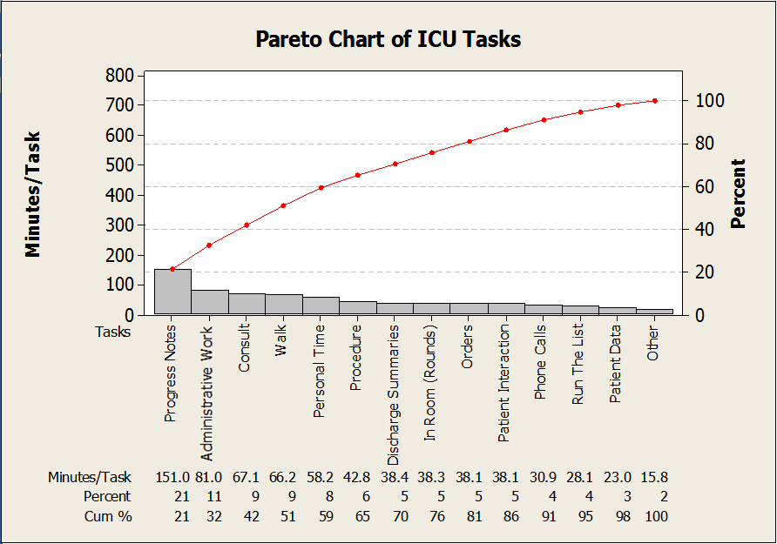
Figure 1: Pareto Chart of ICU Tasks in an Average Day

General Care Unit
The extensive time study revealed that in the General Care unit, PAs spend about 23% of their day writing discharge summaries, the largest amount of any single task. Similar to the ICU, this task alone accounted for almost double the time PAs spend interaction with patients which accounts for about 12% of their day. All of the tasks on an average day in General Care can be seen below in Figure 2.

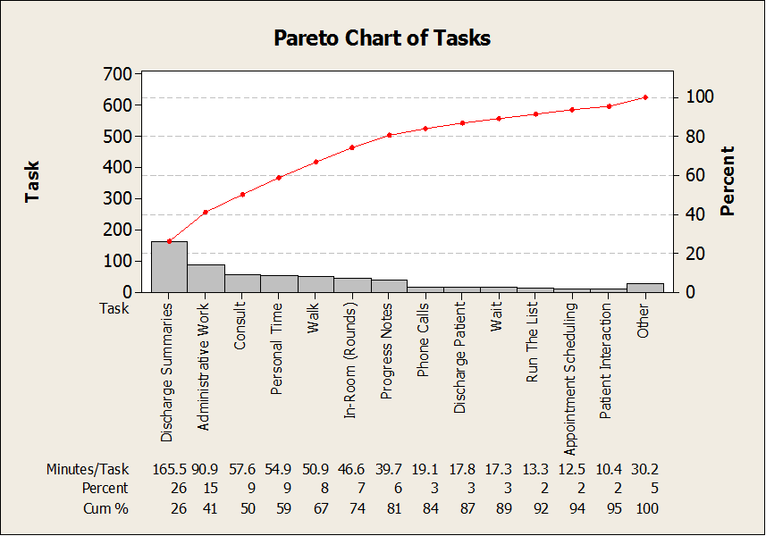
Figure 2: Pareto Chart of General Care Tasks in an Average Day

Task Breakdown Results
The team categorized the PA tasks in both the General Care Unit and the Intensive Care Unit. Due to the differing responsibilities of the PAs of each unit, some categories were only in one unit. These categories are detailed below:

<> Patient Care
- Rounds: Early morning and late morning rounding, when in the patient’s room
- Patient Care: Non procedural interaction with the patient (e.g. circumcision consult)
- Procedure: Medical procedure performed by the PA upon a patient
- Discharge Patient: Delivery of the discharge summary and discussion with the patients
<> Patient Documentation
- Discharge Summary: Completion of paperwork related to a patient’s discharge
- Write Progress Notes: Updating progress notes for a patient
- Put in Order: Placing an order for medication, labs, etc.
- Phone Call: Providing or receiving medical information over the phone
- Pager: Sending or receiving a page
- Email: Writing or reading work-related emails (GC only)
- Schedule Appointment: Scheduling follow-up appointments for patients
- Patient data: Retrieving or storing patient records, test results- x-rays, etc. (ICU only)
<> Administrative Work (conferences, meetings, etc.)
<> Provider Communication
- Run the List: Update on status of all patients currently in unit
- Consult: Discussion with other medical professionals regarding patient care
<> Waste
- Walk: Any time spent walking
- Wait: Any time spent waiting that was not occupied with value-added work
- Personal Time: Lunch, bathroom breaks, non-patient related talking, etc.

The team performed statistical analysis on each of the categories and produced the following results:

Intensive Care Unit
In the ICU, Patient Documentation is the category that took largest percentage of a PAs’ day, about 40% on average, as seen in Figure 3. This is supported by Figure 1, as progress notes took up a majority of their time and are categorized as Patient Documentation. It is also notable that Waste is the second highest category, similar to the ICU.

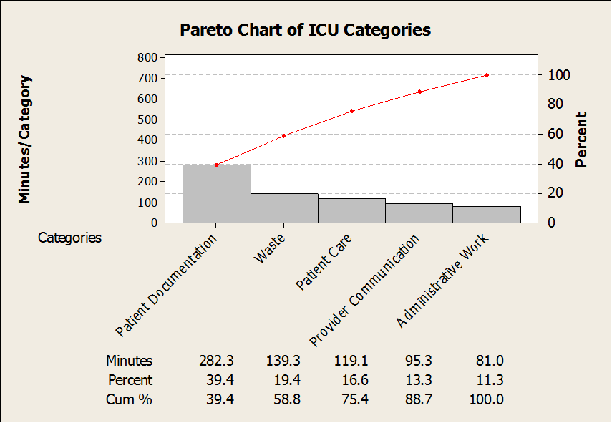
Figure 3: Pareto Chart of ICU Tasks by Category in an Average Day

Pareto charts of task breakdowns by category in the ICU can be found in Appendix A.

General Care Unit
Similar to what was seen in the ICU, the Patient Documentation category accounts for most of a PAs’ day, about 41% on average, as seen in Figure 4. This is supported by Figure 2, as discharge summaries account for a majority of their time. It is also notable that Waste is the second highest category, similar to that of the ICU.

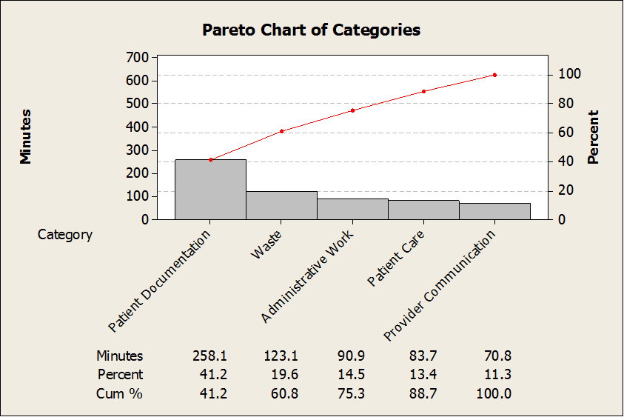
Figure 4: Pareto Chart of General Care Tasks by Category in an Average Day

Pareto charts of task breakdowns by category in the General Care Unit can be found in Appendix C.

Industrial Engineering Tools Used
Using the time study data and the aforementioned time blocks (Wait [that occurs before Work Rounds], Work Rounds, Morning Work, Attending Rounds, and Afternoon Work), the team implemented a Yamazumi chart to further analyze the time study data based on time of day. The team also did a standard utilization analysis of the PAs and analyzed historical data.

Yamazumi - ICU
The Yamazumi chart below, Figure 5, shows the average day of a PA broken down into the four main time blocks. The average duration and standard deviation of each of the time blocks is also shown. It can be seen that the average day of an ICU PA goes until 5:42 pm. This means they are working almost exactly twelve hours each day, which suggests a high utilization level.

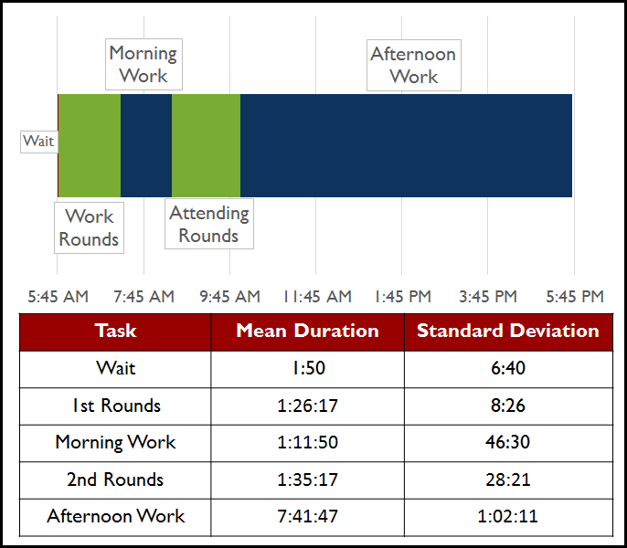
Figure 5: Yamazumi Chart of the ICU on an Average Day

The most complex time of the day is the Afternoon Work block. This time is not as rigidly formed like Rounds or Morning Work, and has the highest standard deviation of the four time blocks. A variety of tasks take place during this time, as can be seen below in Figure 6:

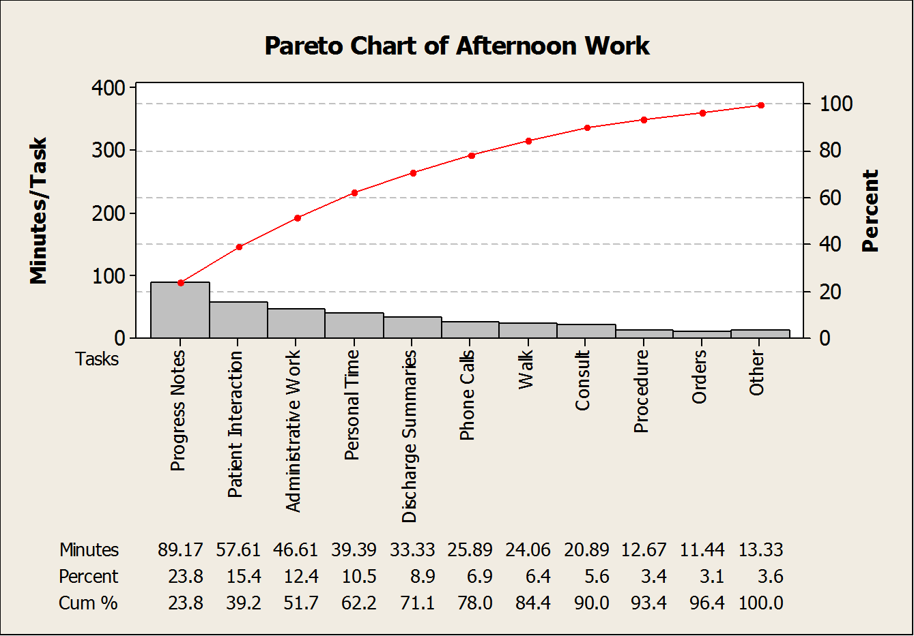
Figure 6: Pareto Chart of ICU Tasks in the Afternoon Work Time Block

Pareto chart breakdowns of ICU tasks in the Work Rounds, Morning Work, and Attending Rounds time blocks can be found in Appendix B.

Yamazumi - General Care
Using the time study data and the aforementioned time blocks (Wait [that occurs before Work Rounds], Work Rounds, Morning Work, Attending Rounds, and Afternoon Work), the team implemented a Yamazumi chart to further analyze the time study data based on time of day. The team also did a standard utilization analysis of the PAs.

The Yamazumi chart below, Figure 7, shows the average day of a PA broken down into the four main time blocks. The average duration and standard deviation of each of the time blocks is also shown. It can be seen that the average day of a General Care PA goes until 4:12 PM, well short of the defined end of the work shift at 5:45 PM. This means they are working well short of twelve hours each day, which suggests a relatively low utilization level.

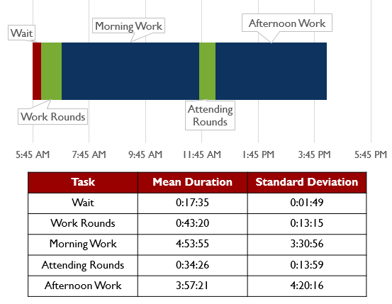
Figure 7: Yamazumi Chart of the General Care Unit on an Average Day

The most complex times of the day are the Morning and the Afternoon Work blocks. These times are not as structured as Work and Attending Rounds. Both the Morning and Afternoon Work Rounds have extremely high standard deviations compared to those of the Work and Attending Rounds. A variety of tasks take place during the Morning and Afternoon Work, as can be seen below in Figures 8 and 9:
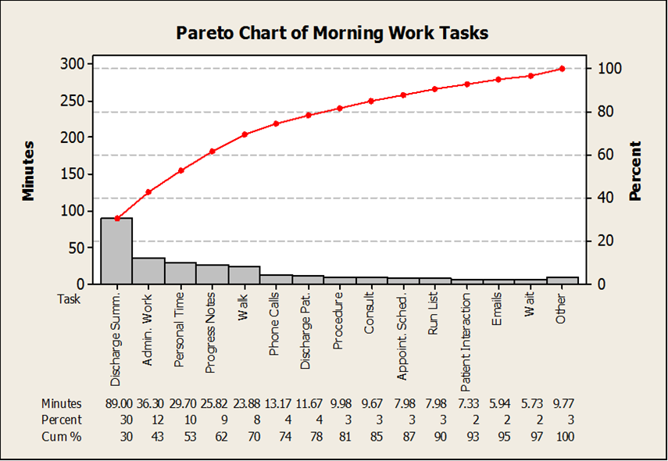
Figure 8: Pareto Chart of General Care Tasks in the Morning Work Time Block

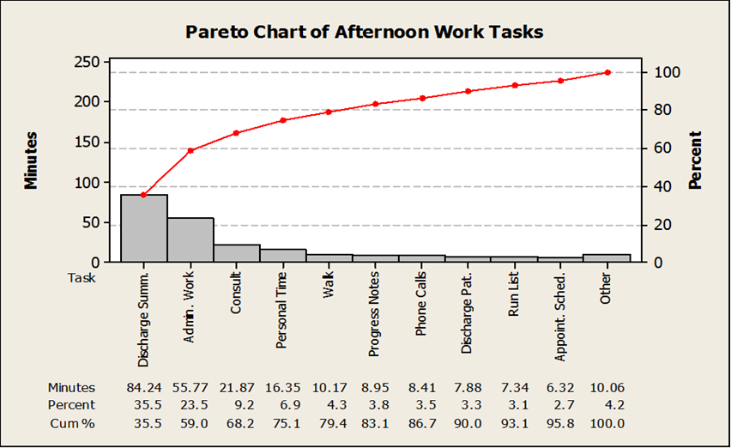
Figure 9: Pareto Chart of General Care Tasks in the Afternoon Work Time Block
Historical Data
The team acquired historical of patient volumes in the ICU and GCU in order to see average patient volumes, as well as the range between maximum and minimum volumes. The time period analyzed was from July 1, 2012 to 27 April, 2013, as this was the largest piece of consecutive data the team had access to. The results can be seen below in Figure 10.

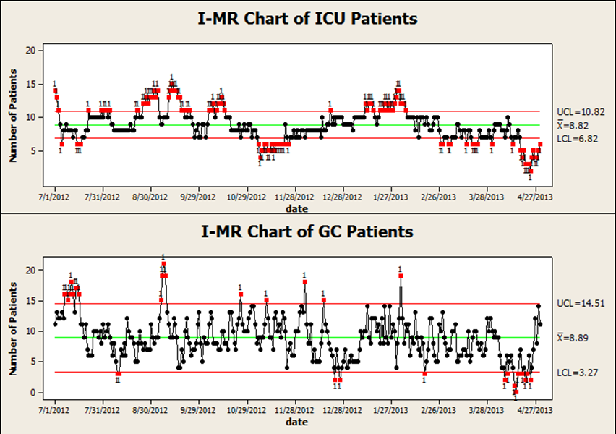
Figure 10: Historical Data on Patient Volumes

The historical data shows that the mean patient volume in the ICU was 8.8 patients, and the study data collected showed a mean patient volume of 9.1 patients. The historical data shows that the mean patient volume in the GC was 8.9 patients, and the study data collected showed a mean patient volume of 8.6 patients.

CONCLUSIONS & RECOMMENDATIONS

The team evaluated both the ICU and GCU findings and was able to draw conclusions and make recommendations based on the analyses that members of team performed. Our primary conclusions and recommendations are based on utilization levels and patient volumes, and are detailed below. Our secondary conclusions and recommendations are intended to improve the system based on these foundational utilization and patient volume conclusions.

Utilization Factors
The utilization level of ICU PAs was 91.22%, and of GCU PAs was 79.2%. These figures were calculated using Equation 1.

(Time Spent at Hospital - Personal Time) / 12hrs
Equation 1: The PAs’ Utilization Factor

Allowing for a 30 minute lunch break and one 15 minute personal break every 4 hours, the team calculated the utilization level goal of about 90%, using Equation 1. Based on our study, which was conducted during average patient volumes, the ICU PAs are over-utilized, and the GCU PAs are under-utilized. This under-utilization in the GCU is due to early completion of work. If calculated using Equation 2, the GCU PAs work saturation level based only on the time spent in the hospital is 92.81%.

(Time Spent at Hospital - Personal Time) / Time Spent at Hospital
Equation 2: The GCU PAs’ In-Hospital Saturation Factor

The team recommends that, rather than early dismissal, the General Care PA be reallocated to the ICU following completion of required GCU work. In the ICU, the GCU PA can assist the over-utilized ICU PA, and minimize the discrepancy between the GCU and ICU utilization levels.

Patient Volume Spikes
Due to patient volume spikes observed in historical data, which can rise to double or fall to less than half of the average patient volumes, the team predicts large variation in PA utilization for both units throughout the year. Hopp and Spearman’s Variability Law holds that “increasing variability always degrades the performance of a production system.” Therefore, this patient volume variability must be buffered by some combination of inventory and capacity. Buffering examples include:

<> Inventory (Full Beds)
- Patients waiting between procedures, medications, or labs
- Healthy patients waiting to be discharged
<> Capacity (Workforce)
- Overtime work for PAs and other medical personnel
- More PAs or other medical personnel
- Faster task completion

The team suggests that a further historical study be conducted to determine seasonality of patient volumes. This study will help the hospital develop a capacity/workforce strategy to cope with high patient volumes.

Task Lengths and Efficiencies
According to the team’s time study, PAs in the ICU spend approximately 2 hours 30 minutes of their average day on progress notes, and PAs in the GC Unit spend approximately 2 hours 45 minutes of their average day on discharge summaries. This means that each of these two major patient documentation tasks composes roughly 20-25% of its respective PA’s average day.

Analysis of patient documentation software was outside of the team’s project scope. However, the team recommends a further study on the process for composing progress notes and discharge summaries.

The team also recommends that the efficiency of progress notes and discharge summaries hold high priority in the ongoing MiChart program development, and that a follow-up study be conducted after full MiChart implementation.

Other Sources Of Variation
The team’s analysis revealed that the start time of attending rounds contributes a large amount of variation to the GCU PAs’ work pattern. The standard deviation of the length of morning work is approximately 3 hours and 30 minutes as a result of this variation.

The team, therefore, recommends the implementation of a more standardized attending rounds schedule.

Appendix A: Pareto Chart Task Breakdowns by Category in the ICU

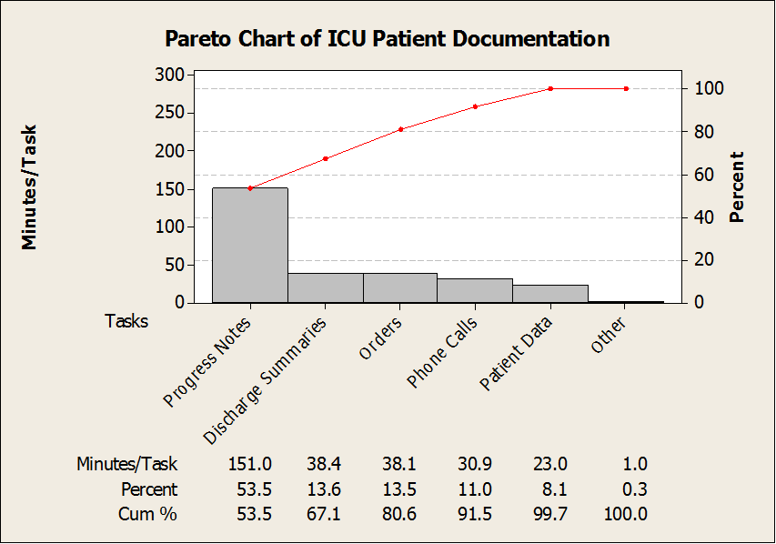
Figure 11: Pareto Chart of ICU Task Breakdown within Patient Documentation

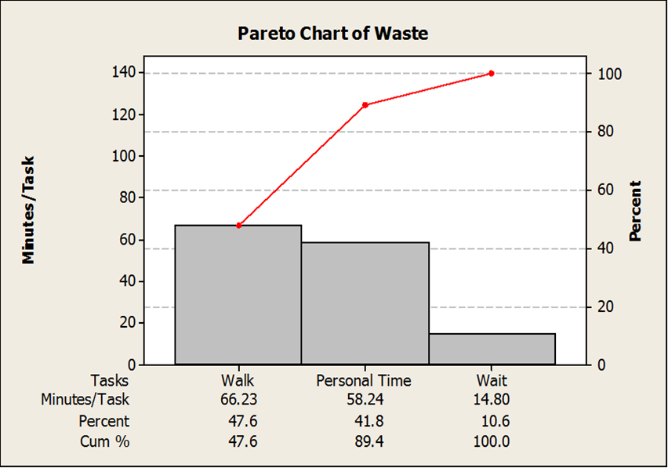
Figure 12: Pareto Chart of ICU Task Breakdown within Waste
A1
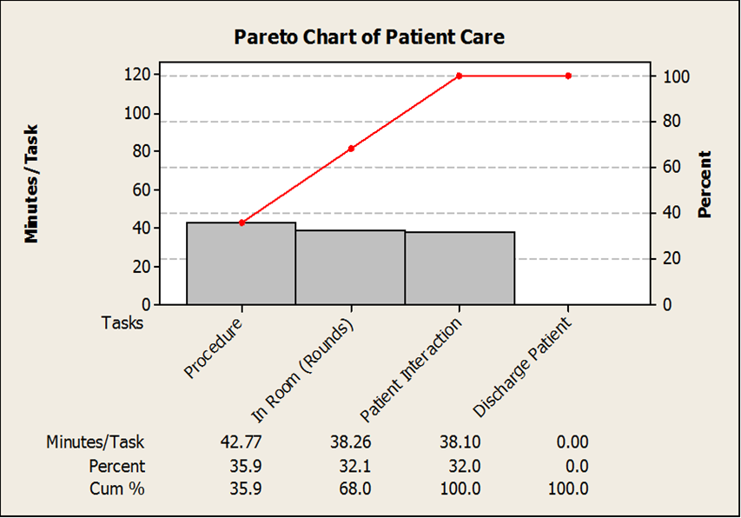
Figure 13: Pareto Chart of ICU Task Breakdown within Patient Care

A2
Appendix B: Pareto Chart Task Breakdowns by Time Block in the ICU

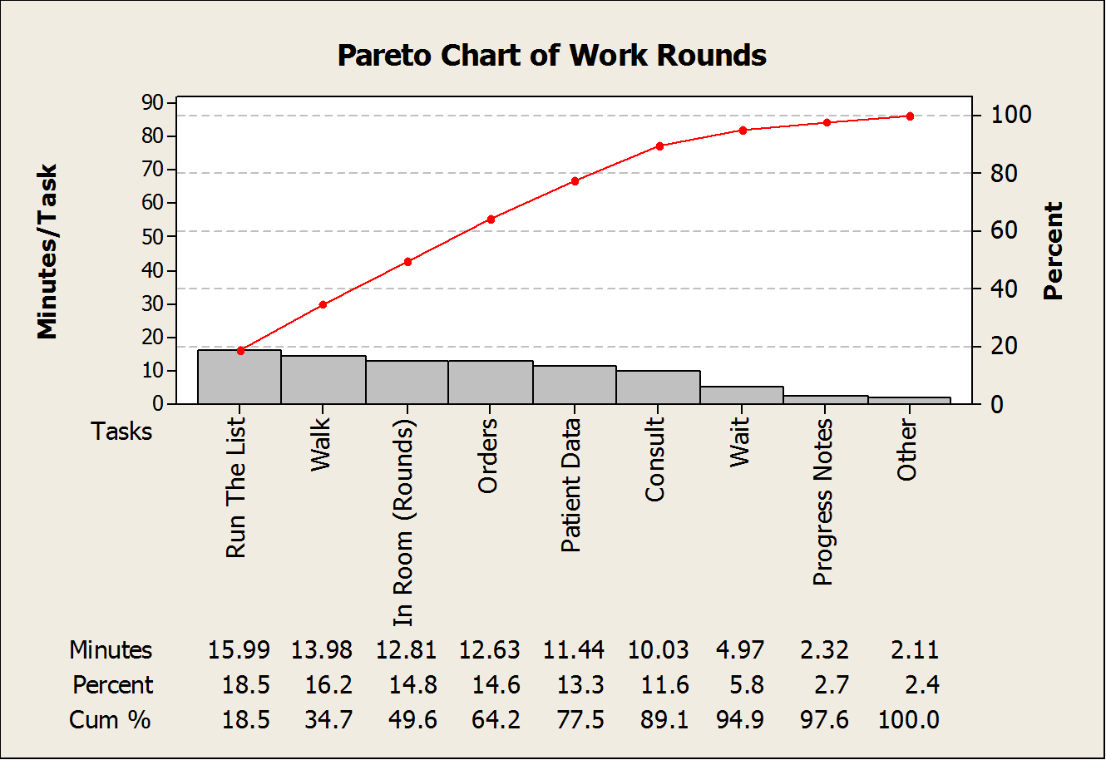
Figure 14: Pareto Chart of ICU Tasks in the Work Rounds Time Block

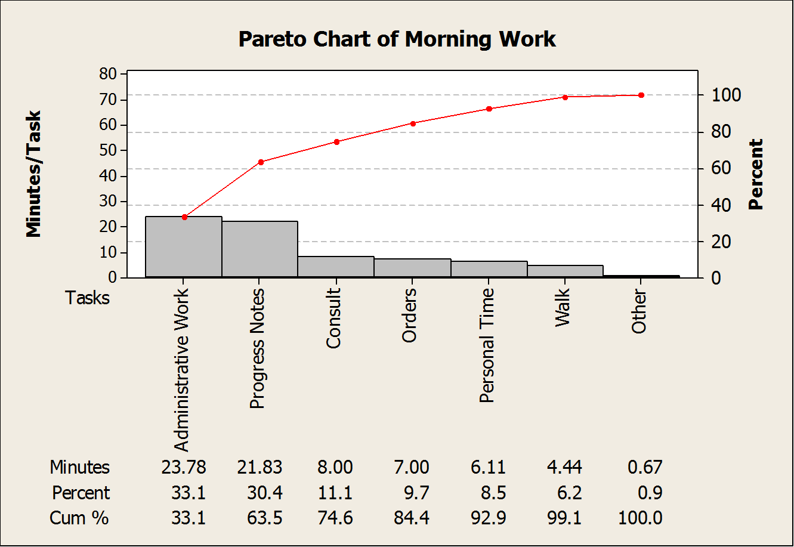
Figure 15: Pareto Chart of ICU Tasks in the Morning Work Time Block
B1
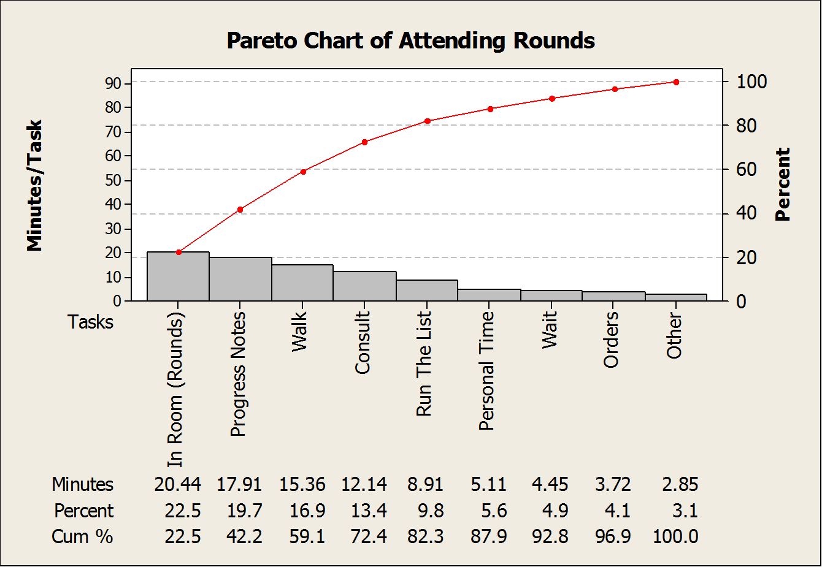
Figure 16: Pareto Chart of ICU Tasks in the Attending Rounds Time Block

B2
Appendix C: Pareto Chart Task Breakdowns by Category in the General Care Unit

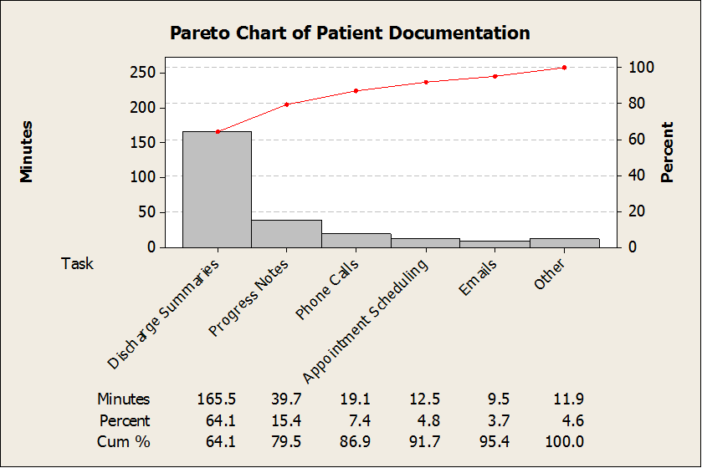
Figure 17: Pareto Chart of GCU Task Breakdown within Patient Documentation

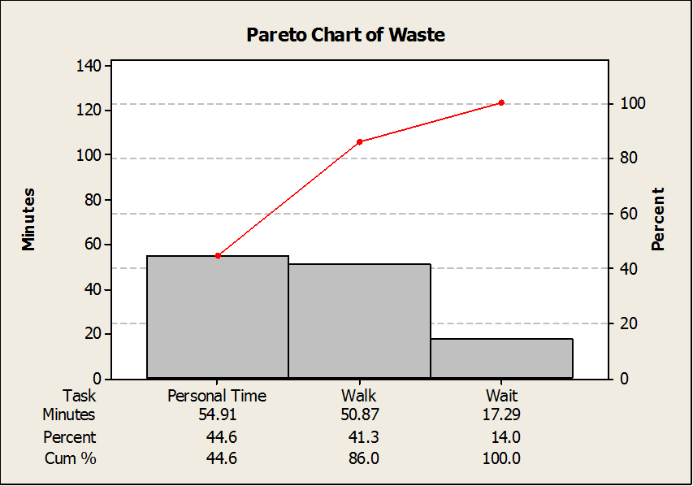
Figure 18: Pareto Chart of GCU Task Breakdown within Waste
C1
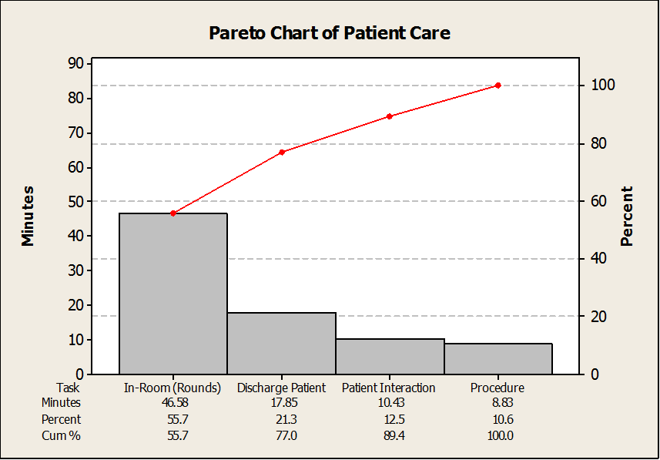
Figure 19: Pareto Chart of GCU Task Breakdown within Patient Care
C2

