Acknowledgements

The family would like to thank so and so for helping with the funeral. Add your own text here to replace this sample Hoover Web Design text. The family would like to thank so and so for helping with the funeral. Add your own text here to replace this sample Hoover Web Design text.

The family would like to thank so and so for helping with the funeral. Add your own text here to replace this sample Hoover Web Design text.

Pallbearers

First Name, Last

First Name, Last

First Name, Last

First Name, Last

First Name, Last

First Name, Last

Interment

Funeral Home Name
123 Hoover Web Design Street
Any City, Any State 296452

Funeral Program © 2014 www.hooverwebdesign.com
- For Personal Use ONLY -

Loved Ones Name

"

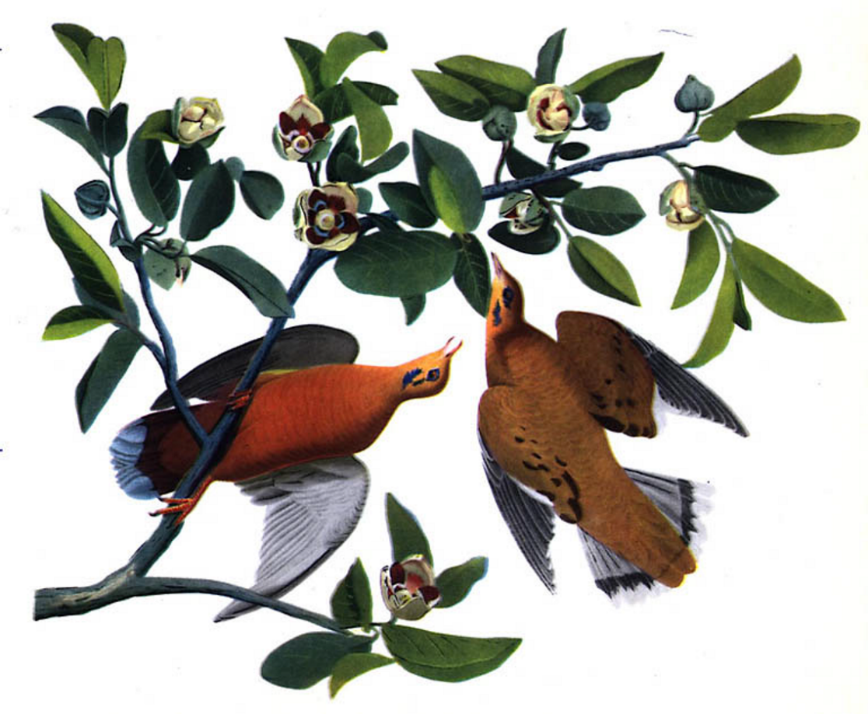
Born January 1, 1970

Departed May 12, 2014

Obituary

Here is where you place the obituary text of your loved one. Just copy and replace the Hoover Web Design sample text that is included here with your own text. Try to keep the text that you use about the same length so that you don't throw off the layout of the funeral program. Here is where you place the obituary text of your loved one. Just copy and replace the Hoover Web Design sample text that is included here with your own text.

Try to keep the text that you use about the same length so that you don't throw off the layout of the funeral program.

Here is where you place the obituary text of your loved one. Just copy and replace the Hoover Web Design sample text that is included here with your own text. Try to keep the text that you use about the same length so that you don't throw off the layout of the funeral program.

Poem

You may place a poem here or whatever you would like to appear here. Customize this area with whatever you wish. Keep the text area about the same length so that the layout is not thrown off.

You may place a poem here or whatever you would like to appear here. Customize this area with whatever you wish. Keep the text area about the same length so that the layout is not thrown off.

You may place a poem here or whatever you would like to appear here. Customize this area with whatever you wish. Keep the text area about the same length so that the layout is not thrown off.

Order of Service

Musical Prelude........................................... Name

Processional ............................................. Name

Musical Selection ........................................ Name

Scriptural Reading ....................................... Name

Prayer ................................................... Name

Reflections .............................................. Name

Eulogy ................................................... Name

Recessional .............................................. Name

