www.CardioSmart.org

Diabetes: Blood Sugar Readings
Normal values for adults who do NOT have prediabetes or diabetes
When you have not eaten (fasting blood sugar): | Less than or equal to 100
2 hours after eating (postprandial): | Less than 140 if you are age 50 or younger; less than 150 if you are age 50 to 60; less than 160 if you are age 60 and older
Random (casual): | Levels vary depending on when and how much you ate at your last meal. In general: 80 to 120 before meals or when waking up; 100 to 140 at bedtime.

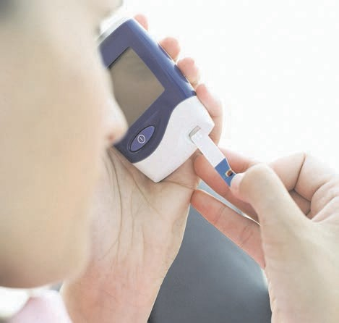What is a blood sugar reading?
A blood sugar reading shows how much sugar, or glucose, is in your blood. A test of your blood sugar may be done to:
- Check for diabetes.
- See how well diabetes treatment is working.
- Check for diabetes that occurs during pregnancy (gestational diabetes).
- Check for low or high blood sugar levels (hypoglycemia or hyperglycemia).

What are normal blood sugar readings?
There are several types of blood sugar tests. Normal results can vary from lab to lab.

Talk with your doctor about what any abnormal results might mean, and about any symptoms and other health problems you have.

Target values for nonpregnant adults who have prediabetes or diabetes

When you have not eaten (fasting blood sugar): | 80 to 130
2 hours after eating (postprandial): | Less than 180
What causes abnormal blood sugar?
High blood sugar can be caused by:
- Diabetes or prediabetes.
- Certain medicines, such as corticosteroids.
Low blood sugar can be caused by:

- Certain medicines, especially those used to treat diabetes.
- Liver disease, such as cirrhosis.
Rarely, high or low blood sugar can be caused by other medical problems that affect hormone levels.

Prediabetes and diabetes
Blood sugar helps fuel your body. Normally, your blood sugar rises slightly after you eat. This makes your pancreas release insulin. Insulin is a hormone that helps your body use and control the amount of sugar in your blood.
Diabetes or prediabetes means your body has trouble making or using insulin. This means your blood sugar can get too high. Over time, high blood sugar levels can damage your eyes, kidneys, nerves, and blood vessels.
Prediabetes means your blood sugar level is above normal but not high enough to mean you have diabetes. Without treatment, prediabetes may become type 2 diabetes.
- If your blood sugar level when you do not eat (fasting blood sugar) is between 100 and 125, you have prediabetes.
Diabetes is a lifelong condition in which sugar stays in the blood rather than entering the body's cells to be used for energy. You may have diabetes if:
- Your fasting blood sugar level is 126 or higher.
- Your 2-hour oral glucose tolerance test result is 200 or higher.
- Your A1c test result is 6.5% or higher. (A1c is a blood test that checks your average blood sugar level over the past 2 to 3 months.)
- Your random blood glucose test is 200 or higher and you have symptoms of diabetes. These may include:
  - Frequent thirst.
  - Frequent urination.
  - Weight loss.

Where can you find out more? Talk to your doctor to find out more about your blood sugar readings. The following organizations can help you learn more about diabetes and prediabetes:
American Association of Diabetes Educators: 1-800-338-3633
www.aadenet.org
American Diabetes Association: 1-800-DIABETES (1-800-342-2383)
www.diabetes.org
National Diabetes Education Program: 1-800-438-5383
www.ndep.nih.gov
National Diabetes Information Clearinghouse: 1-800-860-8747 www.diabetes.niddk.nih.gov

©2007-2015 Healthwise, Incorporated. Healthwise disclaims any liability for use of this information, which does not replace medical advice. 2015-05-zu1861

