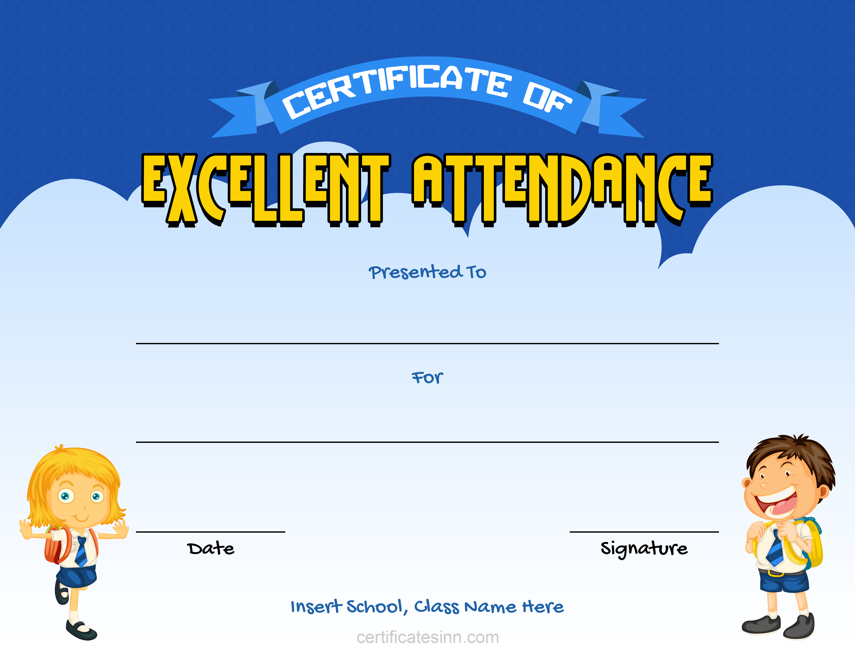

Insert School, Class Name Here

DD / MM / YYYY

Type Description Here

Insert Student Name Here