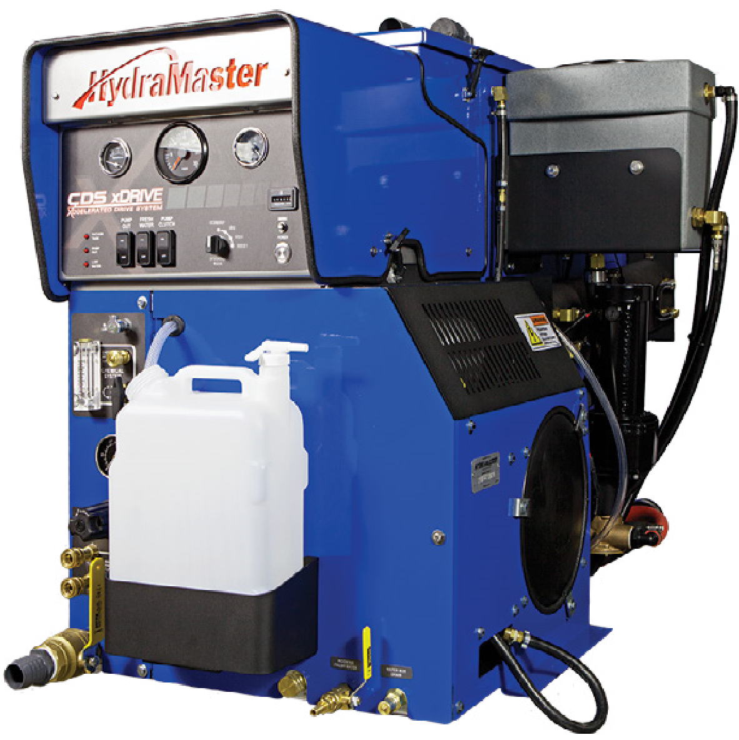

Owner’s Guide and Maintenance Log

HydraMaster
11015 47th Avenue West Mukilteo, Washington 98275
*000-182-900
D*
MAN-46606 Rev. A, January 2017
(P/N 000-182-900D)
No part of this manual may be reproduced or used in any form or by any means (i.e. graphic, electronic, photocopying or electronic retrieval systems) without the express written permission of HydraMaster. Specifications and information in this document are
subject to change without prior notice. All rights reserved. © 2017 HydraMaster
Dear CDS xDrive Owner,
Thank you for selecting HydraMaster carpet cleaning equipment. We take pride in the innovative design and quality of our machines, and want to congratulate you on your purchase. We look forward to a long relationship between you and HydraMaster.
In this package you will find a printed Owner’s Guide and Maintenance Logs with safety information, and a Truckmount Document Package with return envelope. Important: The Truckmount Installation Documentation and Warranty Registration must be completed by you and the distributor and returned to HydraMaster to activate your warranty and receive your free HydraMaster jacket. Your warranty starts on the date of installation. Please ensure the form is filled out completely and returned to us in the preaddressed envelope enclosed with this documentation.
Whether using a digital version or a printed copy, it is extremely important that you read the entire manual. The information contained in this manual is essential for safe operation and machine reliability.
As a HydraMaster owner you will periodically receive updates to this manual. Product Support Bulletins and manual supplements will be sent to you to keep you advised of changes or updates to your machine, it is important that we have your current contact information. You will find important contact information below, to help you with anything you might require.
11015 47
th Avenue West
Mukilteo, WA 98275
800.426.1301
www.hydramaster.com
800.426.4225
fax
425.771.7156
techsupport@hydramaster.com
csorders@hydramaster.com
You can always find the owner’s manual by visiting:
http://hydramaster.com/Support/EquipmentSupport/EquipmentManuals.aspx
Thank you again for choosing HydraMaster. We will continue, as we have for the last 4 decades to do everything possible to ensure that you remain a proud and satisfied HydraMaster owner. Sincerely,
HydraMaster
Important contact information for your reference:
Technical Parts and
Support Customer Service
800.426.1301 800.426.8972

Introduction
This Owner’s Guide provides you with important Contact Information, Warnings and Precautions, Machine Specifications, Operating Instructions and Maintenance Logs. In the back inside cover of this guide you will also find a CD that contains the digital Owner’s Manual.

HOW TO USE THESE RESOURCES
The Owner’s Guide is to be used for quick reference only and is not intended to be a comprehensive source of information. Refer to the Owner’s Manual when more detailed information is needed.
The Machine Maintenance Log is located in the Owner’s Guide. It is wise to keep this Guide in a visible location near the truckmount so that the log stays up to date. Please note that records of maintenance must be kept and copies may be required to be furnished to HydraMaster before any warranty is honored.
The digital Owner’s Manual contains information on everything from cleaning and chemicals to truckmount operation and maintenance. It also contains detailed machine parts lists as well as troubleshooting guides. You should become familiar with the material in the Owner’s Manual as it contains information that is essential for safe operation and increased truckmount reliability.
This Owner’s Guide contains the following sections:
- Machine Specifications
- Responsibilities
- Local Water Precautions
- Waste Water Disposal Advisory
- Operating Instructions
- Maintenance Logs

CONTACT INFORMATION
If you have any questions regarding the operation, maintenance or repair of this machine, please contact your local distributor.
To find a local distributor, please visit our website at http://hydramaster.com/HowToBuy/DealerLocator.aspx
If your question cannot be resolved by your distributor or by the information within this manual, you may contact HydraMaster direct using the following phone numbers.
HOURS | TELEPHONE NUMBERS | E-MAIL ADDRESSES
Monday-Friday  7:00 a.m. to 5:00 p.m.  Pacific Time | Technical Support  (800) 426-1301  FAX : (800) 426-4225 | Technical Support techsupport@hydramaster.com
 | Customer Service/Parts  800) 426-1301  FAX : (800) 426-4225 | Customer Service/Parts  parts@hydramaster.com
When calling your distributor, be sure to reference the serial number and date of purchase.
FOR YOUR REFERENCE:
Serial No.
Date of Purchase:
Purchased From (Distributor):

WARNINGS, CAUTIONS AND NOTICES
HydraMaster uses this
WARNING
symbol throughout the manual to warn of possible injury or death.
This
CAUTION
symbol is used to warn of possible equipment damage.
This NOTICE symbol indicates that federal or state regulatory laws may apply, and also emphasizes supplemental information.

HOT SURFACES: During the operation of this equipment, many surfaces on the machine will become very hot. When near the van for any reason care must be taken not to touch any hot surface, such as the engine or the exhaust.
HEARING PROTECTION: The Occupational Safety and Health Administration (OSHA) recommends the use of hearing protection when a technician is exposed to an average of 85 decibels (this is an
average of exposure over an 8 hour period). This equipment can produce 85 decibels to a distance of
10 feet. Please check with your local state agencies to see if OSHA standards apply to your application.
NO SMOKING: It is unsafe to smoke in or around the vehicle. Do not allow any open flames in or around the vehicle.
CARBON MONOXIDE: This unit generates toxic fumes. Position the vehicle so that the fumes will be directed away from the job site. Do not park where exhaust fumes can enter a building through open doors, windows, air conditioning units or kitchen fans.
TOXIC FUMES: Do not occupy the vehicle when the cleaning equipment is operating. Toxic fumes may accumulate inside a stationary vehicle.
ENGINE EXHAUST: The engine exhaust from this product contains chemicals known to the State of California to cause cancer, birth defects or other reproductive harm.
MOVING PARTS: Never touch any part of the machine that is in motion.
Severe bodily injury may result.
Do not attempt to service battery pack.
Severe bodily injury may result.

The use of some chemicals through your machine can seriously damage the internal plumbing, highpressure pump, chemical pump and heat exchanger. These harmful chemicals include concentrated acid solvents (including d-Limonene), and some paint, oil and grease removers with a high concentration of solvents.
THROUGH-FLOOR DRILLING: Be cautious when drilling holes through the van floor.
Many vans have critical components mounted directly below the van floor that could be damaged by a misplaced drill bit.
LEVEL OPERATION: During operation, the vehicle must be parked on level ground not to exceed + or - 10 degrees. Failure to ensure proper leveling may prevent proper internal lubrication of engine, vacuum and/or high pressure components.
ACID RINSE AGENTS: Some acid rinse products can cause damage to internal machine components. Failure to take appropriate measures to prevent acidic corrosion can result in system
failure and loss of warranty on affected parts
HARD WATER PROTECTION: Failure to take appropriate measures to prevent scale build up can result in system failure and loss of warranty on affected parts. Test the water in your immediate and
surrounding areas with hard water test strips. Assume all water obtained from wells is hard. If you are operating in a hard water area at 3.0 grains or more per gallon, use a water softening system.
FREEZE PROTECTION: Failure to take appropriate measures to prevent equipment damage due to freezing can result in system failure and loss of warranty on affected parts. Placing an electric heater in the vehicle or parking the vehicle indoors will help ensure against freezing, but should not be the primary method of freeze protection.

Do not attempt to open the controller as there are no serviceable components. Opening the controller will invalidate the warranty.
Do not mechanically modify the controller in any way as unexpected damage may occur. Mechanically modifying the controller will invalidate the warranty.
Do not use any other form of fasteners other than those supplied with the controller without contacting HydraMaster for advice. Use of inappropriate fasteners or torques could damage the controller.

MACHINE SPECIFICATIONS
Frame and  Recovery Tank | 26.25”W x 40.75”H x 68.25”L
Total Weight | 775 lbs
Construction | Marine aluminum with epoxy finish
 | Chassis galvanized steel
Power Pack | Vacuum  Blower | Gardner Denver 408 TriFlow
 | Water  Pump | General Pump
Drive System | 3 Phase PMAC Generator
 | 3 Phase Motor
 | (2) PMAC Motor Controllers
 | 48 V battery pack
Chemical  System | Last-step chemical injection, meter controlled
Heating System | 3- Zone
Instruments
 | Electronic tachometer, 0-3,500 rpm
 | Water temperature gauge, 0-320 degrees F
 | Vacuum gauge, 0-30” hg
 | Hour meter, machine run-time
 | Electronic circuit protection breaker, resettable
 | Machine status indicator lamps
 | Chemical flowmeter, 0-10 gph
 | Solution pressure gauge, liquid filled, 0-1,500 psi
 | Water pressure adjustment
 | Blower lubrication port
 | High pressure solution outlets, quick-disconnects
 | Fresh water inlet fitting, quick-disconnect
 | Water box drain valve
 | Chemical controls
Recovery Tank | 100 gallon aluminum
Cleaning Tool/  Wand | One HydraMaster Evolution wand

High Pressure  Hose | 1/4” high temperature, lined, vinyl covered
 | Hose rated to 2,200 psi, 250 degrees F
Other Standard  Equipment | Runtime hour meter
 | Chemical flow meter (0-10 GPM)
 | Chemical flow control valve
 | Vacuum gauge (0"-30" Hg)
 | Solution pressure gauge (0-1,500 PSI)
 | Solution pressure adjustment
 | Pre-wired pump-in switch
 | Pre-wired APO Switch/APO outlet
 | Fresh water inlet
 | Water system drain valve
 | Blower tachometer (0-3,500 RPM)
 | Electronic throttle control
 | Electrical circuit protection (resettable)
 | Solution pump switch
 | 4 speed control
 | CDS Power Transfer package
 | Top-mounted gauge cluster & control console
 | Dual wand solution connections
 | Dual wand vacuum connections
 | Freeze guard system
 | Safety wheel chocks
 | 10 ft x 1 1/2" whip line
 | 10 ft x 1 1/2” drain line
 | 150 feet High Performance Solution/Vacuum Hoses
 | Garden Hose
 | Chemical jug holder
 | 2.5 gallon chemical jug
 | Operation & maintenance manual
 | Embroidered HydraMaster jacket
 | Van decal
 | 3 Year Warranty

RESPONSIBILITIES

Purchaser’s Responsibility
If you are the purchaser, it is the your responsibility to read the Owner’s Manual and to familiarize yourself with the information contained herein, paying special attention to all Warnings and Cautions.

Sales Representative’s Responsibility
Acceptance of Shipment
- If the unit shows any outward signs of damage, do not sign the delivery receipt until you have closely inspected the unit and noted any damage on the delivery receipt.
- The sales representative from whom you purchased your unit is responsible for supervising the receipt of vehicle and communication with the transport company. The sales representative is also responsible for training you in its operation, maintenance and precautions.
Installation Verification
- The correct installation of the unit and recovery tank in your vehicle and the securing of them with bolts and tie down washers.
- Checking the pump, vacuum blower and engine oil levels prior to starting the unit.
- Starting the unit to check the drive system and see that all other systems function normally.
- Checking all hoses, tools/wands and accessories for correct operation.
Training
- A thorough review of the Owner’s Manual with the purchaser.
- Instruction in and familiarization with:
  - How to correctly start up and shut down the unit
  - How to correctly clean with the unit
  - Where and how often to check and change component oil levels
  - How the unit’s systems work, how to troubleshoot the unit
  - How to do basic repairs
  - Safety precautions and their importance
  - How to avoid freezing damage
  - How to avoid hard water damage
- A thorough review of the unit warranty and warranty procedures.
- A thorough review of hard water precautions and warnings.
- How to determine hard water areas.

LOCAL WATER PRECAUTIONS
The quality of water varies greatly. Many areas have an excess of minerals in the water which results in what is commonly called “hard water.” These minerals tend to adhere to the insides of heater coils and other parts of the machines causing damage and a loss of cleaning effectiveness. This influences the reliability and efficiency of equipment in direct proportion to the level of hardness.

Hard Water Advisory
HydraMaster recognizes that any hard water deposits which might occur within the water system of our truckmounts is a serious problem. The precision technology of truckmount heat exchanger systems is intolerant of any foreign material. Hard water deposits will ultimately decrease the performance of the system and are expected to seriously lower the reliability of the machine.
To validate a machine’s warranty, HydraMaster requires that all machines operating in designated “Hard Water Areas” (3.0 grains or more per gallon) be fitted with a water softening system, or a properly installed magnetic-type descaler must be used and maintained. Periodic descaling or acid-rinsing alone is not adequate in these areas. HydraMaster does not recommend any particular type or brand; however, the relative effectiveness of some types of magnetic descalers or softeners may require additional periodic use of descaling agents.
HydraMaster also recommends, in the strongest possible terms, that machines in all areas be fitted with a water softening system for improved operation and reliability.
Failure to take appropriate measures to prevent scale build up can result in system failure and loss of warranty on affected parts.

Hard Water Area Map
The hard water map, shown in Figure 1, defines hard water areas in the lower 48 United States which compromise fluid related components such as hoses, fittings, heaters, pumps, valves and water-cooled engines. For other countries, hard water area maps can be obtained from geological societies.
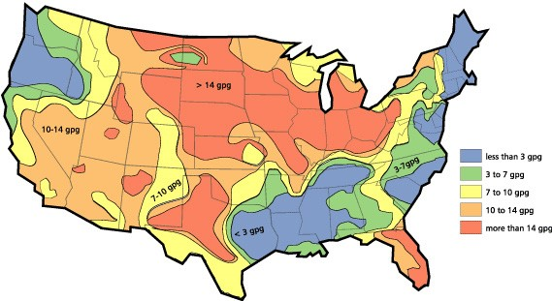
Figure 1. Hard Water Map of Mainland United States
The map shown in Figure 1 is provided for general reference only. Water hardness in your geographical location should be confirmed by testing.

Water Softener
Cleaning efficiency and equipment life is increased, chemical use decreased, and the appearance of cleaned carpets enhanced when water softeners are incorporated in hard water areas. HydraMaster strongly urges the use of water softener units with the CDS xDrive machines in areas exceeding 3.0 grains per gallon.
Failure to use a water softener in these areas will invalidate the machine’s warranty. Referring to the hard water area map shown Figure 1, determine the quality of water in your area and take immediate action if the water hardness exceeds 3.0 grains per gallon.
The relatively low cost of a water softener service is more than made up for by an increased life of machine parts, reduced chemical costs and continued cleaning efficiency. The water softener will also increase the effectiveness of the cleaning chemicals, therefore less chemical will be needed.
Contact a water softener distributor in your area for information on the rental of a simple water treatment unit to carry in your truck. Be sure to change the water softener in accordance with the capability of the softener.
For example: If the softener will treat 900 gallons of water and the machine uses an average of 30 gallons per hour, for an average of 5 hours a day, this equals 150 gallons per day. In 6 days the machine would use 900 gallons of water. Therefore, the softener would need to be changed every 6 working days for maximum softening.

WASTE WATER DISPOSAL ADVISORY
There are laws in most communities prohibiting the dumping of recovered “gray” water from carpet cleaning in any place but a sanitary treatment system.
The cleaning rinse water, recovered into your unit’s vacuum tank, contains materials such as detergents, and must be safely processed before entering streams, rivers and reservoirs.
In most cases, an acceptable method of waste water disposal is to discharge into a municipal sewage treatment system after first filtering out solid material such as carpet fiber. Access to the sanitary system can be obtained through a toilet, laundry drain, RV dump, etc. Permission should first be obtained from any concerned party or agency.
One disposal method which usually complies with the law is to accumulate the waste water and haul it to an appropriate dump site. Another solution to the disposal problem is to equip your CDS xDrive with an Automatic Pump-Out System (APO). These systems are designed to remove waste water from the extractor’s recovery system and actively pump the water through hoses to a suitable disposal drain.
HydraMaster makes an APO System which can be ordered with new equipment or installed later.
When properly configured, the systems will continuously monitor the level of waste water and pump it out simultaneously with the cleaning operation. The hidden benefit of this process is that the technician does not have to stop his/her cleaning to empty the recovery tank.
IN ACCORDANCE WITH EPA, STATE AND LOCAL LAWS, DO NOT DISPOSE OF WASTE WATER INTO GUTTERS, STORM DRAINS, STREAMS, RESERVOIRS, ETC.
The penalties for non-compliance can be serious.
Always check local laws and regulations to be sure you are in compliance.

BATTERY RESET FOR FORD TRANSIT VAN
If the battery has been disconnected or a new battery has been installed, some system settings must be reset after the battery is reconnected.

Refer to the Ford Transit Owner’s Manual for instructions for battery reset conditions.

- Operating Instructions
This section of the manual contains the following instructions:
- Before Operating the CDS xDrive
- CDS xDrive Start Up
- CDS xDrive Shut Down

BEFORE OPERATING THE CDS XDRIVE
- Locate the van and equipment in a well-ventilated area.
The vehicle in which the CDS xDrive operates generates toxic fumes. Position the vehicle so that the
fumes will be directed away from the job site. Do not park where exhaust fumes can enter a building through open doors, windows, air conditioning units or kitchen fans.
- Check the fuel tank to be certain there is adequate fuel to complete the job.
- Position the wheel chocks on one of the front tires.
- If using a water supply hose which has not been used recently or if using a customer’s hose, first connect the hose to the faucet and flush out any debris which may be in the hose. Afterwards connect the hose to the unit.
- Check the chemical jug to see if you have enough concentrated chemical to finish the job. If not, mix and fill a 2.5 gallon chemical jug.
- Connect all required hoses.
- When connecting the pressure hose to the pressure outlet connections at the front of the unit, go to the farthest area to be cleaned and connect to the cleaning tool. This ensures that you have the proper length of hose required to perform the cleaning.
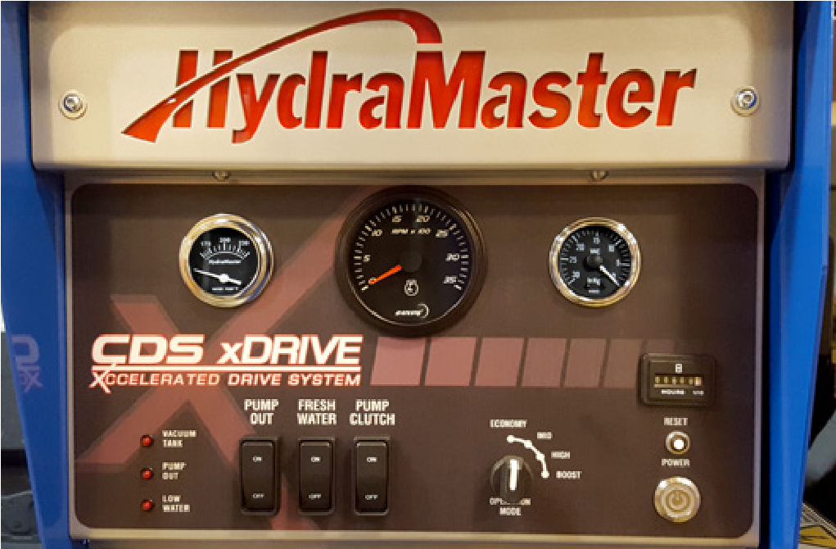Gauge
CDS XDRIVE UPPER DASH
Power
Low Water
Pump Out “on” Indicator
Vacuum Tank
“full” Indicator
Temperture
Main Circuit Breaker
Hour Meter
Vacuum Gauge
Tachometer
Blower Speed
^{Box Indicator} Operation Mode
Selector
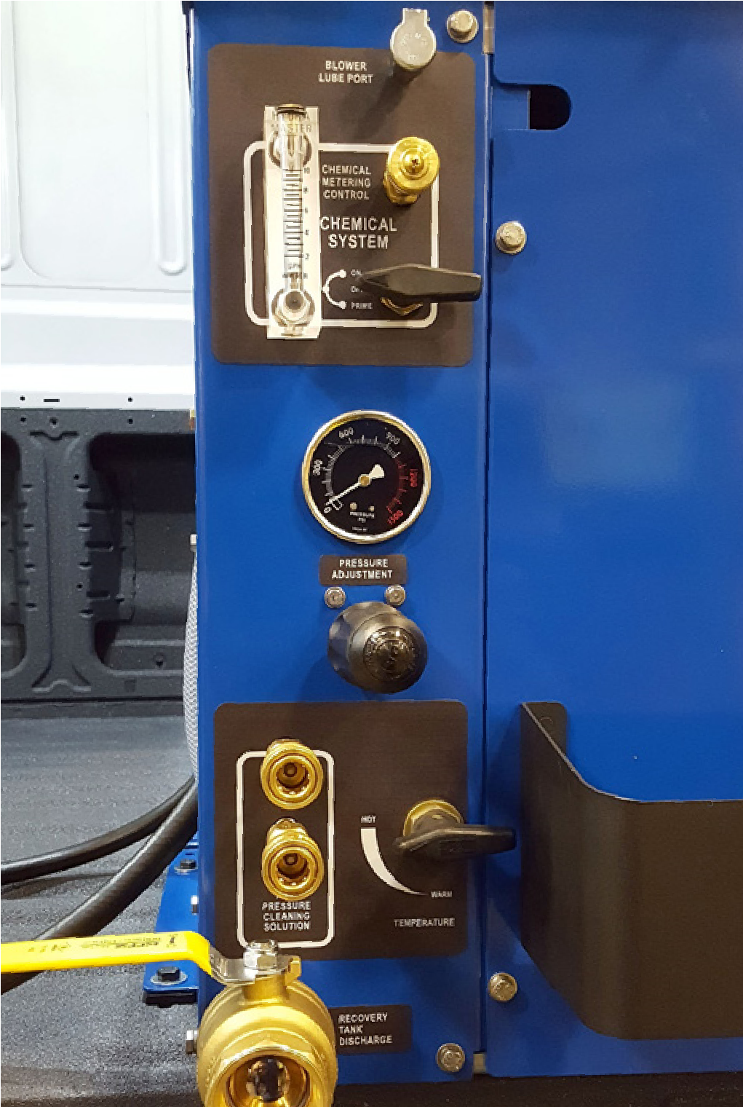
CDS XDRIVE LOWER DASH
Recovery
Tank Drain
Temperature Control Valve
Quick Connect
Solution Out
Pressure
Adjustment
Pump
Pressure
Gauge
Chemical
Flow Meter
Blower Lube Port
Chemical
Adjustment
Chemical
System Valve

CDS xDRIVE START-UP
- Make sure the vehicle’s gear select lever is in the Park position and the parking brake is set. Also make sure all vehicle accessories are turned off (A/C, fan).
The CDS xDrive will not operate correctly without parking brake engaged.
- Start the vehicle’s engine.
- Turn on the POWER switch.
- Select the motor speed - Economy, Mid, High, Boost (Allow the unit to acheive operating RPM).
- Turn on the PUMP CLUTCH switch. Adjust cleaning pressure to desired level.
CDS xDrive Flood restoration work
When using equipment for flood damage, leave the pump clutch off. This will reduce the engine power load and save on fuel consumption.
- Turn on the FRESH WATER switch (if fresh water tank is included).
- Turn the heat control valve to adjust temperature to desired level.
- Turn the CHEMICAL SYSTEM valve to the ‘PRIME’ position to purge any air from the system.
The prime hose is plumbed into the recovery tank.
Leaving the valve in the ‘PRIME’ position will cause excessive chemical usage.
  - When the chemical begins to flow through the flowmeter, with the flow indicator reading maximum flow and the PRIME line pulsing, turn the CHEMICAL SYSTEM valve to ‘ON’. Cap off vacuum if necessary.
  - While spraying the solution from the cleaning tool, adjust the chemical flow by turning the CHEMICAL METERING CONTROL knob to the desired level.
- Optional: Turn the APO switch ‘ON’ if using the Automatic Pump-Out feature.
The APO pump will not engage until the water level rises inside the recovery tank.
- Proceed with the cleaning operation.
The machine will automatically shut down when the recovery tank reaches its full capacity due to the float switch located inside the tank. When this occurs, turn the CDS xDrive POWER switch off and empty the recovery tank. Then, turn the unit back on and continue to clean.

CDS xDRIVE SHUT-DOWN
- Flush clear water through the chemical system for 10 seconds.
- Open the water box drain and actuate the tool/wand valve to run fresh water through the water box, heat exchangers and cleaning tools.
If freeze guarding is necessary, perform the freeze guard procedure at this time. Draining the water box to ½ full or less is recommended to reduce spillage inside the vehicle.
Rinse the system with vinegar on a weekly basis. Rinse the entire system with descaler each month.
- Lay vacuum hoses out in order for all moisture to be removed from the hoses. This prevents spillage of any dirty solution in your vehicle when storing the hoses.
- Disconnect the hoses and put them away.
- If you are using an outside water source, turn the water supply faucet off. Bleed pressure out of the supply hose by loosening the hose at the water supply. Unhook the water supply hose and store it in the vehicle
- Allow the unit to run for a few minutes with the vacuum hose disconnected in order to remove all moisture from the vacuum pump.
- Plug the vacuum inlets. Spray a HydraMaster-recommended lubricant (P/N 000-087-006) into the lube port for about 5 to 7 seconds while the unit is running. This will lubricate the vacuum pump and prevent it from rusting. (The lube port is located on the front panel above the pressure gauge).
- Remove the inlet plugs, turn off CDS xDrive power switch.
- Drain the recovery tank.
If your CDS xDrive is equipped with an APO, first connect a garden hose to the outlet on the front of the machine. The CDS xDrive must be ‘ON’ for APO to operate.
If your CDS xDrive is equipped without an APO, drain the recovery tank through the recovery tank discharge valve.
Do not dump waste in any area which might violate local, state or federal law. If you have the optional APO system, drain the recovery tank into a sanitary drain system.
- After the recovery tank is drained, lift the recovery tank lid and remove the filter basket.
- Clean out any accumulated debris.
- Rinse and re-install.
- Check the pleated blower filter.
- Clean out any accumulated debris.
- Rinse and re-install.
- Recommend leaving the tank lid open overnight for air circulation in the waste tank.
When re-installing the blower filter, ensure that it is fully seated against its mount so that debris cannot pass under it and into the blower.

THROTTLE CONTROL
The throttle control must meet certain conditions to elevate the engine rpm, which are:
SEIC ENABLE-DISABLE CONDITIONS
Vehicle Conditions to Enable  (all required) | Vehicle Conditions that Disable  (any one required)
Parking brake applied | Parking brake disengaged
Foot off of service brake | Depressing service brake
Vehicle in PARK | Vehicle taken out of Park
Foot off of accelerator pedal | Accelerator pedal depressed
Vehicle speed is 0 mph | Vehicle speed is not 0 mph
Brake lights functional | Brake light circuit disconnected
Engine at a stable base idle speed
Transmission oil Temp above 20° F | Transmission oil Temp exceeds 240° F
Engine Coolant Temp 20° F minimum | Engine Coolant Temp above 234° F
 | Catalyst Temperature above limit
SEIC (Stationary Elevated Idle Control)* will be terminated by a safety condition violation. For instance, the SEIC will be terminated if the service brake is depressed at any time during its operation.

Maintenance Logs
To avoid costly repairs and down-time, it is imperative to develop and practice good maintenance procedures from the beginning. These procedures fall into daily, weekly, monthly and quarterly increments, and are outlined in this section. All recommended maintenance must be performed by competent service personnel.
This section covers:
- Operational Maintenance
- Appearance Maintenance
- Long-Term Maintenance Schedule
Record the date and machine hours on the maintenance log provided for your convenience in the
Owner’s Guide. Records of maintenance must be kept and copies may be required to be furnished to HydraMaster before the warranty is honored. It is recommended that you affix a copy of the log on the vehicle door near your unit for convenience and to serve as a maintenance reminder.

OPERATIONAL MAINTENANCE
This section contains recommendations for maintenance that will affect the service life of your unit.
HydraMaster recommends that you follow the vehicle maintenance schedule as stated by the manufacturer. All HydraMaster references to vehicle maintenance serve as general vehicle service reminders. If there are any questions regarding servicing of your vehicle, please contact your local vehicle dealership.

Perform Descaling as Required
Scale deposits on the interior of the heating system can cause a noticeable loss in heating performance. Deposits of this kind result from hard water deposits, excessive chemical use or improper chemicals. The frequency with which descaling procedures are required will vary. If your area has particularly hard water or you see evidence of deposits in the water system, you may have to descale monthly.
To descale your system:
- Add an appropriate descaler chemical to your water box.
- Circulate it through the heating system. Let it stand.
- Flush and repeat as necessary.
- Clean all screens and strainers, and check them frequently following descaling.
If you are circulating a descaler through the flowmeter, make sure to run clean water through the flowmeter after you perform this procedure.

APPEARANCE MAINTENANCE
Maintaining the original appearance of your unit is important for two reasons:
- It represents a big dollar investment for your cleaning business and its appearance should reflect that fact. A dirty machine does not look professional.
- Maintenance, troubleshooting and repair is much easier to accomplish on a clean, well-maintained unit. Regular cleaning of the machine offers you an opportunity to visually inspect all parts of the machine and spot potential problems before they occur.
The following maintenance is recommended by the manufacturer at the frequency indicated:

Daily
- Wipe machine down thoroughly with a damp cloth.
- Flush recovery tank out thoroughly.
- Clean wand to maintain original appearance.
- Wipe down vacuum and high pressure hoses as needed.
- Visually inspect hoses for cuts, etc.

Weekly
- Wipe down entire unit as needed.
- Apply good coat of auto wax to all painted surfaces inside and out.
- Thoroughly clean wand and inspect for clogged jet, debris in vacuum slot and leaking fittings at valve.
- Apply light coat of auto wax to wand. Thoroughly clean vacuum and high pressure hoses including hose cuffs.

LONG-TERM MAINTENANCE SCHEDULE
The following components or systems should be serviced or replaced at the specified intervals.
Component | Interval  (Machine hours / months of service)
High pressure water pump rebuild | 2,000 / 24
Vehicle engine thermostat (Replace with genuine Ford part) | 2,000 / 24
Vehicle engine accessory drive belt | 2,000 /24
CDS xDrive blower silencer and exhaust plumbing | 4,000 / 48
CDS xDrive and vehicle heater hoses | 4,000 / 48
CDS xDrive wire harness | 4,000 / 48

Date
Hour Meter Reading
Technician Initials
Vehicle/CDS xDrive - check for leaks
❐       
Pump oil - check
❐       
Belts and pulleys - check for wear        
High pressure lines-internal - check for chafing        
Recovery tank inlet filter - remove and clean        
Recovery tank - clean        
Chemical container - remove and clean        
Vac. relief valve - inspect, clean        
Engine rpm - check with CDS xDrive unit
❐        operating
Float switches - clean and inspect        
Hoses and quick connects; check for wear;
❐        replace as needed
ATTENTION: Additional break-in period maintenance required!
One time change of pump oil after 50 hours of
❐
operation; every 300 hours thereafter.

Blower oil - change after first 100 hours of use. 

Monthly Maintenance

Flush chemical system with vinegar    

All fasteners; tighten as needed    

Engine air cleaner - inspect  

Battery terminals - clean as needed  

Blower drive belt - check   Quarterly Maintenance (250 Hours, unless indicated otherwise)

Chemical pump valves and diaphragm - check 

Chemical pump - inspect 

Vehicle fuel lines - check for chaffing or wear 

CDS xDrive wiring harness - check for chafing or
- wear

Bearings/power pack pillow block - grease 

Vehicle wiring harness - check for chafing or
- wear

Pump oil - change (every 300 hours) 

Blower oil - change (every 400 - 500 miles) 

Every 500 Hours

Salsa Heat Exchanger (if equipped) - clean and
- 
inspect

Yearly Maintenance (or Every 1,000 Hours, Whichever Comes First)

Vehicle - complete service 

Cooling system - flush 

Transmission fluid - change 

Blower Drive Belt 

Date
Hour Meter Reading
Technician Initials
Vehicle/CDS xDrive - check for leaks
❐       
Pump oil - check
❐       
Belts and pulleys - check for wear        
High pressure lines-internal - check for chafing        
Recovery tank inlet filter - remove and clean        
Recovery tank - clean        
Chemical container - remove and clean        
Vac. relief valve - inspect, clean        
Engine rpm - check with CDS xDrive unit
❐        operating
Float switches - clean and inspect        
Hoses and quick connects; check for wear;
❐        replace as needed
ATTENTION: Additional break-in period maintenance required!
One time change of pump oil after 50 hours of
❐
operation; every 300 hours thereafter.

Blower oil - change after first 100 hours of use. 

Monthly Maintenance

Flush chemical system with vinegar    

All fasteners; tighten as needed    

Engine air cleaner - inspect  

Battery terminals - clean as needed  

Blower drive belt - check   Quarterly Maintenance (250 Hours, unless indicated otherwise)

Chemical pump valves and diaphragm - check 

Chemical pump - inspect 

Vehicle fuel lines - check for chaffing or wear 

CDS xDrive wiring harness - check for chafing or
- wear

Bearings/power pack pillow block - grease 

Vehicle wiring harness - check for chafing or
- wear

Pump oil - change (every 300 hours) 

Blower oil - change (every 400 - 500 miles) 

Every 500 Hours

Salsa Heat Exchanger (if equipped) - clean and
- 
inspect

Yearly Maintenance (or Every 1,000 Hours, Whichever Comes First)

Vehicle - complete service 

Cooling system - flush 

Transmission fluid - change 

Blower Drive Belt 

Date
Hour Meter Reading
Technician Initials
Vehicle/CDS xDrive - check for leaks
❐       
Pump oil - check
❐       
Belts and pulleys - check for wear        
High pressure lines-internal - check for chafing        
Recovery tank inlet filter - remove and clean        
Recovery tank - clean        
Chemical container - remove and clean        
Vac. relief valve - inspect, clean        
Engine rpm - check with CDS xDrive unit
❐        operating
Float switches - clean and inspect        
Hoses and quick connects; check for wear;
❐        replace as needed
ATTENTION: Additional break-in period maintenance required!
One time change of pump oil after 50 hours of
❐
operation; every 300 hours thereafter.

Blower oil - change after first 100 hours of use. 

Monthly Maintenance

Flush chemical system with vinegar    

All fasteners; tighten as needed    

Engine air cleaner - inspect  

Battery terminals - clean as needed  

Blower drive belt - check   Quarterly Maintenance (250 Hours, unless indicated otherwise)

Chemical pump valves and diaphragm - check 

Chemical pump - inspect 

Vehicle fuel lines - check for chaffing or wear 

CDS xDrive wiring harness - check for chafing or
- wear

Bearings/power pack pillow block - grease 

Vehicle wiring harness - check for chafing or
- wear

Pump oil - change (every 300 hours) 

Blower oil - change (every 400 - 500 miles) 

Every 500 Hours

Salsa Heat Exchanger (if equipped) - clean and
- 
inspect

Yearly Maintenance (or Every 1,000 Hours, Whichever Comes First)

Vehicle - complete service 

Cooling system - flush 

Transmission fluid - change 

Blower Drive Belt 

Date
Hour Meter Reading
Technician Initials
Vehicle/CDS xDrive - check for leaks
❐       
Pump oil - check
❐       
Belts and pulleys - check for wear        
High pressure lines-internal - check for chafing        
Recovery tank inlet filter - remove and clean        
Recovery tank - clean        
Chemical container - remove and clean        
Vac. relief valve - inspect, clean        
Engine rpm - check with CDS xDrive unit
❐        operating
Float switches - clean and inspect        
Hoses and quick connects; check for wear;
❐        replace as needed
ATTENTION: Additional break-in period maintenance required!
One time change of pump oil after 50 hours of
❐
operation; every 300 hours thereafter.

Blower oil - change after first 100 hours of use. 

Monthly Maintenance

Flush chemical system with vinegar    

All fasteners; tighten as needed    

Engine air cleaner - inspect  

Battery terminals - clean as needed  

Blower drive belt - check   Quarterly Maintenance (250 Hours, unless indicated otherwise)

Chemical pump valves and diaphragm - check 

Chemical pump - inspect 

Vehicle fuel lines - check for chaffing or wear 

CDS xDrive wiring harness - check for chafing or
- wear

Bearings/power pack pillow block - grease 

Vehicle wiring harness - check for chafing or
- wear

Pump oil - change (every 300 hours) 

Blower oil - change (every 400 - 500 miles) 

Every 500 Hours

Salsa Heat Exchanger (if equipped) - clean and
- 
inspect

Yearly Maintenance (or Every 1,000 Hours, Whichever Comes First)

Vehicle - complete service 

Cooling system - flush 

Transmission fluid - change 

Blower Drive Belt 

Date
Hour Meter Reading
Technician Initials
Vehicle/CDS xDrive - check for leaks
❐       
Pump oil - check
❐       
Belts and pulleys - check for wear        
High pressure lines-internal - check for chafing        
Recovery tank inlet filter - remove and clean        
Recovery tank - clean        
Chemical container - remove and clean        
Vac. relief valve - inspect, clean        
Engine rpm - check with CDS xDrive unit
❐        operating
Float switches - clean and inspect        
Hoses and quick connects; check for wear;
❐        replace as needed
ATTENTION: Additional break-in period maintenance required!
One time change of pump oil after 50 hours of
❐
operation; every 300 hours thereafter.

Blower oil - change after first 100 hours of use. 

Monthly Maintenance

Flush chemical system with vinegar    

All fasteners; tighten as needed    

Engine air cleaner - inspect  

Battery terminals - clean as needed  

Blower drive belt - check   Quarterly Maintenance (250 Hours, unless indicated otherwise)

Chemical pump valves and diaphragm - check 

Chemical pump - inspect 

Vehicle fuel lines - check for chaffing or wear 

CDS xDrive wiring harness - check for chafing or
- wear

Bearings/power pack pillow block - grease 

Vehicle wiring harness - check for chafing or
- wear

Pump oil - change (every 300 hours) 

Blower oil - change (every 400 - 500 miles) 

Every 500 Hours

Salsa Heat Exchanger (if equipped) - clean and
- 
inspect

Yearly Maintenance (or Every 1,000 Hours, Whichever Comes First)

Vehicle - complete service 

Cooling system - flush 

Transmission fluid - change 

Blower Drive Belt 

Date
Hour Meter Reading
Technician Initials
Vehicle/CDS xDrive - check for leaks
❐       
Pump oil - check
❐       
Belts and pulleys - check for wear        
High pressure lines-internal - check for chafing        
Recovery tank inlet filter - remove and clean        
Recovery tank - clean        
Chemical container - remove and clean        
Vac. relief valve - inspect, clean        
Engine rpm - check with CDS xDrive unit
❐        operating
Float switches - clean and inspect        
Hoses and quick connects; check for wear;
❐        replace as needed
ATTENTION: Additional break-in period maintenance required!
One time change of pump oil after 50 hours of
❐
operation; every 300 hours thereafter.

Blower oil - change after first 100 hours of use. 

Monthly Maintenance

Flush chemical system with vinegar    

All fasteners; tighten as needed    

Engine air cleaner - inspect  

Battery terminals - clean as needed  

Blower drive belt - check   Quarterly Maintenance (250 Hours, unless indicated otherwise)

Chemical pump valves and diaphragm - check 

Chemical pump - inspect 

Vehicle fuel lines - check for chaffing or wear 

CDS xDrive wiring harness - check for chafing or
- wear

Bearings/power pack pillow block - grease 

Vehicle wiring harness - check for chafing or
- wear

Pump oil - change (every 300 hours) 

Blower oil - change (every 400 - 500 miles) 

Every 500 Hours

Salsa Heat Exchanger (if equipped) - clean and
- 
inspect

Yearly Maintenance (or Every 1,000 Hours, Whichever Comes First)

Vehicle - complete service 

Cooling system - flush 

Transmission fluid - change 

Blower Drive Belt 

MAINTENANCE CHART - 8 TO 600 HOURS
Adjust | A
Check | CH
Clean and Inspect | C/I
Clean and Lubricate | C/L
Flush | F
Lubricate | L
Replace | R
Check engine oil level
Check blower oil level
Check pump oil level
Empty recovery tank inlet filter
Inspect and clean orifice and filters
Inspect and clean garden hose screen
Visually inspect machine for loose wires, oil leaks, water leaks, etc
Inspect recovery tank stainless steel filter for clogging or damage; clean, repair or replace as needed
Inspect and clean the vacuum slot on the cleaning wand. Watch for sharp edges that may tear the carpet; remove any sharp edges as required
Lubricate blower lube port with a HydraMaster-recommended spray lubricant (P/N 000-087-006)
Engine oil and filter | INTERVAL IN HOURS CDS xDrive - FORD TRANSIT  Change oil and filter every 3,000 miles or 3 months, whichever comes first
Pump oil *  Blower oil ** | Change after first 50 hours of use  Use Aeon PD synthetic oil; change after first 100 hours of use.
SERVICE  Float switches | 8 | 25  C/I | 50  C/I | 75  C/I | 100  C/I | 125  C/I | 150  C/I | 175  C/I | 200  C/I | 225  C/I | 250  C/I | 275  C/I | 300  C/I | 325  C/I | 350  C/I | 375  C/I | 400  C/I | 425  C/I | 450  C/I | 475  C/I | 500  C/I | 525  C/I | 550  C/I | 575  C/I | 600  C/I
Check around vehicle and CDS xDrive for evidence of  oil/fluid leaks |  |  | CH | CH | CH | CH | CH | CH | CH | CH | CH | CH | CH | CH | CH | CH | CH | CH | CH | CH | CH | CH | CH | CH | CH
All belts and pulleys (check for wear) |  |  | CH | CH | CH | CH | CH | CH | CH | CH | CH | CH | CH | CH | CH | CH | CH | CH | CH | CH | CH | CH | CH | CH | CH
High pressure lines - internal  (check for chafing) |  |  | CH | CH | CH | CH | CH | CH | CH | CH | CH | CH | CH | CH | CH | CH | CH | CH | CH | CH | CH | CH | CH | CH | CH
Recovery tank (clean thoroughly with high pressure washer) |  |  | C/I | C/I | C/I | C/I | C/I | C/I | C/I | C/I | C/I | C/I | C/I | C/I | C/I | C/I | C/I | C/I | C/I | C/I | C/I | C/I | C/I | C/I | C/I
Chemical container - remove and clean |  |  | C/I | C/I | C/I | C/I | C/I | C/I | C/I | C/I | C/I | C/I | C/I | C/I | C/I | C/I | C/I | C/I | C/I | C/I | C/I | C/I | C/I | C/I | C/I
Blower inlet filter inside recovery tank |  |  | C/I | C/I | C/I | C/I | C/I | C/I | C/I | C/I | C/I | C/I | C/I | C/I | C/I | C/I | C/I | C/I | C/I | C/I | C/I | C/I | C/I | C/I | C/I
Vehicle engine rpm on CDS Hoses and quick connects; check for wear; replace as  needed |  |  | CH  CH | CH  CH | CH  CH | CH  CH | CH  CH | CH  CH | CH  CH | CH  CH | CH  CH | CH  CH | CH  CH | CH  CH | CH  CH | CH  CH | CH  CH | CH  CH | CH  CH | CH  CH | CH  CH | CH  CH | CH  CH | CH  CH | CH  CH
* Pump oil, GP series 100 Vacuum Relief Valve - inspect, clean |  | C/I | R  C/I | CH  C/I | CH  C/I | CH  C/I | CH  C/I | CH  C/I | CH  C/I | CH  C/I | CH  C/I | CH  C/I | R  C/I | CH  C/I | CH  C/I | CH  C/I | CH  C/I | CH  C/I | CH  C/I | CH  C/I | CH  C/I | CH  C/I | CH  C/I | CH  C/I | R  C/I
SERVICE  Flush chemical system with vinegar | 8 | 25 | 50  F | 75 | 100  F | 125 | 150  F | 175 | 200  F | 225 | 250  F | 275 | 300  F | 325 | 350  F | 375 | 400  F | 425 | 450  F | 475 | 500  F | 525 | 550  F | 575 | 600  F
All fasteners; tighten as needed *** |  |  | CH |  | CH |  | CH |  | CH |  | CH |  | CH |  | CH |  | CH |  | CH |  | CH |  | CH |  | CH
Engine air cleaner filter |  |  |  |  | C/I |  |  |  | C/I |  |  |  | C/I |  |  |  | C/I |  |  |  | C/I |  |  |  | C/I
Battery connections  Blower drive belt (P/N 000010-009) |  |  |  |  | C/I  CH |  |  |  | C/I  CH |  |  |  | C/I  CH |  |  |  | C/I  CH |  |  |  | C/I  CH |  |  |  | C/I  CH
Chemical pump valves and diaphragm |  |  |  |  |  |  |  |  |  |  | CH |  |  |  |  |  |  |  |  |  | CH
Chemical pump |  |  |  |  |  |  |  |  |  |  | CH |  |  |  |  |  |  |  |  |  | CH
Vehicle fuel lines (chafing or wear) |  |  |  |  |  |  |  |  |  |  | CH |  |  |  |  |  |  |  |  |  | CH
All wiring harnesses (chafing or wear) |  |  |  |  |  |  |  |  |  |  | CH |  |  |  |  |  |  |  |  |  | CH
** Blower oil  SERVICE | 8 | 25 | 50 | 75 | R  100 | 125 | 150 | 175 | 200 | 225 | 250 | 275 | 300 | 325 | 350 | 375 | R  400 | 425 | 450 | 475 | 500 | 525 | 550 | 575 | 600
Blower Heat Exchanger Check all phase cable connections and phase cable for damage or overheating |  |  |  |  |  |  |  |  |  |  |  |  |  |  |  |  |  |  |  |  | C/I  CH
Van's cooling system; add new anti-freeze |  |  |  |  |  |  |  |  | Per | form | comp | lete v | ehicl | e mai | ntena | nce y | early
DAILY MAINTENANCE CDS xDrive - FORD TRANSIT
Van's transmission fluid
* Refers to pump oil
** Refers to blower oil
References to van maintenance in this section in no way relieve customer of responsibility to follow all Ford maintenance procedures.
*** Check blower, front end fasteners

MAINTENANCE CHART - 675 TO 1200 HOURS
Adjust | A
Check | CH
Clean and Inspect | C/I
Clean and Lubricate | C/L
Flush | F
Lubricate | L
Replace | R
Check engine oil level
Check blower oil level
Check pump oil level Empty recovery tank inlet filter
Inspect and clean orifice and filters
Inspect and clean garden hose screen
Visually inspect machine for loose wires, oil leaks, water leaks, etc
Inspect recovery tank stainless steel filter for clogging or damage; clean, repair or replace as needed
Inspect and clean the vacuum slot on the cleaning wand. Watch for sharp edges that may tear the carpet; remove any sharp edges as required
Lubricate blower lube port with a HydraMaster-recommended spray lubricant (P/N 000-087-006)
Engine oil and filter | INTERVAL IN HOURS CDS xDrive - FORD TRANSIT  Change oil and filter every 3,000 miles or 3 months, whichever comes first
Pump oil *  Blower oil ** | Change after first 50 hours of use  Use Aeon PD synthetic oil; change after first 100 hours of use.
SERVICE  Float switches | 675  C/I | 700  C/I | 725  C/I | 750  C/I | 775  C/I | 800  C/I | 825  C/I | 850  C/I | 875  C/I | 900  C/I | 925  C/I | 950  C/I | 975  C/I | 1000  C/I | 1025  C/I | 1050  C/I | 1075  C/I | 1100  C/I | 1125  C/I | 1150  C/I | 1175  C/I | 1200  C/I
Check around vehicle and CDS xDrive for evidence of  oil/fluid leaks | CH | CH | CH | CH | CH | CH | CH | CH | CH | CH | CH | CH | CH | CH | CH | CH | CH | CH | CH | CH | CH | CH
All belts and pulleys (check for wear) | CH | CH | CH | CH | CH | CH | CH | CH | CH | CH | CH | CH | CH | CH | CH | CH | CH | CH | CH | CH | CH | CH
High pressure lines - internal  (check for chafing) | CH | CH | CH | CH | CH | CH | CH | CH | CH | CH | CH | CH | CH | CH | CH | CH | CH | CH | CH | CH | CH | CH
Recovery tank (clean thoroughly with high pressure washer) | C/I | C/I | C/I | C/I | C/I | C/I | C/I | C/I | C/I | C/I | C/I | C/I | C/I | C/I | C/I | C/I | C/I | C/I | C/I | C/I | C/I | C/I
Chemical container - remove and clean | C/I | C/I | C/I | C/I | C/I | C/I | C/I | C/I | C/I | C/I | C/I | C/I | C/I | C/I | C/I | C/I | C/I | C/I | C/I | C/I | C/I | C/I
Blower inlet filter inside recovery tank | C/I | C/I | C/I | C/I | C/I | C/I | C/I | C/I | C/I | C/I | C/I | C/I | C/I | C/I | C/I | C/I | C/I | C/I | C/I | C/I | C/I | C/I
Vehicle engine rpm on CDS Hoses and quick connects; check for wear; replace as  needed | CH  CH | CH  CH | CH  CH | CH  CH | CH  CH | CH  CH | CH  CH | CH  CH | CH  CH | CH  CH | CH  CH | CH  CH | CH  CH | CH  CH | CH  CH | CH  CH | CH  CH | CH  CH | CH  CH | CH  CH | CH  CH | CH  CH
* Pump oil, GP series 100 Vacuum Relief Valve - inspect, clean | CH  C/I | CH  C/I | CH  C/I | CH  C/I | CH  C/I | CH  C/I | CH  C/I | CH  C/I | CH  C/I | R  C/I | CH  C/I | CH  C/I | CH  C/I | CH  C/I | CH  C/I | CH  C/I | CH  C/I | CH  C/I | CH  C/I | CH  C/I | CH  C/I | R  C/I
SERVICE  Flush chemical system with vinegar | 675 | 700  F | 725 | 750  F | 775 | 800  F | 825 | 850  F | 875 | 900  F | 925 | 950  F | 975 | 1000  F | 1025 | 1050  F | 1075 | 1100  F | 1125 | 1150  F | 1175 | 1200  F
All fasteners; tighten as needed *** |  | CH |  | CH |  | CH |  | CH |  | CH |  | CH |  | CH |  | CH |  | CH |  | CH |  | CH
Engine air cleaner filter |  | C/I |  |  |  | C/I |  |  |  | C/I |  |  |  | C/I |  |  |  | C/I |  |  |  | C/I
Battery connections  Blower drive belt (P/N 000-010009) |  | C/I  CH |  |  |  | C/I  CH |  |  |  | C/I  CH |  |  |  | C/I  R |  |  |  | C/I  CH |  |  |  | C/I  CH
Chemical pump valves and diaphragm |  |  |  | CH |  |  |  |  |  |  |  |  |  | CH
Chemical pump |  |  |  | CH |  |  |  |  |  |  |  |  |  | CH
Vehicle fuel lines (chafing or wear) |  |  |  | CH |  |  |  |  |  |  |  |  |  | CH
All wiring harnesses (chafing or wear) |  |  |  | CH |  |  |  |  |  |  |  |  |  | CH
** Blower oil  SERVICE | 675 | 700 | 725 | 750 | 775 | R  800 | 825 | 850 | 875 | 900 | 925 | 950 | 975 | 1000 | 1025 | 1050 | 1075 | 1100 | 1125 | 1150 | 1175 | R  1200
Blower Heat Exchanger Check all phase cable connections and phase cable for damage or overheating |  |  |  |  |  |  |  |  |  |  |  |  |  | C/I  CH
Van's cooling system; add new anti-freeze |  |  |  |  | P | erfor | m co | mplet | e vehi | cle m | ainte | nanc | e year | ly |  |  |  |  | F
DAILY MAINTENANCE CDS xDrive - FORD TRANSIT
Van's transmission fluid R
* Refers to pump oil
References to van maintenance in this section in no way relieve customer of responsibility to follow all Ford maintenance procedures.
** Refers to blower oil
*** Check blower, front end fasteners

