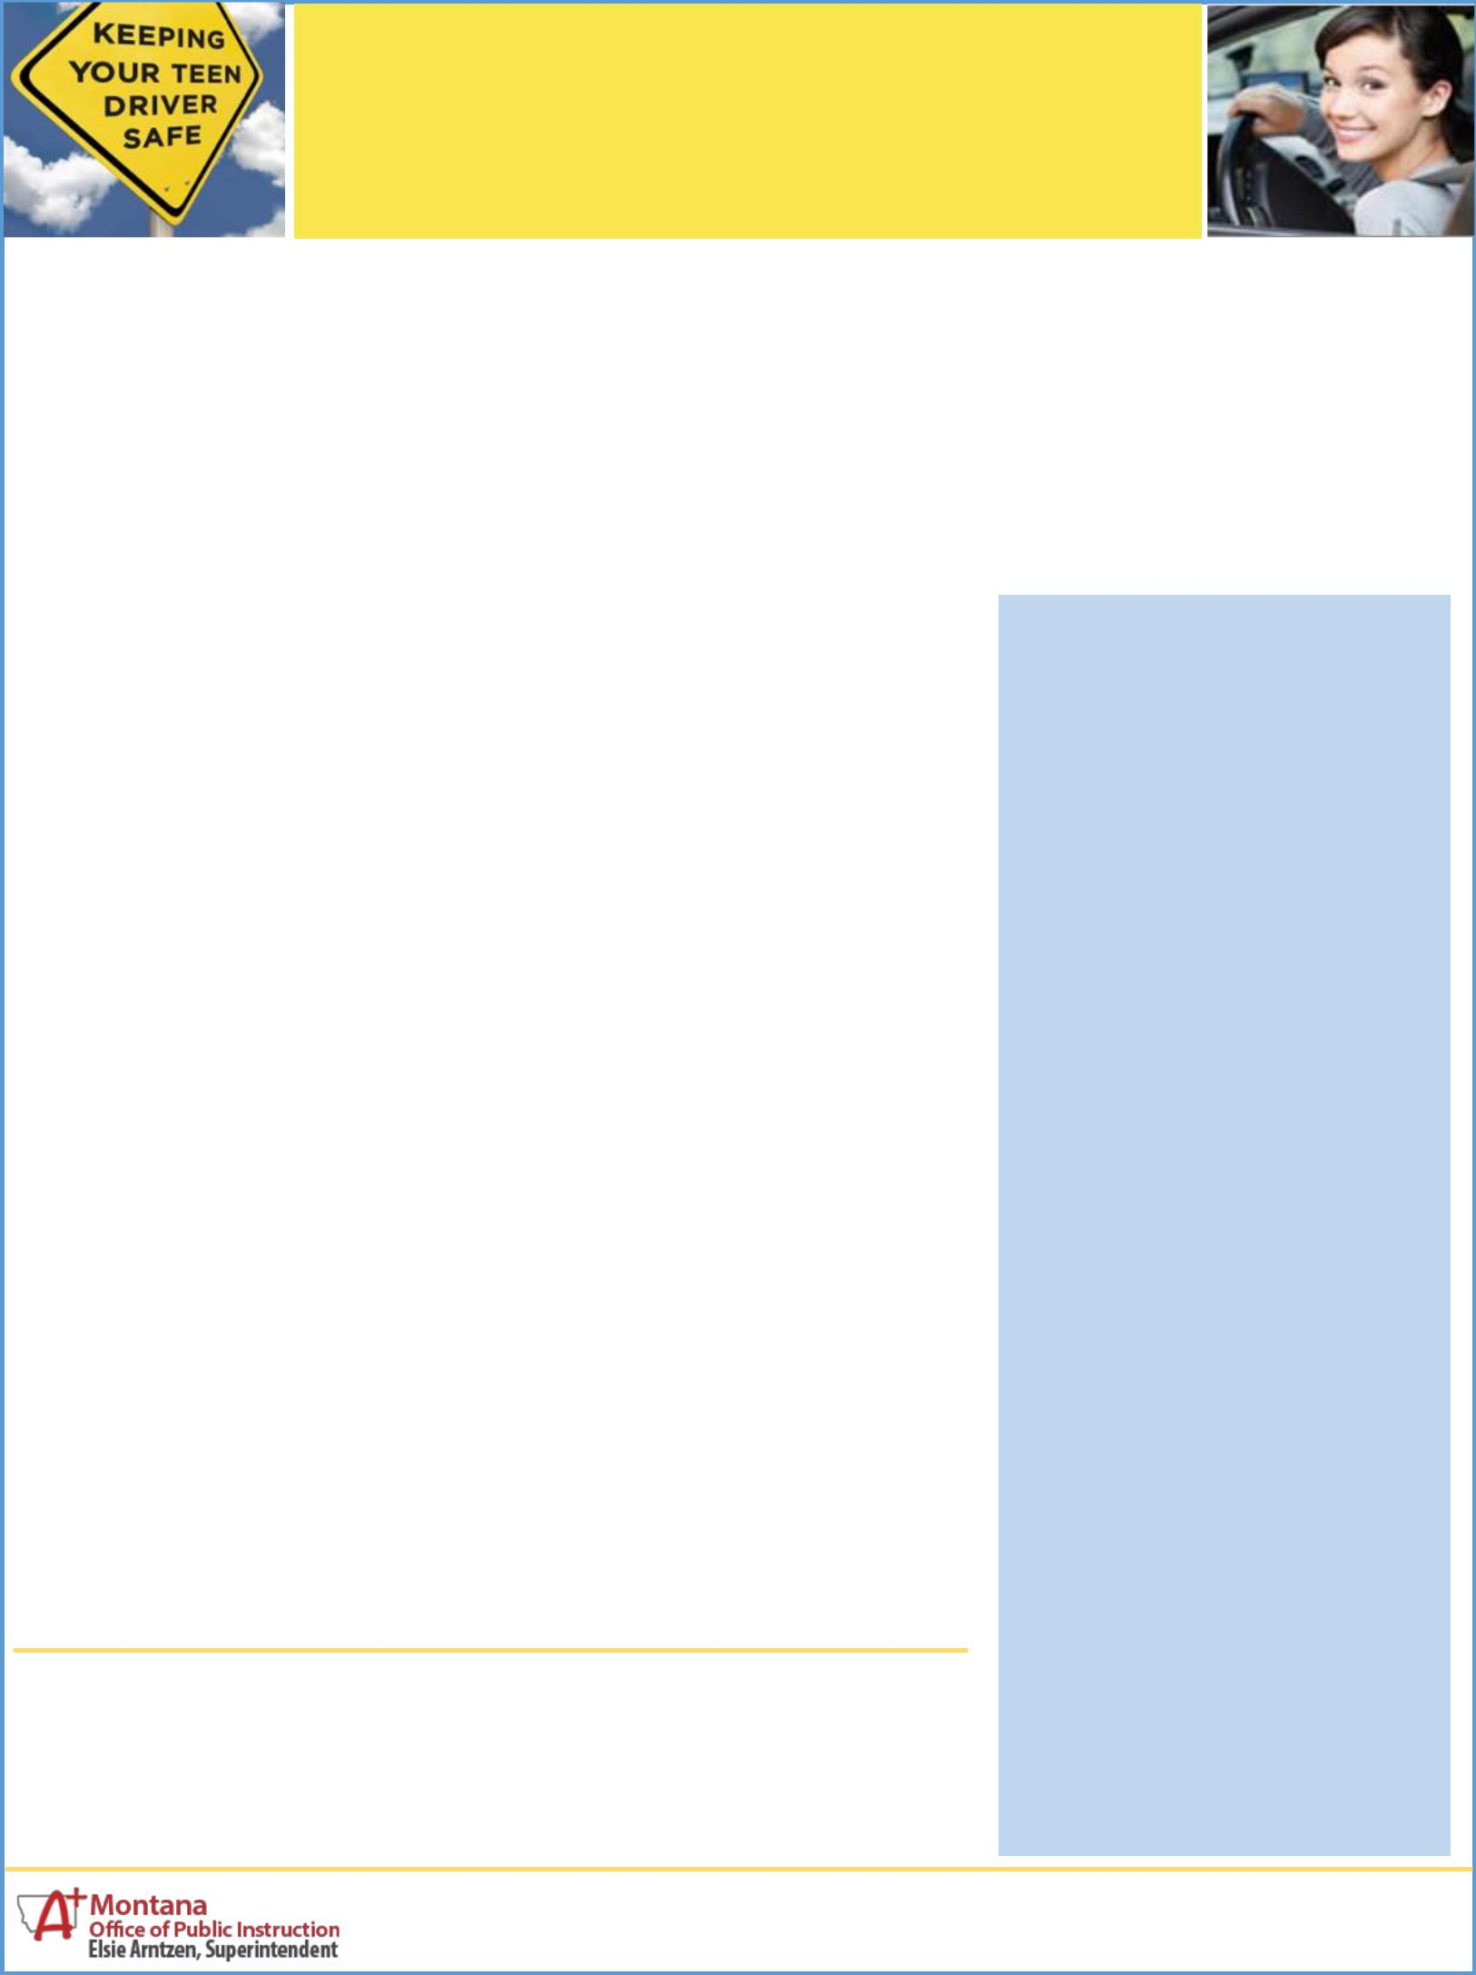
GDL: Graduated Driver Licensing in Montana

STEP 1
LEARNER

LICENSE

WHEN: Starts with the Learner License obtained in a state-approved driver education program no earlier than age 14½ or with a Learner License without driver education at age 16 or older.

Teens with a Learner License can ONLY be supervised by a licensed parent/guardian or licensed adult authorized by the parent/guardian.

The parent/guardian who signed the driver license application is legally liable for any damages or losses resulting from a crash when the teen driver is behind the wheel.

HOW LONG: One year.

Supervised driving is for a minimum of six months and 50 hours - 10 hours must be at night. Practice in

varied weather, traffic, and road conditions.

CONDITIONS: Seat belts use required: each occupant must wear a seat belt. The driver must remain free from traffic violations and alcohol/drug offenses.

STEP 2

GDL RESTRICTED LICENSE

WHEN: Teens may apply to drive independently after successful completion of Step 1, with parent/ guardian certification of 50 hours of supervised driving practice, and no traffic violations and alcohol/drug offenses.

HOW LONG: One year or when driver reaches age 18.

CONDITIONS: Seat belt use required: each occupant must wear a seat belt.

Curfew from 11 pm to 5 am:

Darkness increases crash risk , so night driving is not allowed between 11:00 p.m. and 5:00 a.m.,

unless travel is for school, church, work, or farm-related activities.

Limit passengers: For the first six months may have only one passenger; for the second six months may have up to three passengers. Others allowed if passengers are family members or the teen is being supervised by a licensed adult driver.

STEP 3

FULL PRIVILEGE DRIVER LICENSE

WHEN: Upon successful completion of Steps 1 and 2 or when driver reaches age 18.

Montana's GRADUATED DRIVER LICENSING (GDL) law (MCA 61.5.132-

- is a three-step program that reduces the risk while new drivers under age 18 develop and improve their driving skills. Teens still get to drive—with supervision—and gradually gain experience to begin driving on their own, but with restrictions on night driving and passengers.

Young drivers face the highest crash risk in darkness and each teen passenger doubles the crash risk. Safety research is clear that newly licensed drivers should start driving with no young passengers.

Learning to drive is a complex, ongoing process that requires responsibility and thousands of miles of practice to develop competence, skill, and judgment. Just like with sports and music, good habits and abilities grow through experience and good coaching.

Penalties—GDL Law Violations

First Offense – Not less than 20 hours or more than 60 hours of community service.

Second Offense – Suspension of restricted driver license for six months.

After teens have their full privilege license, parents should continue to drive with their teen, monitor, model, and enforce the rules, and encourage safe driving habits.

For more GDL information and resources, visit www.opi.mt.gov or call the Traffic Education Office at (406) 444-4432.

Revised May 2017

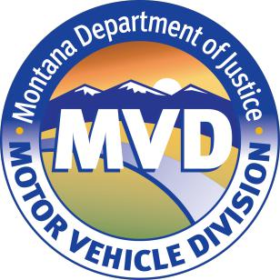
PRACTICE DRIVING LOG

Use this log to track your teen’s 50 hours of practice driving (including 10 hours at night) OR consider using a mobile application log, such as “RoadReady” for IOS devices or “Fast Track Driving Log Free” for Android devices.

This Driving Log belongs to:

Date | Conditions & Skills | Amount Initials
 | EX: intersections, full | of Time
 | stops, yields, scanning
 | for hazards

Date | Conditions & Skills | Amount Initials
 | EX: intersections, full | of Time
 | stops, yields, scanning
 | for hazards

TOTAL TIME

X

Parent/Guardian

X

Teen Driver

