Part 395
Hours of Service Drivers

93

Part 395
Hours of Service of Drivers

Hours of Service Final Rule Issued (Property Carrier)

Final rule for property carriers issued in 2011 by FMCSA. Drivers are limited to driving 11 hours and working no more than 14 hours each day with 10 hours resting between shifts. Drivers are also limited to 60 hours on duty in 7 consecutive days or 70 hours on duty in 8 consecutive days. Complete information is available at: www.fmcsa.dot.gov/rules-regulations/ topics/hos/index.htm

General Rule

The hours of service rules apply to all motor carriers and drivers, with exceptions found in paragraphs (b) through (k) of Section 395.1.

On-Duty Time

Means all time from the time a driver begins to work or is required to be in readiness to work until the time the driver is relieved from work and all responsibility for performing work. On duty time shall include:

- All time at a plant, terminal, facility, or other property of a motor carrier or shipper, or on any public property, waiting to be dispatched, unless the driver has been relieved from duty by the mo-tor carrier.

- All time inspecting, servicing, or conditioning any commercial motor vehicle at any time.

- All driving time as defined in the term driving time.

- All time, other than driving time, in or upon any commercial motor vehicle except time spent rest-ing in a sleeper berth.

- All time loading or unloading a commercial motor vehicle, supervision, or assisting in the loading or unloading, attending a commercial motor ve-hicle being loaded or unloaded, remaining in readiness to operate the commercial motor vehicle, or in giving or receiving receipts for shipments loaded or unloaded.

- All time repairing, obtaining assistance, or re-maining in attendance upon a disabled commercial motor vehicle.

- All time spent providing a breath sample or urine specimen, including travel time to and from the collection site, in order to comply with the ran-dom, reasonable suspicion, post-accident, or follow-up testing required by Part 382 when directed by a motor carrier.

- Performing any other work in the capacity, em-ploy, or service of a motor carrier; and

- Performing any compensated work for a person who is not a motor carrier.

On-duty time does not include:

- Any time resting in a parked vehicle (also applies to passenger-carrying drivers.)

- Up to two hours in the passenger seat immediately before or after eight consecutive hours in the

sleeper berth. This applies only property-carrying CMVs in motion.

100 Air-Mile Radius Exemption

A driver is exempt from maintaining the driver’s daily log requirements of Section 395.8 if all of the follow-ing are true:

- The driver operates within a 100 air-mile radius of the normal work reporting location

- The driver returns to the work reporting location and is released from work within 12 consecutive hours

- Each 12 hours on duty are separated by at least eight consecutive hours of off duty for passenger carriers and 10 consecutive hours off duty for property carriers.

- The driver does not exceed a maximum of 10 hours driving time following eight consecutive hours off duty for passenger carriers and 11 hours driving time following 10 consecutive hours of off duty for property carriers.

- The motor carrier that employs the driver main-tains and retains for a period of six months accu-rate and true time records that show:

  - The total number of hours the driver is on duty each day

  - The time the driver reports for duty each day

  - The time the driver is released from duty each

95

day

- The total time for the preceding seven days for first-time or intermittent drivers

Driving Time

Means all time spent at the driving controls of a com-mercial motor vehicle in operation.

Passenger Carrying Vehicles

10-Hour Rule

Drivers are allowed to drive for ten hours following eight consecutive hours off duty.

15-Hour Rule

A motor carrier cannot permit or require a driver to drive after 15 hours are spent on duty following 8 consecutive hours off.

60 and 70 Hour Rules

A motor carrier must not permit or require a driver to drive after a total of:

- 60 hours on duty in 7 consecutive days or

- 70 hours on duty in 8 consecutive days

- If the driver works more than one job of any kind, that time must also be included as on duty time

Driver’s Record of Duty Status

Every driver shall prepare a record of duty status (driver’s daily log) in his/her own handwriting for each 24-hour period, unless operating under the 100 air-mile radius exemption.

Failure to complete or retain the log, or knowingly falsifying logs or other reports, makes the driver and/ or carrier liable to prosecution.

Property Carrying Vehicles

Motor carriers and drivers must comply beginning on

January 4, 2004 with the following:

11-Hour Rule

Drivers are allowed to drive for 11 hours following 10 consecutive hours off duty.

14-Hour Rule

A motor carrier cannot permit or require a driver to drive after 14 hours are spent on duty following 10 consecutive hours off.

16 Hour Exemption

395.1(o) A property-carrying driver is exempt from

395.3(a)(2), the 14-hour rule, when:

- The driver returns and is released from his normal work reporting location for the previous 5 duty tours;

- The driver returns to his normal work reporting location and is released within 16 hours; and

- The driver has not used this exemption within the previous six consecutive days, except that the 16-hour provision may be used after any period of be-ing off duty for 34 or more consecutive hours.

60 and 70 Hour Rules

A motor carrier must not permit or require a driver to drive after a total of:

- 60 hours on duty in 7 consecutive days or

- 70 hours on duty in 8 consecutive days

- If the driver works more than one job of any kind, that time must also be included as on duty time

30 Minute Rest Breaks
Operators may drive only if eight hours or less have passed since the end of the driver’s last off-duty period of at least 30 minutes.

The 30-minute break requirement does not apply to :

- Any driver that operates within 100 air-miles of their normal work reporting location if they comply with time limitations and recordkeeping requirements.

- Non-CDL drivers who operate within a 150

96

air-mile radius of the location where the driver reports for duty if the driver complies with time limitations and recordkeeping requirements.

34 Hour Restart Provision

395.3(c)(1) & (2) allows the driver to restart the 60/70 hour period when:

- Any period of 7 or 8 consecutive days may end with the beginning of any off-duty period of 34 or more consecutive hours.

Driver’s Record of Duty Status

Every driver shall prepare a record of duty status (driver’s daily log) in his/her own handwriting for each 24-hour period, unless operating under the 100 air-mile radius exemption.

Failure to complete or retain the log, or knowingly falsifying logs or other reports, makes the driver and/ or carrier liable to prosecution.

Non-CDL 150 Air-Mile Radius Provision

Operators of property-carrying commercial motor vehicles not requiring a CDL, as defined in Part 383, may be covered by the Non-CDL 150 air-mile radius provision. Note that the applicability depends on the type of vehicle being driven, not whether the operator possesses a CDL.

Drivers of Non -CDL vehicles who are operating with-in 150 air-mile radius of their normal work reporting location and return to their normal work reporting location at the end of their duty tour are now covered by separate HOS provisions.

These drivers are required to comply with the follow-ing:

- The 11 hours driving, minimum 10 hours off-duty, 14 consecutive hour duty period, 60/70 hours in 7/8 days, 34-hour restart all applies.

- On any 2 days of every 7 consecutive days, the driver may extend the 14-hour duty period to 16 hours.

- There is no requirement that the driver be released from duty at the end of the 14- or 16-hour duty periods. The driver may continue to perform non-driving duties, which would be counted against the

60/70 hour weekly limitation.

- Time records may be used in lieu of records of duty status.

97

Each item, required to be entered, on the Driver’s Record of Duty Status is listed below, followed by a cryptic explanation of when the information should be recorded.

- Date - Entered when the driver first comes on duty.

- Total miles driving today - Entered at the end of the driver’s workday.

- Truck or tractor and trailer number - Entered just prior to operating the vehicle.

- Name of carrier - Entered when the driver first comes on duty. The name of the motor carrier may be preprinted.

- Driver’s signature/certification - Entered at the end of the driver’s workday.

- Main office address - Entered when the driver first comes on duty. The address of the motor car-rier may be preprinted.

98

- Remarks - Entered whenever an event occurs that requires an entry in the remarks section. (Tire check - emergency condition)

- Name of co-driver - Entered when the co-driver is known (prior to the commencement of driving operations).

- Total hours - Computed and entered at the end of the driver’s workday.

- Shipping document number(s), or name of ship-per and commodity - Entered at the time the trip is assigned to the driver (when loaded).

- 24 hour period describing duty status.
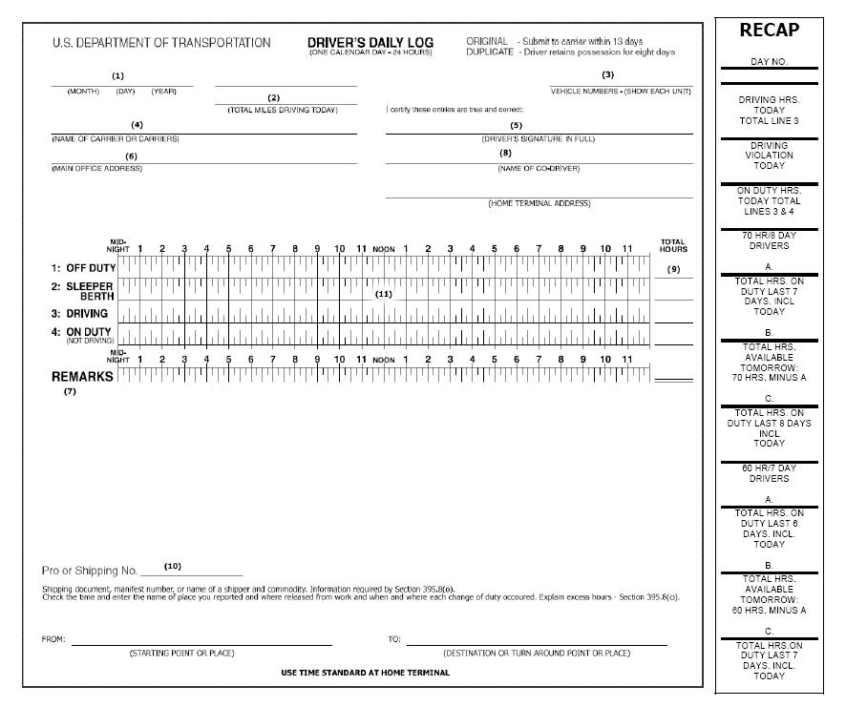

Note: All supporting documents including toll tickets, fuel receipts, scale tickets, etc. must be maintained with duty status records for six months in accordance with 395.8(k)(i).

Daily Hours Of Service

Employee Name/# ­ |  |  |  |  |  |  |  |  |  | Month/Year
Each day provide the following information: |  |  |  |  |  |  |  |  | Property Carrier
 |  |  |  |  |  |  |  |  |    Do not work more than 12 hours in one day.
1. |  | Time you report for work each day. |  |  |  |  |  |  |    Do not drive more than 11 hours in one day.
 |  |  |  |  |  |  |  |  |    Must be “off duty” at least 10 consecutive hours
2. |  | Time you are released from work each day. |  |  |  |  |  |  | between work periods.
 |  |  |  |  |  |  |  |  | Passenger Carrier
3. |  | The total hours worked each day. |  |  |  |  |  |  |    Do not work more than 12 hours in one day.
 |  |  |  |  |  |  |  |  |    Do not drive more than 10 hours in one day.
(see title 49 CFR, section 395.1(e)) |  |  |  |  |  |  |  |  | *must be “off duty” at least 8 consecutive
 |  |  | Hours of Service (395.1e) |  |  |  |  |  | COMMENTS
 |  | Date | Start |  | End | Total | Unit #
 |  | 1 | : |  | :
 |  | 2 | : |  | :
 |  | 3 | : |  | :
 |  | 4 | : |  | :
 |  | 5 | : |  | :
 |  | 6 | : |  | :
 |  | 7 | : |  | :
 |  | 8 | : |  | :
 |  | 9 | : |  | :
 |  | 10 | : |  | :
 |  | 11 | : |  | :
 |  | 12 | : |  | :
 |  | 13 | : |  | :
 |  | 14 | : |  | :
 |  | 15 | : |  | :
 |  | 16 | : |  | :
 |  | 17 | : |  | :
 |  | 18 | : |  | :
 |  | 19 | : |  | :
 |  | 20 | : |  | :
 |  | 21 | : |  | :
 |  | 22 | : |  | :
 |  | 23 | : |  | :
 |  | 24 | : |  | :
 |  | 25 | : |  | :
 |  | 26 | : |  | :
 |  | 27 | : |  | :
 |  | 28 | : |  | :
 |  | 29 | : |  | :
 |  | 30 | : |  | :
 |  | 31 | : |  | :

99

100

Daily Hours Of Service & Vehicle Condition Report

Each day provide the following information:
1. | Time you report for work each day |  |  |  |  |  |  |  | If vehicle is deficient show # in column below:
2. Time you end work each day
3. | The total hours worked each day |  |  |  |  |  |  |  | 0 - NO DEFECTS FOUND |  |  |  | 6 - Horn
 |  |  | PROPERTY CARRIER
*DO NOT WORK MORE THAN 12 HOURS IN ONE DAY. |  |  |  |  |  |  |  |  | 1 - Service Brakes |  |  |  | 7 - Windshield Wipers
*DO NOT DRIVE MORE THAN 11 HOURS IN ONE DAY.
*MUST BE "OFF DUTY" AT LEAST 10 CONSECUTIVE |  |  |  |  |  |  |  |  | 2 - Parking Brakes |  |  |  | 8 - Rear Vision Mirrors
HOURS BETWEEN WORK PERIODS.
 |  |  | PASSENGER CARRIER |  |  |  |  |  | 3 - Steering Mechanisms |  |  |  | 9 - Coupling Devices
*DO NOT WORK MORE THAN 12 HOURS IN ONE DAY.
*DO NOT DRIVE MORE THAN 10 HOURS IN ONE DAY. |  |  |  |  |  |  |  |  | 4 - Lighting Devices & Reflectors |  |  |  | 10 - Wheels & Rims
*MUST BE "OFF DUTY" AT LEAST 8 CONSECUTIVE
HOURS BETWEEN WORK PERIODS. |  |  |  |  |  |  |  |  | 5 - Tires |  |  |  | 11 - Emergency Equipment
 |  |  |  | Hours of Service (395.1E) |  |  |  |  | Vehicle Condition Report |  | Vehicle Condition Report (396.11)
 |  |  |  |  |  |  |  |  |  |  |  | Signatures Required
Date |  | Start |  | End | Total |  | Unit | Trailer | Explanation of Defects |  | Driver’s |  | Repairman’s |  | Next Trip
 |  |  |  |  | Hrs. |  | # | # |  |  | Signature |  | Signature |  | Driver’s Signature
1 |  | : |  | :
2 |  | : |  | :
3 |  | : |  | :
4 |  | : |  | :
5 |  | : |  | :
6 |  | : |  | :
7 |  | : |  | :
8 |  | : |  | :
9 |  | : |  | :
10 |  | : |  | :
11 |  | : |  | :
12 |  | : |  | :
13 |  | : |  | :
14 |  | : |  | :

_____________________________________

Month/Year Name/# Employee ___________________________________________

 |  | Hours of Service (395.1e) |  |  |  | Vehicle Condition Report |  | Vehicle Condition Report (396.11)
 |  |  |  |  |  |  |  |  | Signatures Required
Date | Start | End | Total | Unit | Trailer | Explanation of Defects | Driver’s |  | Repairman’s |  | Next Trip
 |  |  | Hrs. | # | # |  | Signature |  | Signature |  | Driver’s Signature
15 | : | :
16 | : | :
17 | : | :
18 | : | :
19 | : | :
20 | : | :
21 | : | :
22 | : | :
23 | : | :
24 | : | :
25 | : | :
26 | : | :
27 | : | :
28 | : | :
29 | : | :
30 | : | :
31 | : | :

101

Hours-Of-Service Record For First Time Or Intermittent Drivers

Instructions

When using a driver for the first time or intermit-

tently, a signed statement must be obtained, giving

the total time on duty (driving and on duty) during

the immediate preceding seven days and the time at

which the driver was last relieved from duty prior to

beginning work

Name: (Print) ______________________________________________________________________

First | Middle | Last
DAY | TOTAL TIME ON DUTY
1 | _________
2 | _________
3 | _________
4 | _________
5 | _________
6 | _________
7 | _________
_______________________________________
TOTAL | _________

I hereby certify that the information contained herein is true to the best of my knowledge and belief, and that my last period of release from duty was from:
_______________________________________ to _______________________________________

(Hour/Date) (Hour/Date)

Signature _____________________________________________ Date ______________________

102

Submitting/Retaining Duty Status Log

The driver must submit the original log sheet to the employing carrier within 13 days after comple-tion. When a motor carrier uses a driver initially or intermittently, that carrier must obtain from him/her a signed statement giving the total time on duty dur-ing the immediately preceding 7 days and the time at which he/she was last relieved of duty. Records of duty status must be maintained for a minimum of six months at the carrier’s principal place of business, with all supporting documents.

ELD Final Rule Summary

- On December 10, 2015, FMCSA announced its final rule requiring the adoption and use of electronic logging devices

- The rule requires fleets and drivers required to complete paper logs to adopt and use compliant ELDs by December 2017

- FMCSA will allow fleets and drivers using “ELD-like” devices meeting the current standards for Automatic On-Board Recording Devices (see 49 CFR 395.15) to continue to use such devices until Decem-ber 2019

- Limited Exceptions: The final rule allows limited exceptions to the ELD mandate, including:

o Drivers who use paper logs for not more than 8 days during any 30 day period;

o Drivers who conduct driveaway-towaway opera-tions, where the vehicle is the product being deliv-ered;

o Drivers of vehicles manufactured before model year 2000 (due to vehicle connectivity concerns; this is a change from the proposed rule);

o Drivers who operate using the logbook timecard exception (i.e. short-haul 100-air mile drivers)

- ELDs are required to record vehicle location at every change of duty status and at a minimum of 60-minute intervals.

- Supporting Documents: Because ELDs effectively negate the need for supporting documents to verify driving time, FMCSA has implemented new docu-ment retention requirements to verify on-duty, not

driving time. The final rule requires fleets to retain up to eight supporting documents from several categories (see below) per driver for each 24-hour period

- ELDs must be able to transfer data electronically

- Manufacturers are required to test and certify to FMCSA that their devices meet the new standards

- The final rule includes several provisions to guard against harassment of drivers

- In the event that an ELD malfunctions, the driver is required to immediately begin completing a paper log and to reconstruct logs for each of the past 7 days, unless the driver already possesses the records or the records are retrievable from the ELD.

- Authorized use of a commercial motor vehicle (CMV) for personal conveyance will not be recorded as on-duty driving, but rather off-duty time

- Drivers will be able to make edits and annotations to their electronic logs

- All ELDs must be capable of exporting data in a standard file format to facilitate importing by other systems

Link to FMCSA’s Q & A for this requirement:

https://www.fmcsa.dot.gov/hours-service/elds/faqs

103

