Form | Missouri Department of Revenue
4901
 | Driver Experience Log
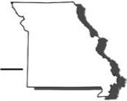
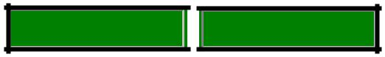
Reset Form Print Form
This Driver Experience Log is provided, for your convenience, as a tool to help track the progress of a beginning driver. This log may be used as verification of the required 40 hours of behind-the-wheel driving. A minimum of ten hours of behind-the-wheel driving must have occurred during nighttime hours. The teen’s parent, grandparent, legal guardian or certified instructor with a federal residential job training program must accompany the teen to the license office when applying for the intermediate license.

Date | Start Time | End Time | Total Time |  | Trainer’s Name

Grand Total

Driver License Bureau | Phone: | (573) 526-2407 |  | Form 4901 (Revised 02-2014)
 |  |  | Visit www.dor.mo.gov/drivers/
P.O. Box 200 | Fax: | (573) 522-6062
Jefferson City, MO 65105-0200 | E-mail: | dlbmail@dor.mo.gov | for additional information.

