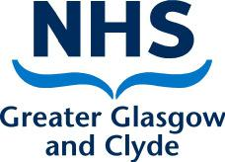

Please give us your feedback

Now that you are leaving this ward, we would like to ask you a question about your
experience. When you are finished please put this card in the box provided.

How likely are you to recommend our ward to friends and family if they needed similar care or treatment? Please put a cross in the box of your choice.

Extremely Likely | Please can you tell us the main reason for the
 | score you have given?
Likely
Neither Likely or Unlikely
Unlikely
Extremely Unlikely

Please do not fold this card. Thank you!
If you would like to give us more detailed feedback please visit
www.nhsggc.org.uk/patientfeedback or call 0141 201 5598

Universal Feedback:
Your Opinion Matters

NHS Greater Glasgow and Clyde is committed to
listening to our patients, carers and service users.

We will use your feedback to ensure that we continually

improve our services for our patients.

Please complete the other side of this card and

put it in the box provided.

Please note that none of the information you give can or
will be used to identify you as an individual.

Please do not fold this card.

