Your name
Teacher’s name, Class
Title of Book
Author: Name
Type of book: Enter type of book here

Introduction
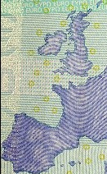
Give an overview of the book, indicating what the focus of your book report will be. You can replace the picture on the right with a picture of the cover of the book.

Author
Outline the author’s life, focusing on the timeframe that includes the writing of this book.

Main characters
Character One | Describe this character.
Character Two | Describe this character.
Character Three | Describe this character.
Character Four | Describe this character.

Story
Break the book down into a logical number of sections. This example shows “Beginning,” “Middle,” and “End,” but books often have many more relevant sections.

Themes
Describe the theme(s) of the book.

Evaluation
Make your main points here. Evaluate the book. Draw your conclusions.

