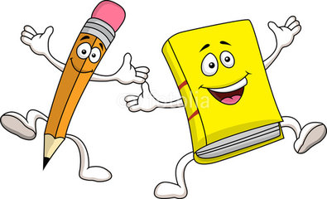
Book Report

Title ______________________________________________
Author____________________________________________
The story was _________________________________________________________________________
Describe what happened in the beginning of the story?
____________________________________________________________________________________________________________________________________________________________________________________________________________________________________________________________________________________________________________________________________________________
Describe what happened in the middle of the story?
____________________________________________________________________________________________________________________________________________________________________________________________________________________________________________________________________________________________________________________________________________________
Describe what happened in the end of the story?
____________________________________________________________________________________________________________________________________________________________________________________________________________________________________________________________________________________________________________________________________________________

Did you like this book? Tell why or why not?

