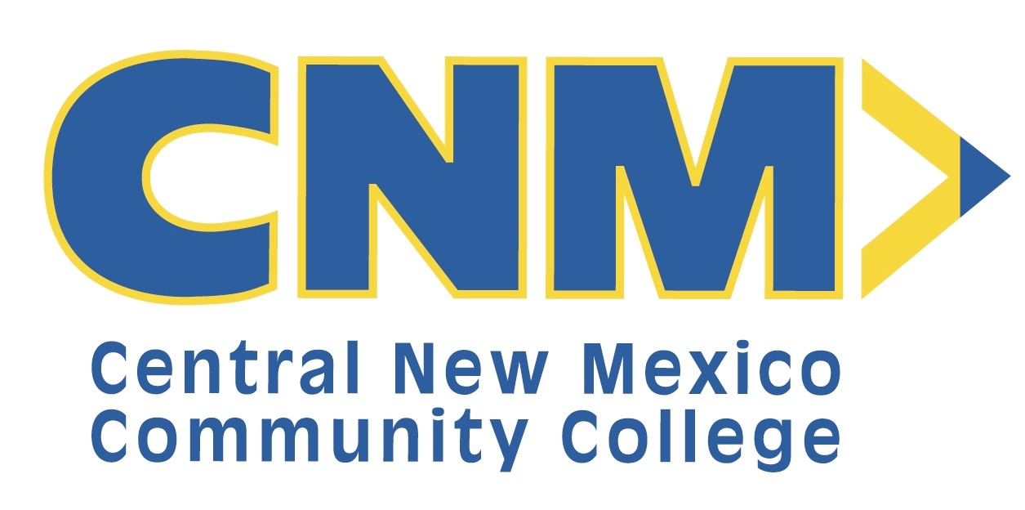

EMPLOYEE PERFORMANCE EVALUATION

Employee Name | Date of Hire
ID Number | Review Period
Department | Job Title
Supervisor Name | Supervisor ID Number

It is the policy of CNM to conduct formal performance evaluations on staff employees six (6) months after date of hire and then at least once annually. The Performance Evaluation is to reflect a positive and collaborative approach. Performance evaluation is a continuing process undertaken by both the employee and the supervisor, and the six- (6) month or annual written review is to formally reflect the interchanges that have taken place throughout the review period. The purpose of performance evaluations is to support attainment of the college’s goals and objectives. In order to do this, the supervisor and employee review the employee’s performance and development needs. The performance evaluation is also a time to identify and acknowledge an employee’s successes and achievements. CNM accomplishes its goals and objectives by establishing a working environment which supports quality work performance, encourages and supports personal and job-related development, and improves communication between supervisor and employee.

CNM Goals:
Expand CNM’s caring approach to student success.
Create and enhance a systemic approach to partnerships and community building.
Build on CNM’s multi-faceted diversity.
Strengthen CNM’s comprehensive identity.
Innovate to sustain CNM’s success for future generations.

To achieve the Governing Board’s Goals, CNM will:
- Encourage and support students by offering the best opportunities for occupational and workforce training, certificates, associate degrees, transfer credit, skill development and continuous learning.
- Respond quickly to community needs by promoting and maintaining program quality and relevant curricula to support economic development.
- Encourage and support faculty and staff in their roles and offer opportunities for growth, professional development and recognition.
- Meet change through innovation and technology.
- Foster communication, cooperation and collaboration within CNM and between and among other educational institutions and the community.
- Ensure that CNM is welcoming, friendly and service oriented to attract and retain students.
- Provide affordable and accessible education.
- Respect and promote diversity.
- Develop, improve, and maintain physical resources at CNM to facilitate learning.
- Maintain fiscal integrity and responsibility.
- Provide accountability through an ongoing system of evaluation, analysis and adjustment.

In supporting these goals, employees and immediate supervisors will:

- Conduct an annual review to assess goals and objectives, achievement levels and improvements.
- Establish individual performance goals and objectives aligned with CNM's strategic direction.

E = Exceeds Expectations | M = Meets Expectations | I = Needs Improvement | N = Does Not Meet  Expectations | N/A = Not Applicable

CARING RATING
1. Establishes and maintains effective working relationships.
2. Acts in a professional manner in dealing with co-workers and the public.
3. Exhibits clear verbal and written communications.
4. Listens to and considers other viewpoints and new ideas.
5. Demonstrates patience, consideration, and respect for others.
Comments:

CIVILITY
1. Is flexible and open to change.
2. Is open to feedback and accepts constructive criticism.
3. Is responsive, consistent and fair.
Comments:

EXCELLENCE
1. Gets the job done.
2. Maintains high standards and quality of work.
3. Aligns work with CNM Strategic Direction.
Comments:

HOPE
1. Encourages and supports students, peers, subordinates, and supervisor.
Comments:

E = Exceeds Expectations | M = Meets Expectations | I = Needs Improvement | N = Does Not Meet  Expectations | N/A = Not Applicable

INTEGRITY RATING
1. Takes responsibility and accepts accountability.
2. Works within assigned authority.
3. Uses resources (time, human, financial, supplies, and equipment) appropriately.
4. Adheres to established policies and procedures.
Comments:

LEADERSHIP
1. Initiates improvements/innovations in work performed.
Comments:

DIVERSITY
1. Creates or supports an inclusive environment.
2. Works effectively with diverse groups.
Comments:

RESULTS
1. Accomplishes required tasks in a timely manner.
2. Plans ahead and prioritizes tasks.
3. Produces work that is accurate, complete, and meets expectations.
4. Makes informed decisions.
5. Accepts responsibility and takes corrective action.
Comments:

E = Exceeds Expectations | M = Meets Expectations | I = Needs Improvement | N = Does Not Meet  Expectations | N/A = Not Applicable

COMMUNITY BUILDING RATING
1. Responds quickly, accurately, and appropriately to internal and external inquiries.
2. Participates in efforts that positively affect the internal and external communities.
3. Practices responsible citizenship, i.e. volunteers for College activities, being a good neighbor and/or contributes to improving the campus community.
Comments:

SUPERVISOR COMMENTS:

EMPLOYEE COMMENTS:

CURRENT YEAR GOALS AND PROFESSIONAL DEVELOPMENT:

NEXT YEAR GOALS:

SIGNATURES:
Employee Signature/Date |  | ___________________________ | ___________
Supervisor Signature/Date |  | ___________________________ | ___________
Director/Dean Signature/Date |  | ___________________________ | ___________
Vice-President Review |  | ________________________ | __________

