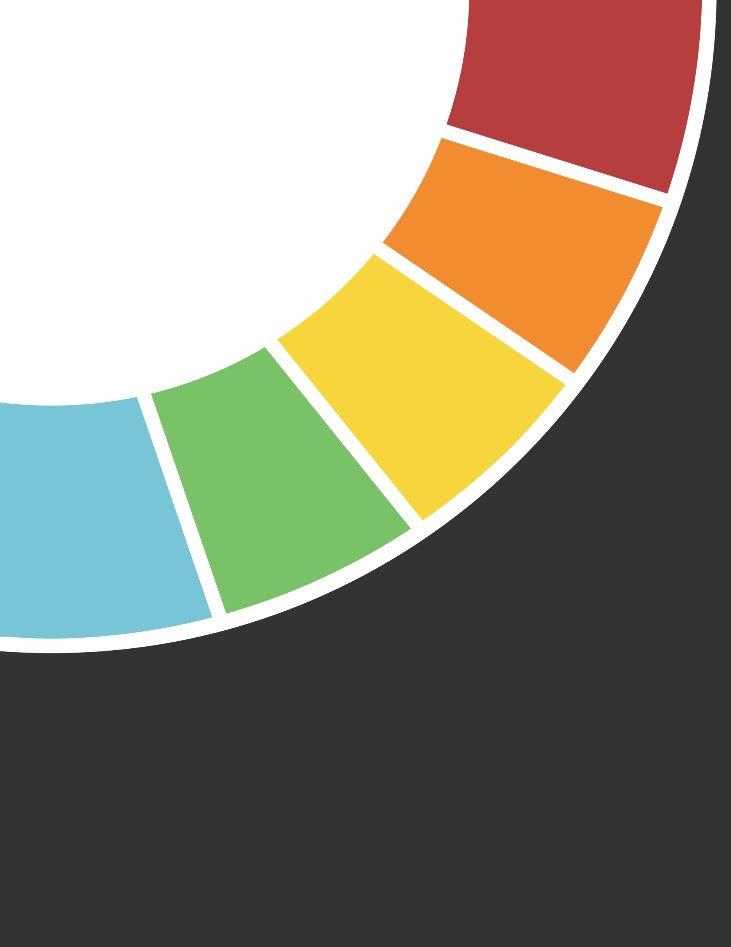

2019

REPORT

ANNUAL

Email: info@mail.com

Ph: +1 555 555-5555