

*On the Way to the Library*

Favorite Playground Games

World Traveler’s Club

Super Fun Math Puzzles

The Smartest Kids Read Great Books

*Dinoasuar Bones*

FUN RECYCLING CRAFTS

Reading is Fun

*I Love to Read Books*

I’m Going to Study in College

Architecture Fun

Dragons by the Sea



Shh!

I’m trying to READ

*Bookworms*

Biology

Tricks for Dogs

Cat Toys

VOL III

|  |
| --- |
| Fun Holiday Crafts |
| History Facts |
| Art for the Ages |
| How to Draw Horses |

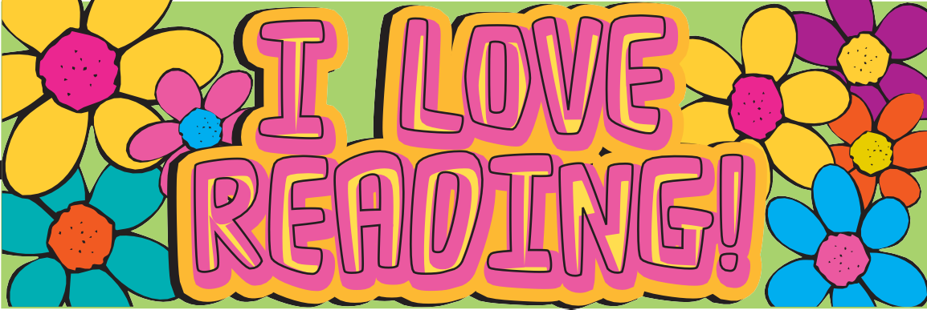

**READING!**

**I LOVE**

BOOKS

I

