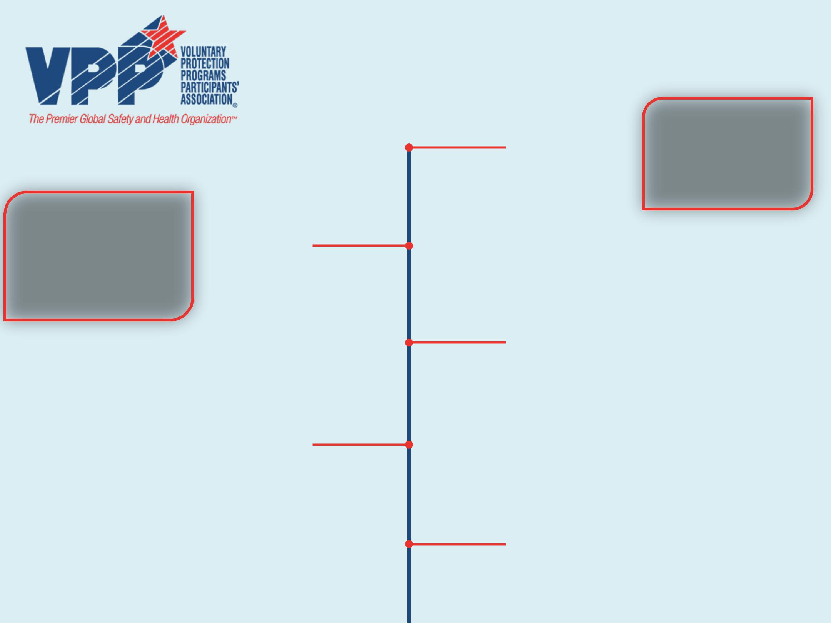
Timeline

1984

VPPPA Established

Founding Chairperson:

Ron Amerson

1st Annual National Conference

Washington, DC

1986

3rd Annual National Conference Schaumberg, IL

1988

1st Meeting of

VPP Participants

Meeting Held in Washington, DC

Sponsored by OSHA

1985

2nd Annual National Conference Atlanta, GA

1987

4th Annual National Conference Atlanta, GA

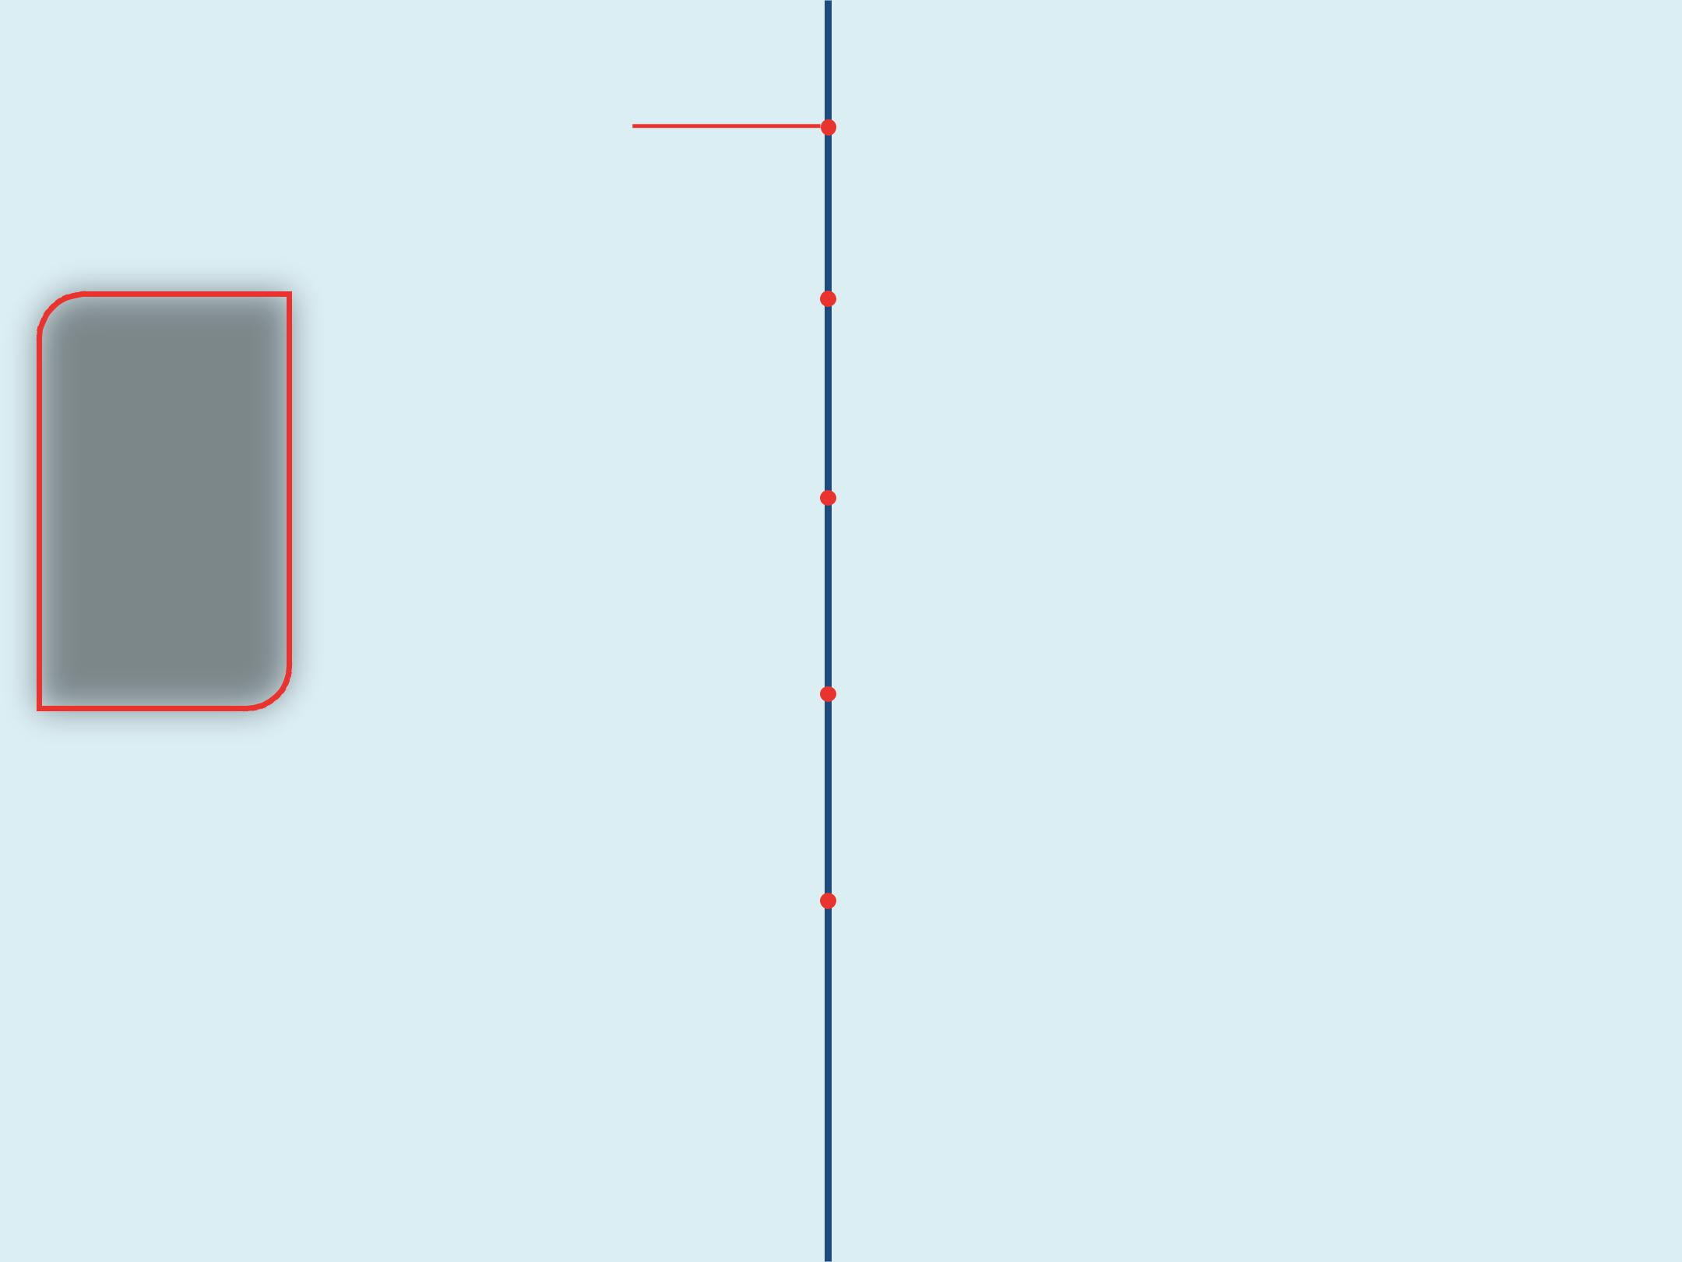  5th Annual National Conference |  |  | 1989
San Antonio, TX
 |  |  |  |  | Paid Membership Categories
 |  | 1990 |  |  | Established
VPPPA is Incorporated |  |  |  |  | 6th Annual National Conference
1st Executive Director: |  |  |  |  | Denver, CO
Margaret “Peggy”
Richardson |  |  | 1991
First Staff Hired
7th Annual National Conference |  |  |  |  | 8th Annual National Conference
Washington, DC
 |  | 1992 |  |  | Orlando, FL
9th Annual National Conference
San Antonio, TX |  |  | 1993

2nd Executive Director: Lee Anne Jillings

2nd Chairperson: Robert Stegall

Mentoring Program Created

1994 10th Annual National Conference

Phoenix, AZ

Conference Surpasses 1,000

Participants

11th Annual National Conference

Washington, DC

1996

13th Annual National Conference New Orleans, LA

1998

The Leader Magazine

Inaugural Issue

15th Annual National

Conference Washington, DC

2000

1995
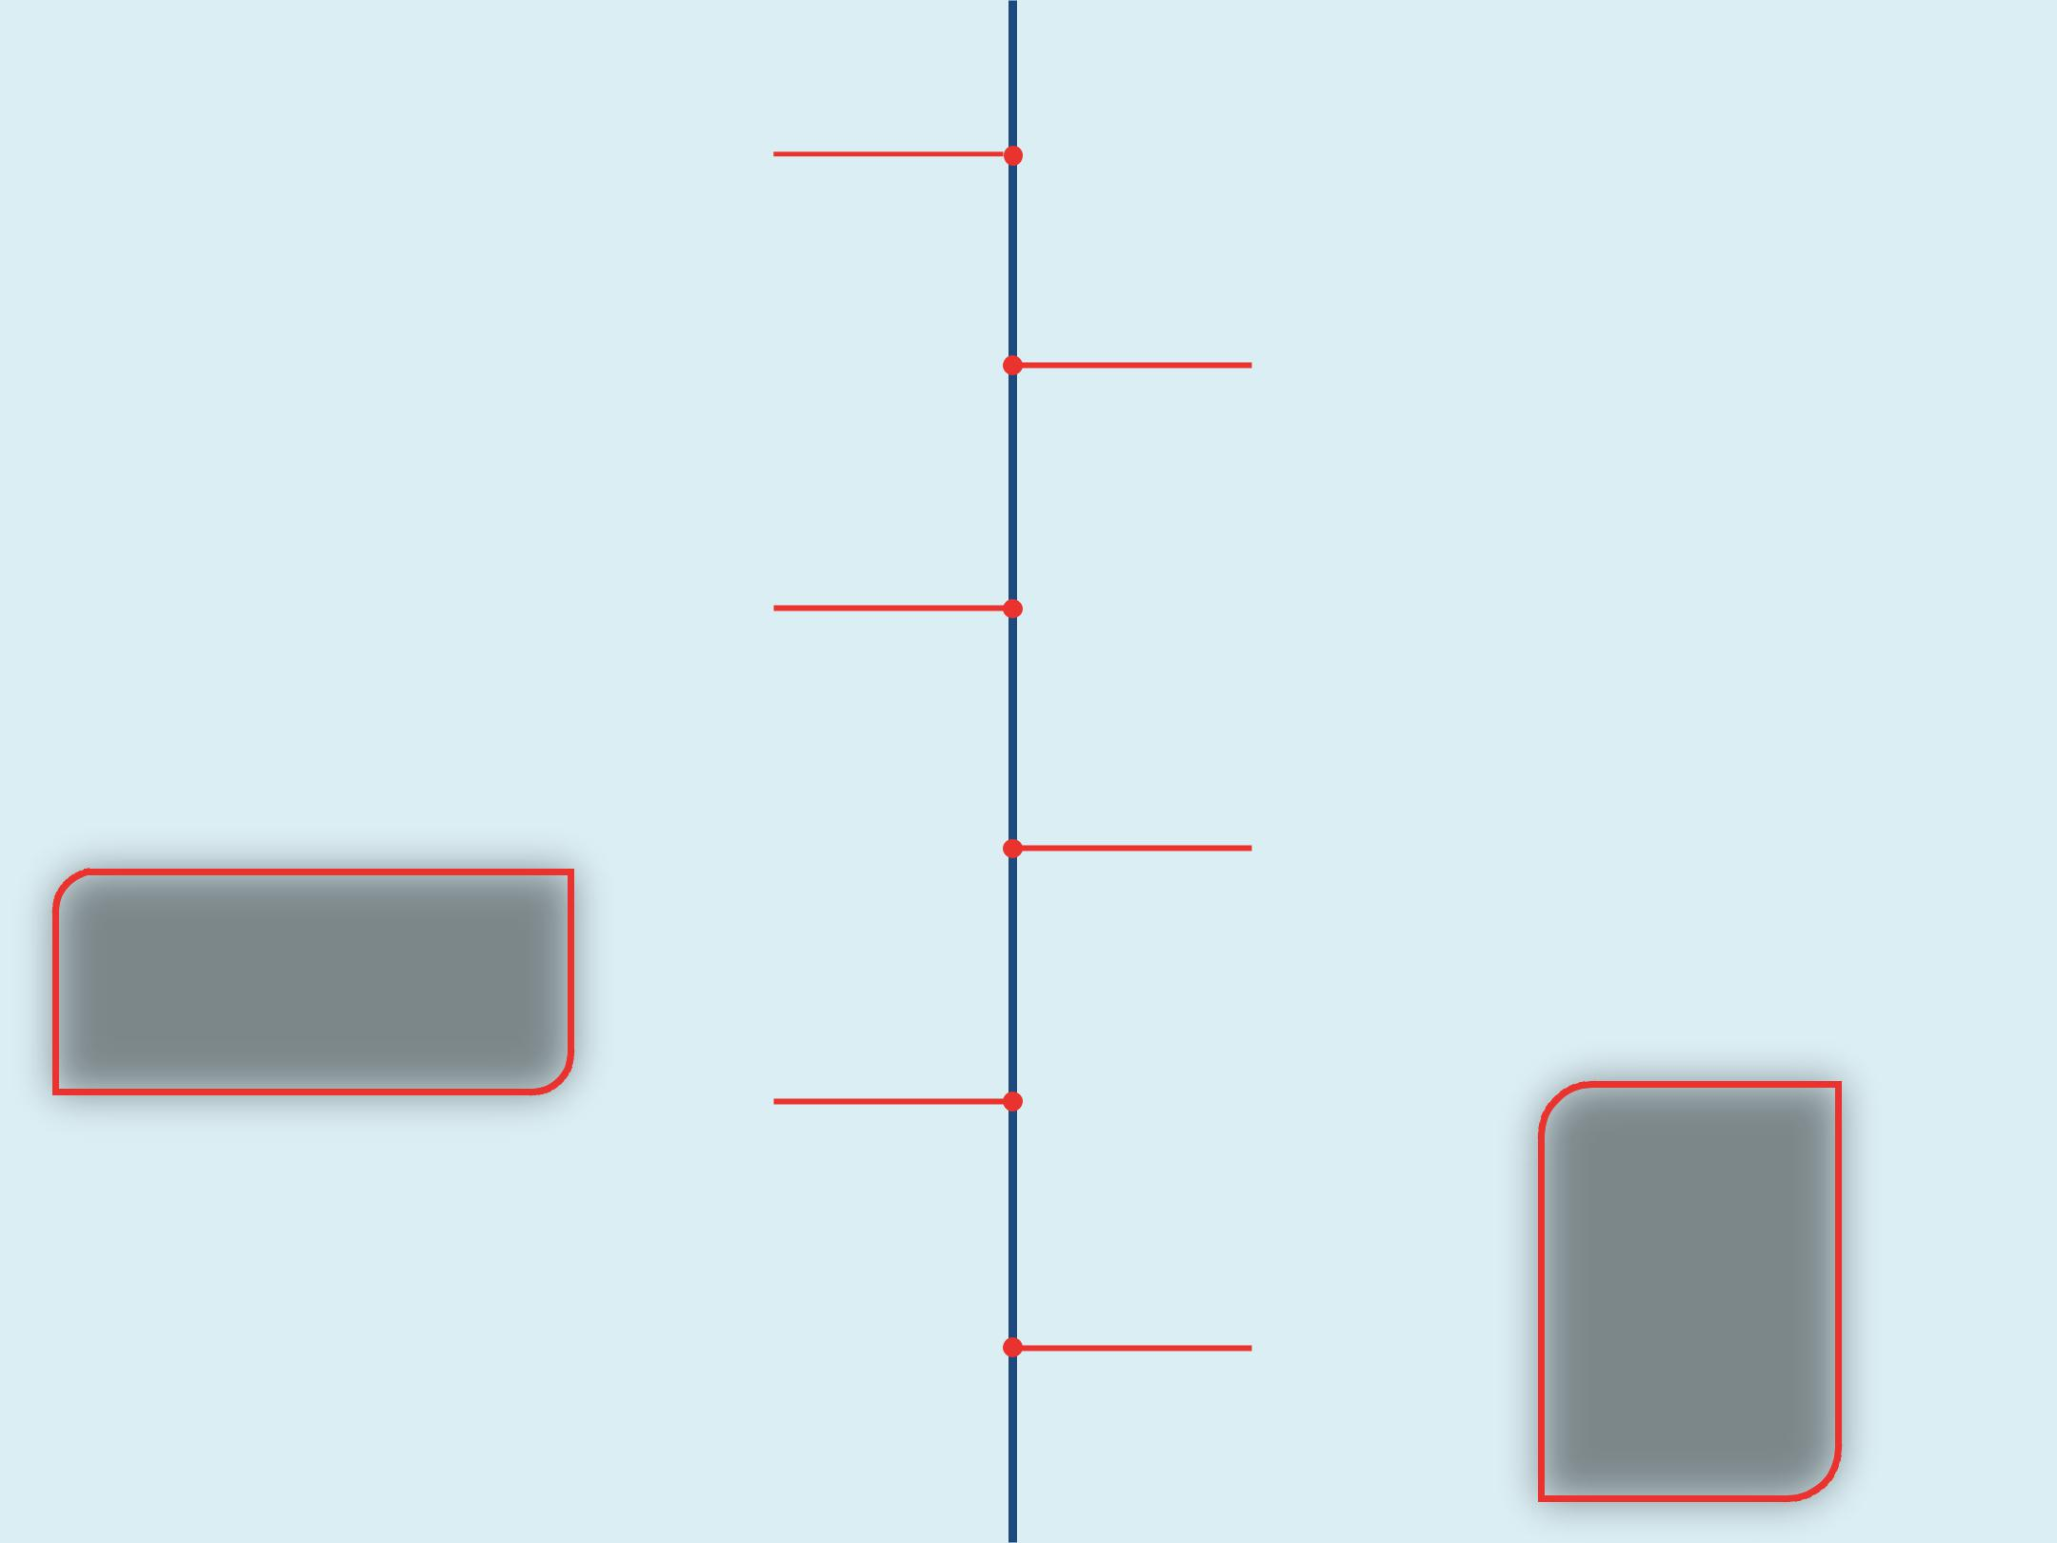

12th Annual National Conference Orlando, FL

1997

3rd Chairperson:

Bob Brant

14th Annual National Conference

Chicago, IL

1999

4th Chairperson:

June Brothers

16th Annual National Conference

Seattle, WA

VPPPA Website Launched

Conference Surpasses 2,000

Participants

17th Annual National Conference

New Orleans, LA

2002

19th Annual National Conference Washington, DC

2004

1st 4th Executive Director:

R. Davis Layne

1st Assistant Executive Director:

Adam K. Pawlus

1st Scholarships Introduced

21st Annual National Conference Dallas, TX

2006

2001
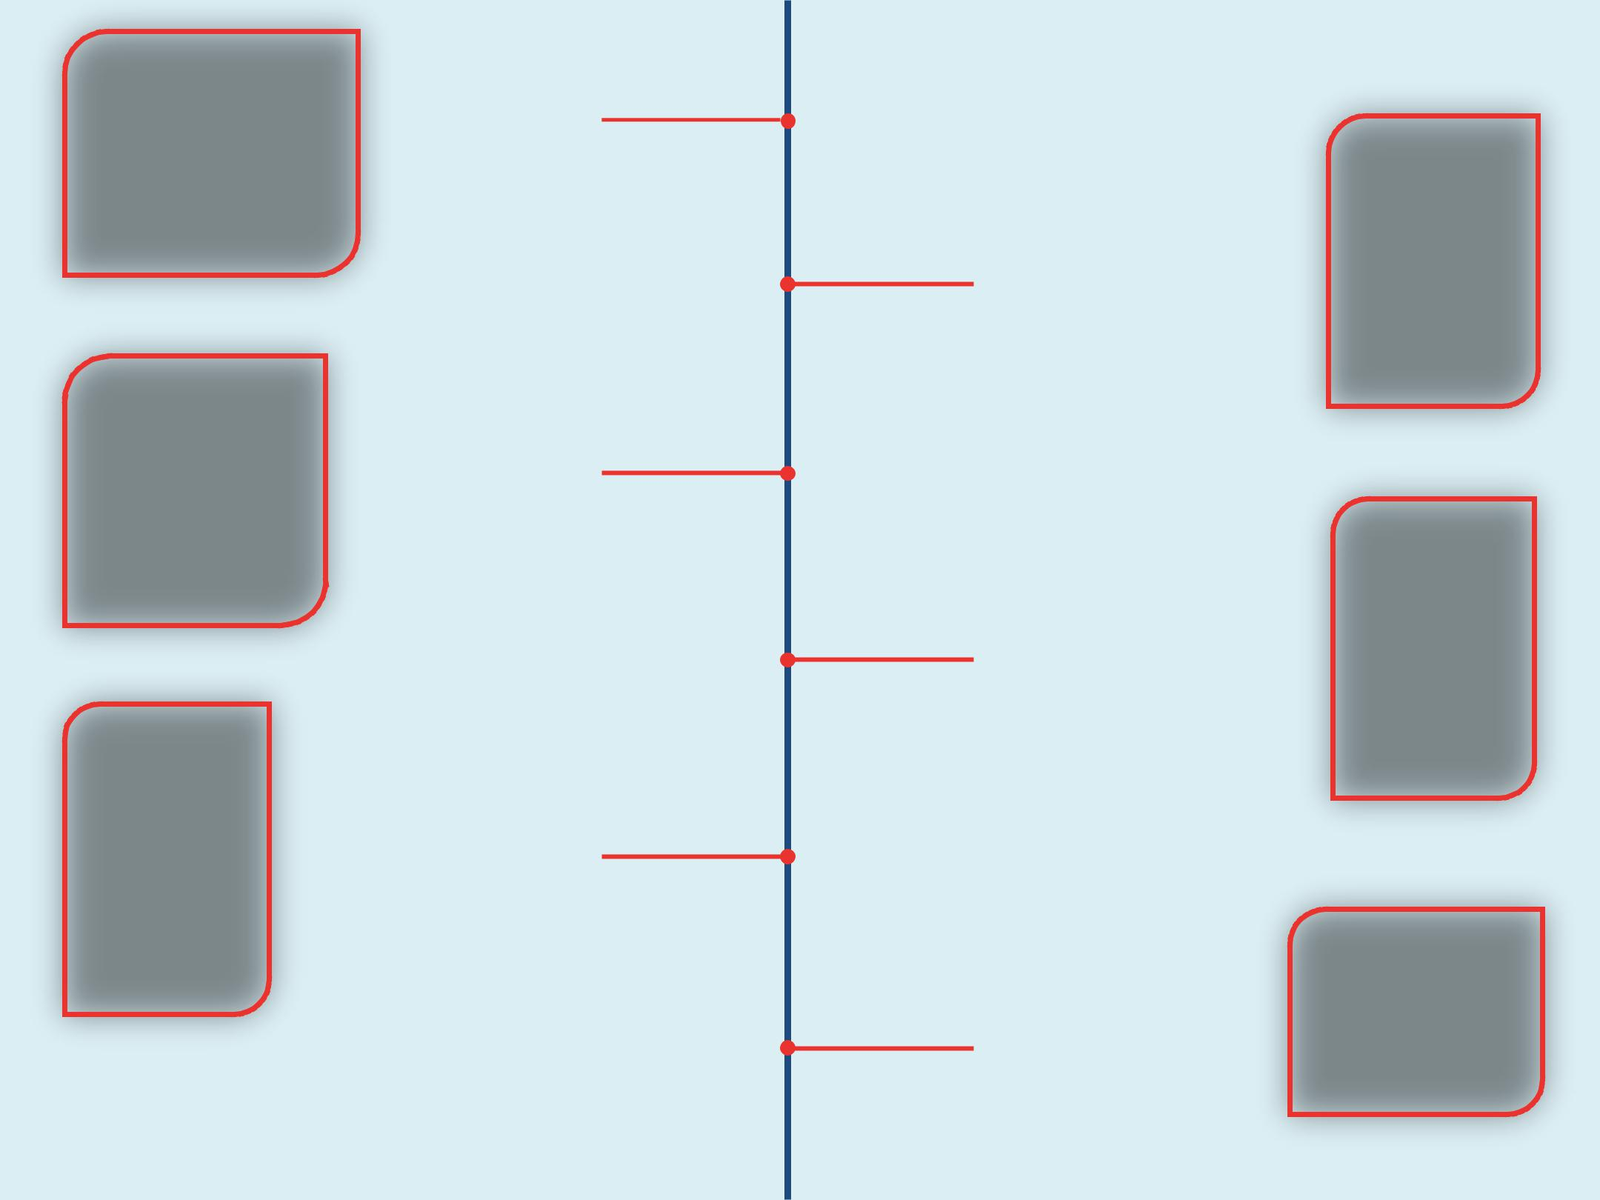

10 VPPPA Chapters Established

3rd Executive Director:

Paul Villane

18th Annual National Conference Orlando, FL

2003

20th Anniversary of VPPPA

5th Chairperson:

Mike Maddox

20th Annual National Conference Las Vegas, NV

2005

22nd Annual National Conference

Orlando, FL

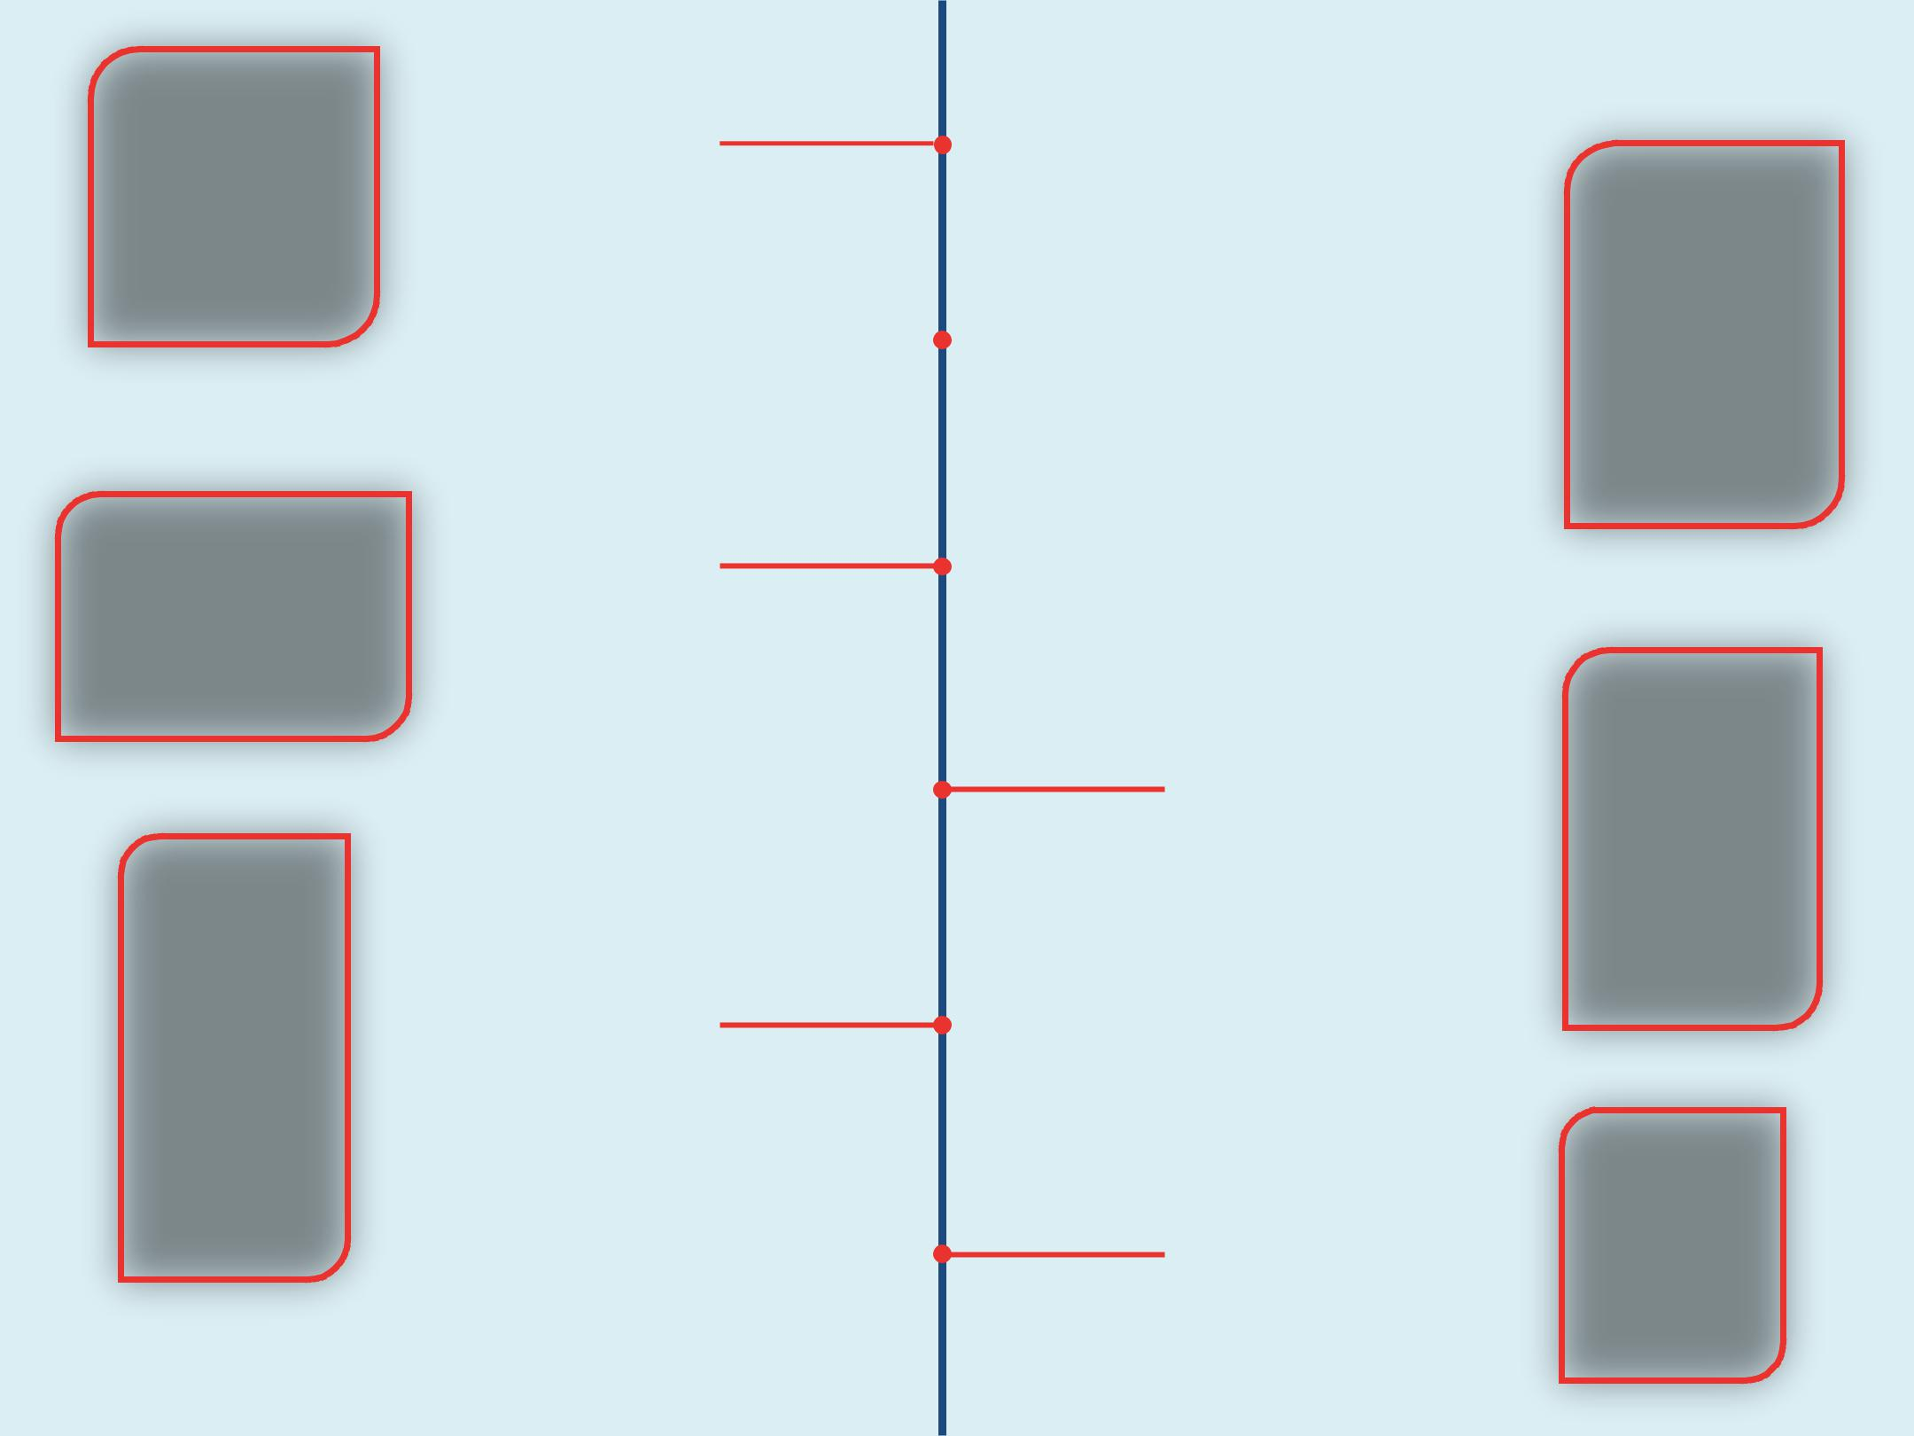
23rd Annual National Conference

Washington, DC | 2007

VPP Reaches 2,000 Sites

 |  | 6th Chairperson:
2008 |  | David L. Jackson

24th Annual National Conference

Anaheim, CA

25th Anniversary of VPPPA

2009

25th Annual National Conference

San Antonio, TX

7th Chairperson:

Mike Maddox

2010

Conference Surpasses 3000 Participants

27th Annual National Conference New Orleans, LA
26th Annual National Conference

Orlando, FL

2011

28th Annual National Conference

Anaheim, CA

2012

29th Annual National Conference Nashville, TN

2014

The Leader is Nominated for

the Folio Award

31st Annual National Conference Grapevine, TX

2016

National Conference Rebranded as Safety+ National Symposium

Safety+ National Symposium

New Orleans, LA

2018

2013
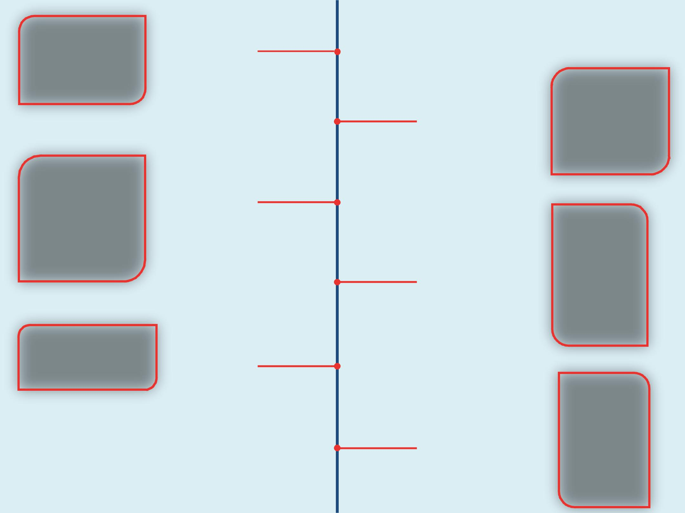

30th Anniversary of VPPPA

30th Annual National Conference

National Harbor, MD

2015

8th Chairperson:

Mike Guillory

5th Executive Director:

Mike Maddox

32nd Annual National Conference

Kissimmee, FL

2017

9th Chairperson:

J.A. Rodriguez, Jr.

The Leader Wins Gold for Feature Article from the Excel Awards

First Strategic Plan Approved

Symposium Surpasses 3500 Participants

Safety+ National Symposium Nashville, TN

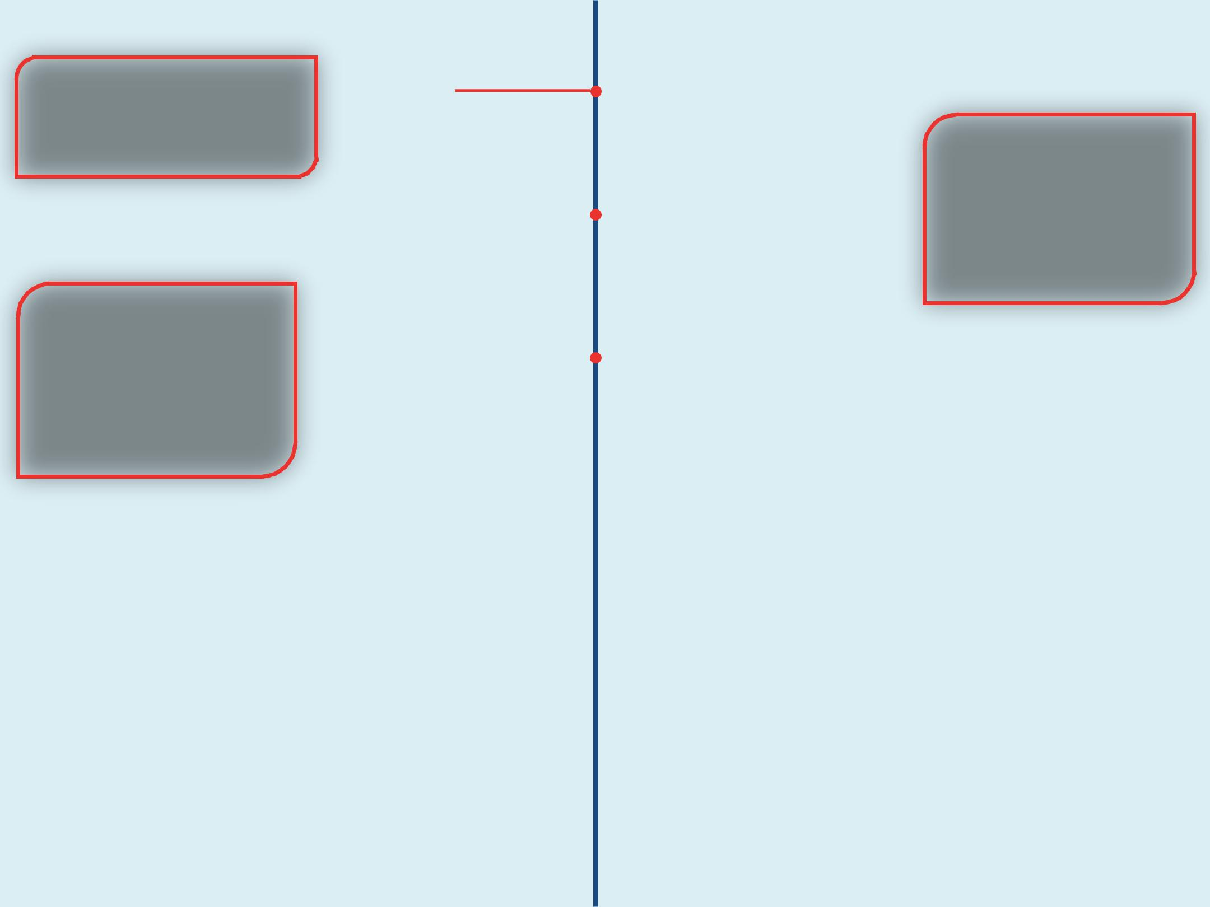
35th Anniversary of VPPPA

Safety+ National Symposium

New Orleans, LA

2019

Safety+ National Symposium

2020 |  | Orlando, FL

August 25-28, 2020

Marriott Orlando

World Center

Safety+ National Symposium

Nashville, TN |  | 2021

August 31-September 3, 2021

Gaylord Opryland Convention

Center

2022 2022 Strategic Plan Fulfilled

2026 Strategic Plan Set 2023

2024 40th Anniversary of VPPPA

