MEL’S KITCHEN CAFE

10TH ANNIVERSARY TIMELINE
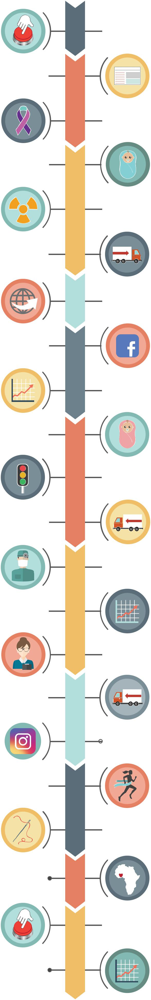

2007

JULY

Unknowingly publish a recipe that will go viral and will be my most popular

recipe to date (Sweet and SourChicken!)

2008

JANUARY

Healthy baby boy

#4 is born!

NOVEMBER

Hit publish on my
1st ever blog recipe!

AUGUST

Diagnosis of thyroid cancer while 17 weeks pregnant; major surgery to
remove thyroid and lymph nodes

2009

FEBRUARY

Radiation for cancer treatments

AUGUST

Move from Utah

to Green Bay, WI

2010

MARCH
Create an oicial MKC

Facebook page (inally!!)

2011

APRIL

Miracle baby girl
(after four awesome boys

- a miscarriage) is born!

2012

SEPTEMBER

Move from Green Bay, WI, to Roseau, MN (and manage to survive life in a

hotel for 7 weeks)

MARCH

Finally move my blog from mykitchencafe.blogspot.com to
www.melskitchencafe.com

NOVEMBER

About die when I hit ONE MILLION pageviews
in a month

MAY

Decide to quit my blog; change my mind within 48 hours and keep
plugging along (repeat this
scenario at least every quarter)

MARCH

Major surgery to ix complications lingering from childbirth + cancer

SEPTEMBER

About die when I hit TWO MILLION pageviews in a month

2013

OCTOBER

Finally hire a virtual assistant
(my sister!) to help out with the

crazy amount of blogging
tasks needing to be done

AUGUST

Move from Roseau, Minnesota

to Boise, Idaho
2014

AUGUST

Run my irst (and last)

half marathon

2015

JUNE
Travel to Ghana, Africa, with Mentors, | 2016
men and women in poverty
come back and tell you about it and

you raise over $50,000 (!!) to help

2017
DECEMBER

About die when I hit

3.5 MILLION PAGEVIEWS
in this month!

NOVEMBER

Decide to get with the program and start an oicial Instagram page

DECEMBER

Find basal cell carcinoma on face; MOHS surgery and 30 stitches
from nose to eye

NOVEMBER

Hit publish on 1,769th post!

