Family Vacation (Savings Goal Tracker Sheet)

Vacation Destination:
Vacation Dates:
Overall Savings Goal ($):

(Estimated Vacation Costs) Location Cost Web/Phone Info. Other Info.
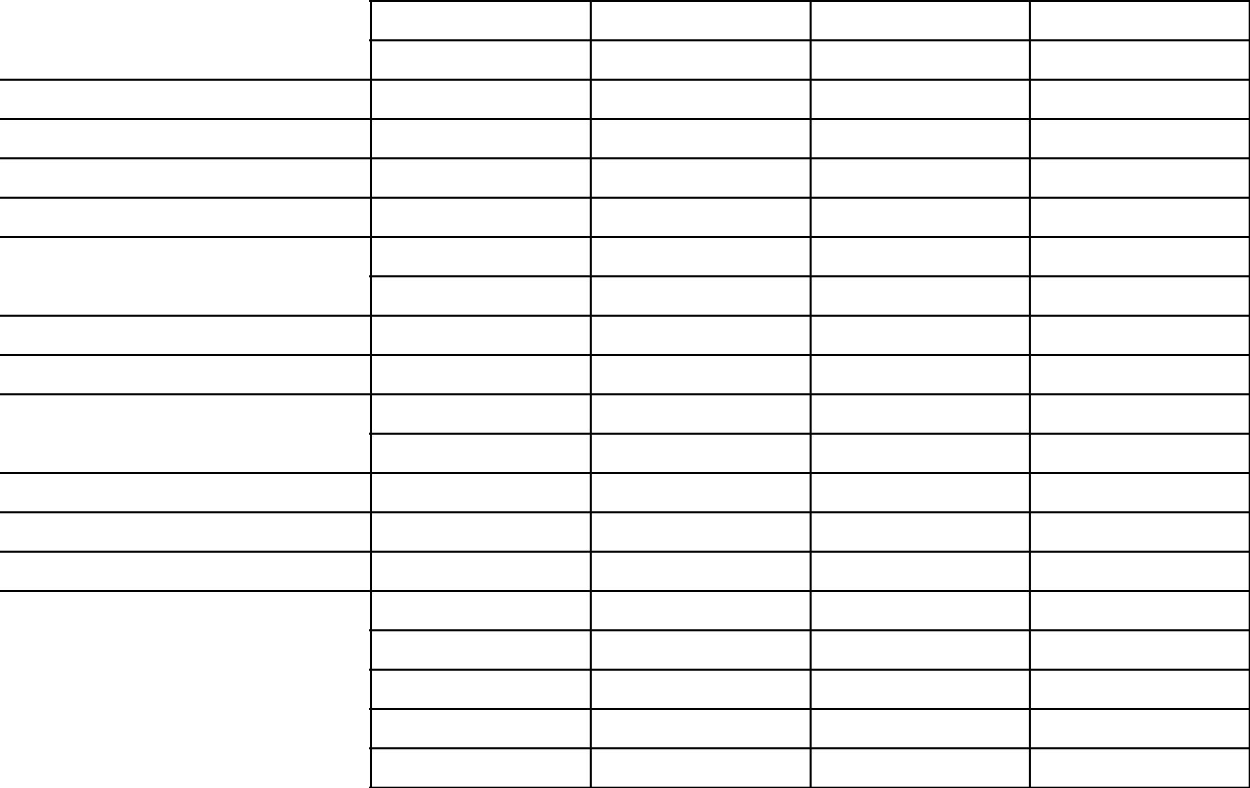

Activities Planned/Ideas

Hotel/Lodging

Meals

Transportation Expenses

Travel/Medical Insurance

Souvenirs

Misc.-tips, cell coverage boost, etc.

Repairs/emergencies-vacation fund
Vacation Saving Ideas | Vacation Goal Thermometer (use to fill in level of funds saved for vacation)
Work odd jobs for neighbor |  | AMOUNT | Date
Collect loose change out vehicles | GOAL MET!!!!
Save change out each dollar broken
Set up a monthly automatic transfer
Instead of Christmas/birthday gifts-
contribute funds to vacation | Almost There!!!


Keep Saving!!

Getting Started!
Vacation Fund Tracker Sheet

Date & Funds In Total Vacation Fund
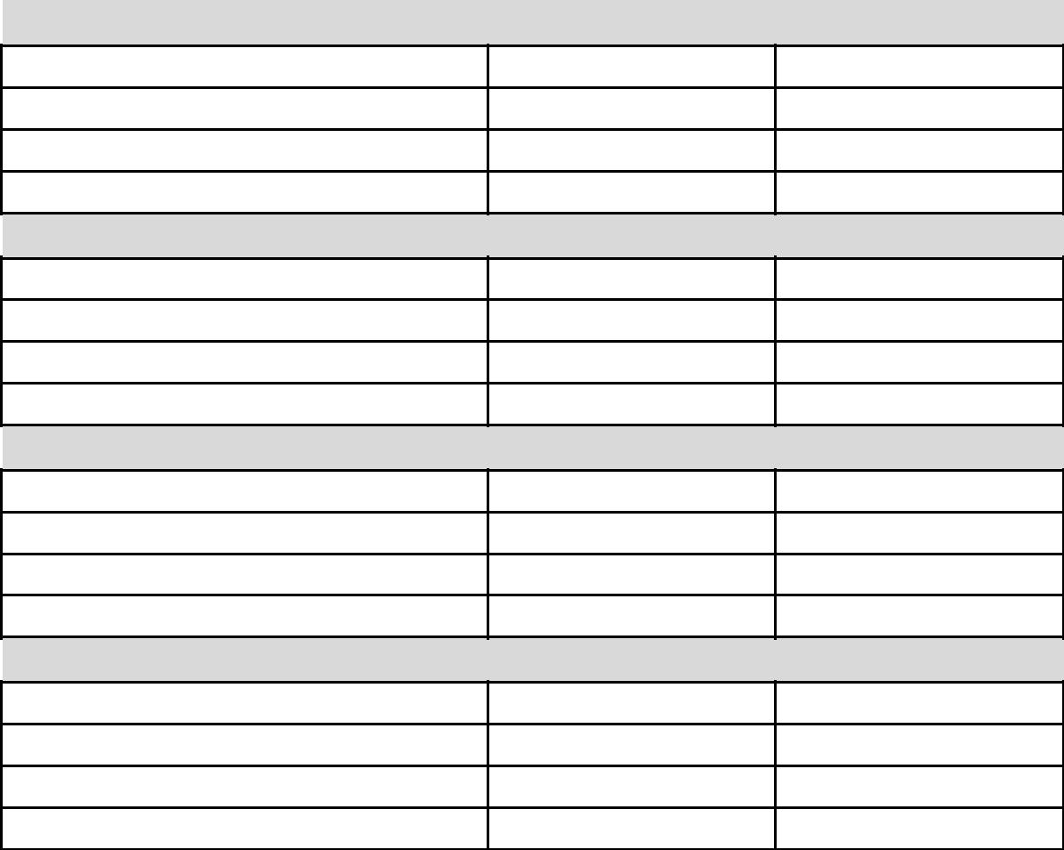

Jan. Begin Month Balance

Feb. Begin Month Balance

Mar. Begin Month Balance

April Begin Month Balance

 | Date & Funds In/ Out | Total | Vacation Fund
 | May Begin Month Balance
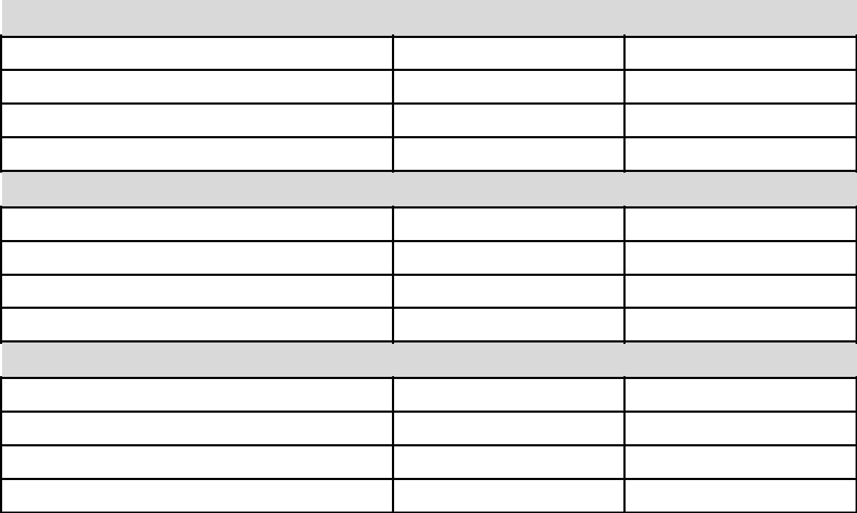
June Begin Month Balance

July Begin Month Balance

Aug. Begin Month Balance

 | Date & Funds In/ Out | Total | Vacation Fund
 | Sept. Begin Month Balance
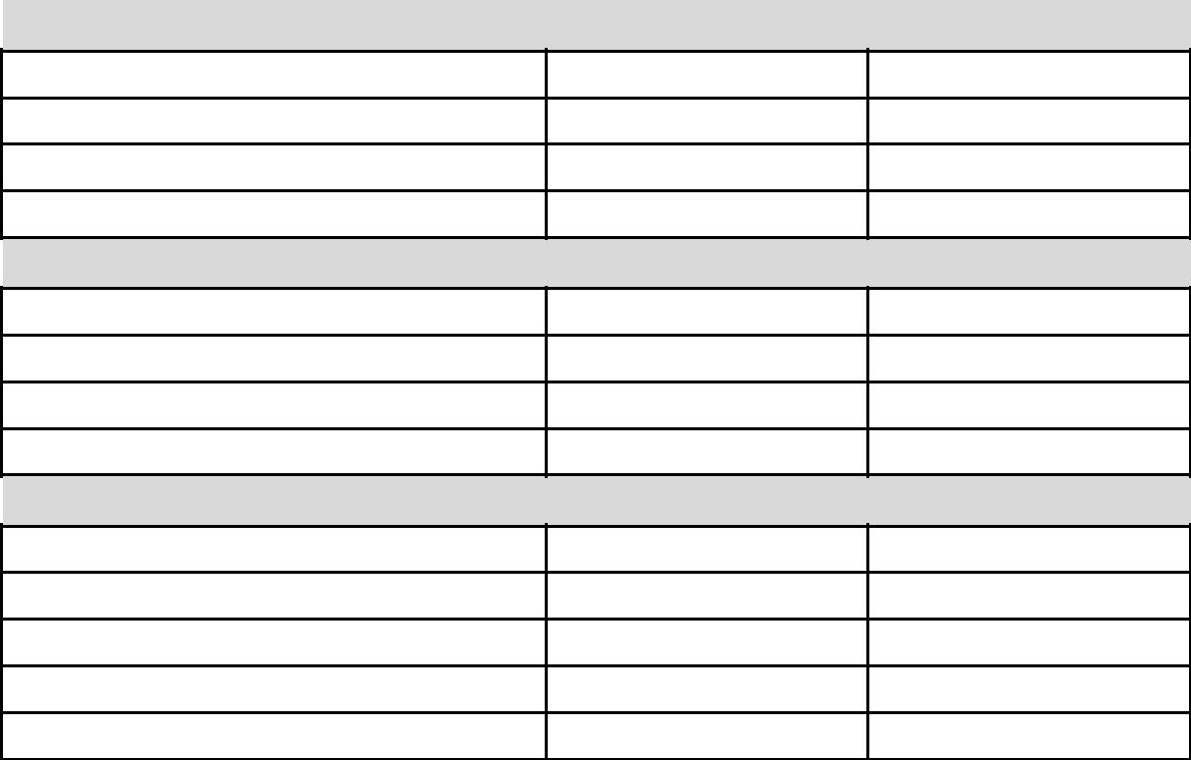
Oct. Begin Month Balance

Nov. Begin Month Balance

Dec. Begin Month Balance


