Project Charter

Project Name: |  | Data Center and Servers
Project Team Leads: |  | Guy Falsetti, JJ Urich
Project Manager: |  | Kris Halter
Team Dynamix Project Number: |  | 241095

Project Overview

To consolidate the 36+ server rooms and closets on campus into a target of 4 centrally governed,

Managed, and supported multi-tenant data centers.

Project Purpose and Benefits to Campus

Several factors are currently converging to make this an opportune time for the University of Iowa to review its model for housing, securing, and managing its computing servers and equipment. They are:

- The commissioning of the Information Technology Facility (ITF) on the Research Park/Oakdale campus provides highly efficient enterprise data center space previously not available.

- The University’s “2020 Vision” Sustainability Targets include a goal to achieve net-negative energy growth from 2010 to 2020 despite projected campus growth. Reduced IT energy use is expected to contribute to this.

- Technologies such as virtualization and remote server management have matured and can be more widely deployed.

- University efficiency initiatives over several years have put continuing pressure on IT staff resources, so changes that free up IT staff to work on higher-priority IT needs are recognized as necessary.

Project Scope Statement

- Maintain a thorough inventory, evaluation, and classification of data center and server room spaces across campus, computing equipment housed in them, and services provided.
  - Retire – If server/service is no longer is needed, retire the server or service.

  - Consolidate – If the service can be migrated to an existing service, consolidate.

  - Virtualize – Evaluate the current workload, CPU, memory, and disk requirements. If software will support virtualization, move to a virtual guest on central server farm.

  - Cloud – Evaluate the current workload, CPU, memory, and disk requirements. If the software will support a cloud provider move the service to the cloud.
  - Replace – Evaluate the current hardware age and configuration. If out of warranty and/or not in a configuration suitable for the data center then replace the hardware with new equipment.
  - Migrate – If all other options are exhausted. Move the equipment.

- Develop process for moving Non-High Performance Computing (HPC) clusters. A team would look at evaluating each server/service.
- Gather current energy usage or calculate estimates in the current location.
- Develop data center services, operational models, and SLA’s that facilitate consolidating data

Charter Template v 1.5 Page 1 of 6

Project Charter

Centers spaces. Work to ensure that services provide remote management capability and levels of support comparable to a local facility.
- Identify schedule/sequence of server moves and room retirements.

- In each room, assess the services provided by each server, identify target (move to central service, virtualize, or move server) and move services/servers as needed.

- Identify contingencies as required for services that can’t move and/or perform cost benefit analysis for possible exemptions.
- Assessing current data center services and revising and creating new services to address gaps.

- Transitioning of servers and services to consolidate data centers and server rooms.

- Decommissioning vacated server rooms so they are ready to be repurposed.

Out of scope:

- High performance computing (HPC) clusters.

- College of Medicine managed buildings and rooms.

- UIHC/HCIS managed buildings and rooms.

- Decommissioning of ITF.

- Lift and Shift.

High-Level Requirements

Reviews of other campuses’ efforts to consolidate data centers indicate that savings and benefits are generally achieved in the ways listed below. We recommend that these methods facilitate the approach to optimize the Data Center model at the University of Iowa.

- Most actual ongoing savings is found in virtualizing stand-alone servers (savings in IT staff time and energy reduction).

- Significant ongoing savings can be found in converting out-of-date and less efficient computing equipment to newer and more efficient equipment (savings in energy reductions).

- Additional savings is realized from moving equipment from dispersed or less energy-efficient data centers to modern, efficient facilities and reducing the number of facilities (savings in energy, facilities - CRACs, generators, etc - and also in staff time for not managing dispersed facilities).

- Major non-financial benefits include consistent security standards and management practices (reduces institutional risk and staff time via economies of scale and decreased duplication of effort).

- Life cycle management of equipment.

- Data Centers of the Future – Cloud computing will become more mainstream. Consolidating server resources into a “University of Iowa” Cloud Computing environment will allow us future growth and flexibility. Advanced networking between cloud and local data centers will be a requirement of future services.

i.

Charter Template v 1.5 Page 2 of 6
Project Charter

High-Level Risks

- Significant up-front costs to either virtualize, buy new equipment or move equipment.

- Significant labor needed to reconfigure existing services to perform in a virtual environment or remote facility.

- Potential increase in staff time to travel to central facility for ongoing maintenance and operations functions (no longer able to simply walk next door to fix a server).

- Overhead and start-up costs to develop and provide data center services in a more “retail” environment (more procedures and policies are needed to broaden access and usage of a data center to serve a variety of campus needs).

- Flexibility to rapidly deploy equipment or try novel approaches by Colleges, Departments, and Researchers may be adversely impacted.

- Resistance to change by organizations that house equipment in and manage a local data center or server room.

- Fractional Savings – Staffing savings are based on reduction of overall Systems Admin management of servers. If we reduce the workload of a partial staff responsibility but don’t reduce the head count then the University will not see all the operational savings.

•

Assumptions and Constraints

Assumptions:

- Institutional support for moving faculty/research equipment.

- Server consolidation breakdown
O 25%: Research HPC Clusters -- cannot be virtualized and require replacement o 25%: Application servers that can be consolidated into existing portfolio
O 40%: Server workload that can be virtualized

  - 10%: Servers that will need to be replaced with physical devices

- Re-evaluation of data center access is necessary.

- Development of necessary ITAR compliance at one or more centrally managed data centers.

Constraints:

- Available funding to replace current non-rack mountable equipment with rack-mountable systems for data center.
- Upgrades to building uplinks and/or other networking upgrades to support latency and bandwidth requirements as needed.

- Server rooms not fully decommissioned may not fully realize forecasted energy, staff and MEP expense savings

Charter Template v 1.5 Page 3 of 6
Project Charter

Project Governance

Data Center and Servers Leadership Team

Goal – Overall responsibility to consolidate the 36+ data centers on campus down to 4 data centers by July 2018.

- Top Level project team will report up to the CIO’s OneIT steering group.

- Overall coordination of the Governance Team and the Technical Team.

- Coordinates the timing of the DC Project Teams.

- Capital and staffing resource allocation for the DC Project Teams.

Data Center Governance

Goal – An ongoing policy and process focus group with the overall operation of the data centers.

- Lead by Data Center Manager (Jerry Protheroe).

- Set the policies for operation of the data centers.

- Set process for maintaining highly available services in the data center.

- Coordinates infrastructure maintenance in the data center.

- Documentation of Service Level Agreements with Technical team.

- Capacity planning for the data center (power, cooling, floor space and networking funding models, chargeback models, and life cycles of equipment).

- Ongoing collaboration with Facilities to review the programing on new buildings for server room spaces.

Data Center Technical
Goal – Day to day operations of moving services and equipment out of departmental data centers and into an enterprise class facility.

- Lead by TBD

- Evaluation of the services in the data centers and how they would move.

- Placement of services in appropriate network.

- Ensuring supportability of hardware that is placed in data center.

- Working to ensure Governance policies and processes are followed.

- Documentation of Service Level Agreements with Governance team.

- Data Center Web site with a service catalog.

Data Center Project Team
Goal – Form group around the de-commission of a specific data center or server room.

- Lead by a member from the Data Center Technical team.

- Membership would include the Technical group and Local IT Support or technical contact for server room under consideration

- SST team or Research Team would be pulled in based on the service being deployed.

Data Center Advisor Team

Goal – to get campus input to the process on consolidation

- Lead by DCS Project Manager (Kris Halter).

- Input to governance, technical and project teams on SLA’s, life cycle management, funding/charge back models, services, etc…

- Membership would be from a broad representation of campus.

Charter Template v 1.5 Page 4 of 6
Project Charter
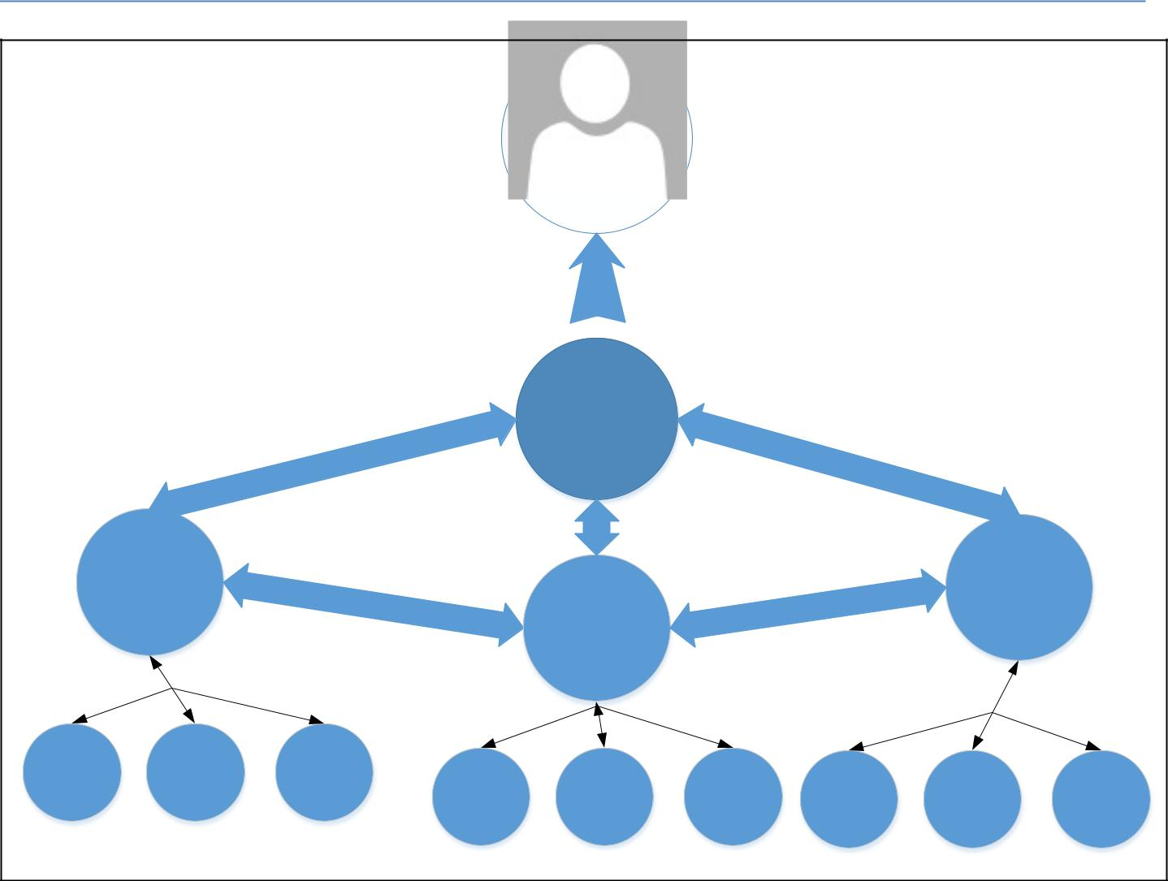

 |  |  | Name
 |  |  | OneIT Steering Committee
 |  |  | Guy Falsetti
 |  |  | DC Optimization
 | JJ Urich |  |  |  |  | Jerry Protheroe
 | Technical |  |  |  |  | Jerry Protheroe
 | Technical |  |  |  |  | Governance
 |  |  | Kris Halter
 |  |  | Advisor
Server Room 1 | Server Room 2 | Server Room 3
DC Project Team | DC Project Team | DC Project Team | Department
 |  | Department | Department | Department | Department | Department | Department
 |  | DC Project Team | DC Project Team | DC Project Team | DC Project Team | DC Project Team | DC Project Team

Anticipated Cost Savings Categories

MEP Analysis

Each of the 36+ server rooms were evaluated on Mechanical and Electrical usage. A Power Utilization Efficiency factor was applied. We then factored staff savings on management of the facilities. Finally we added any systems to the current data centers as a cost to run that Data Center.

Staffing analysis

Currently the ITS Server Support Team manages 487 physical and 1,010 virtual servers with a staff of 19. This gives SST an average of 72 servers per systems administrator. The departmental IT units report 659 physical and 487 virtual servers with an effort of 25.3 FTE of effort to manage the systems. The ITS Research Services team supports 629 servers on two clusters with a staff of 4.

Average cost for a Systems Administrator is $100,000 per year.

Charter Template v 1.5 Page 5 of 6
Project Charter

Preliminary Milestones | Target Date
Charter Approval | 05/01/2015
Team Kick off | 05/31/2015
Committee Approval of Project Plan | 05/31/2015
Governance Framework | 08/31/2015
Funding acquired | 08/31/2015
Server Room migrations | 08/01/2018
Close Out | 08/02/2018

Project Team |  |  | Role
Guy Falsetti |  |  | Co-Lead, Coordinator
JJ Urich |  |  | Co-Lead, Technical Team Lead
Jerry Protheroe |  |  | Data Center Governance Team Lead
Kris Halter |  |  | Advisor Team Lead
Stakeholders: |  | Refer to Stakeholder Registry
Potential Implementation Cost: |  | DC Server Consolidation FY16 - $250K
 |  | DC Network Aggregation FY16 - $350K
 |  | DC Facilities FY16 - $280K
 |  | DC Server Consolidation FY17 - $250K
 |  | DC Network Aggregation FY17 - $350K
 |  | DC Facilities FY17 - $280K
 |  | Staffing, Manager and 2 x Systems Admin - $300K
Target Start Date: |  | 05/02/2015
Target Close Out Date: |  | Rolling implementation – 08/02/2018
☐ | Charter Ratification Date |  | MM/DD/YY
Charter Template v 1.5 |  |  | Page 6 of 6

