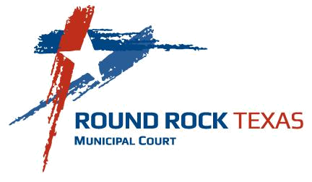
Round Rock Municipal Court
301 West Bagdad Ave., Suite 120
Round Rock, Texas 78664

Phone: (512) 218-5480
Fax: (512) 218-7079

Customer Survey & Comment Card

Please rate the following:
 |  | Low |  |  |  | High
When calling Municipal Court, how would you rate the court “Message Director”?: |  | 1 | 2 | 3 | 4 | 5
Additional Comments:
 |  | Low |  |  |  | High
How did you feel after serving jury duty? |  | 1 | 2 | 3 | 4 | 5
Additional Comments:
 |  | Low |  |  |  | High
How would you rate the information provided on the Municipal Court Webpage: |  | 1 | 2 | 3 | 4 | 5
Additional Comments:
 |  | Low |  |  |  | High
How would you rate your visit to Municipal Court? |  | 1 | 2 | 3 | 4 | 5
Additional Comments:
 |  | Low |  |  |  | High
Did you find the information provided on the citation form helpful? |  | 1 | 2 | 3 | 4 | 5
Additional Comments:
 |  | Low |  |  |  | High
Was there adequate staff available to assist you? |  | 1 | 2 | 3 | 4 | 5
Additional Comments:
 |  | Low |  |  |  | High
Was the information provided by staff adequate and informative? |  | 1 | 2 | 3 | 4 | 5
Additional Comments:
 |  | Low |  |  |  | High
Were the staff friendly and demonstrate a good attitude & tone of voice: |  | 1 | 2 | 3 | 4 | 5
Additional Comments:

Check each place you appeared:

( ) Municipal Clerk’s office ( ) Jury Trial Docket

( ) Juvenile Court ( ) Indigent Docket

( ) Adult appearance docket
( ) Conference with the Prosecutor

( ) Pre-trial Docket
( ) Judge Trial Docket

Is there anyone you would like to recognize who was especially helpful?

Do you have other comments or suggestions?

If you would like the Court Administrator to contact you, please complete the following:

Name: Phone #:

E-mail Address:

