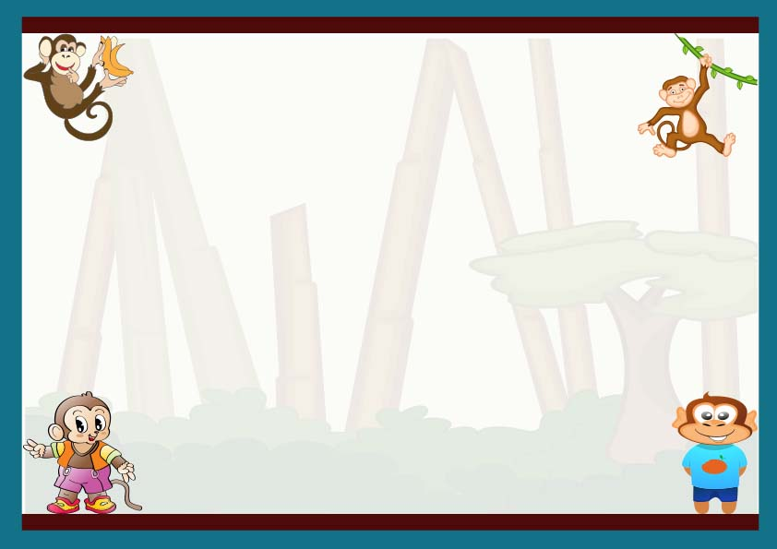

**__________________**

**Dated on**

**__________________**

**Signed By**

This certifies that _________________

Has officially adopted ______________

And has welcomed this monkey into their home forever!

**Certificate of Adoption**