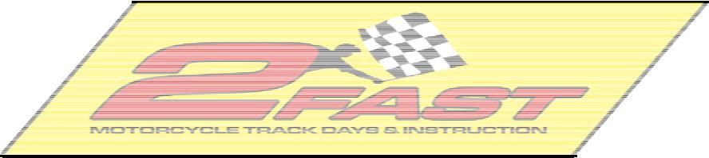

Christmas Party - December 3rd, 2005

Orton House - 6pm - 9pm

7820 238th Street SE, Woodinville, WA 98072

Christmas Party Pot-Luck Sign Up Sheet

Main Dish

(meats, casseroles, pasta, burgers . . .)

- Mark & Taji - Seafood Alfredo

- Greg Orton- Paella (rice, meat, veggies)

- Corey Rastetter - Casserole

- Andy & Maryl Lee Orton

5)

6)

7)

8)

9)

10)

Side Dish

(salads, breads, beans, fruit . . .)

- J. Debrueler - Ham/Cheese Macaroni Salad

- Jay Saathoff - Smoked Salmon

- Brett Hutton - Garlic Bread

- Marshall Dale - Salad

- Joe Coulter - Calico Baked Beans

- Brad & Cindy Gua - Taco Dip w/chips

- Corey Rastetter - Deviled Eggs

- Danny Stanley - Greek Dolma Appetizer

9)

10)

 |  | Dessert
 |  | (something sweet and yummy to eat)
 | 1) | Brett Hutton
 | 2) | Dave Robins
 | 3) | Stu Feldt
 | 4)

5)

6)

Unable to Attend

( ya ya excuses excuses )

- Geoffrey Lambert

2) | Jake Frame
3) | Scott Avery

- Kory & Janet Gill

5) Wertman's

- Briggs Willoughby

