
Appendix E: Healthy Meeting Toolkit

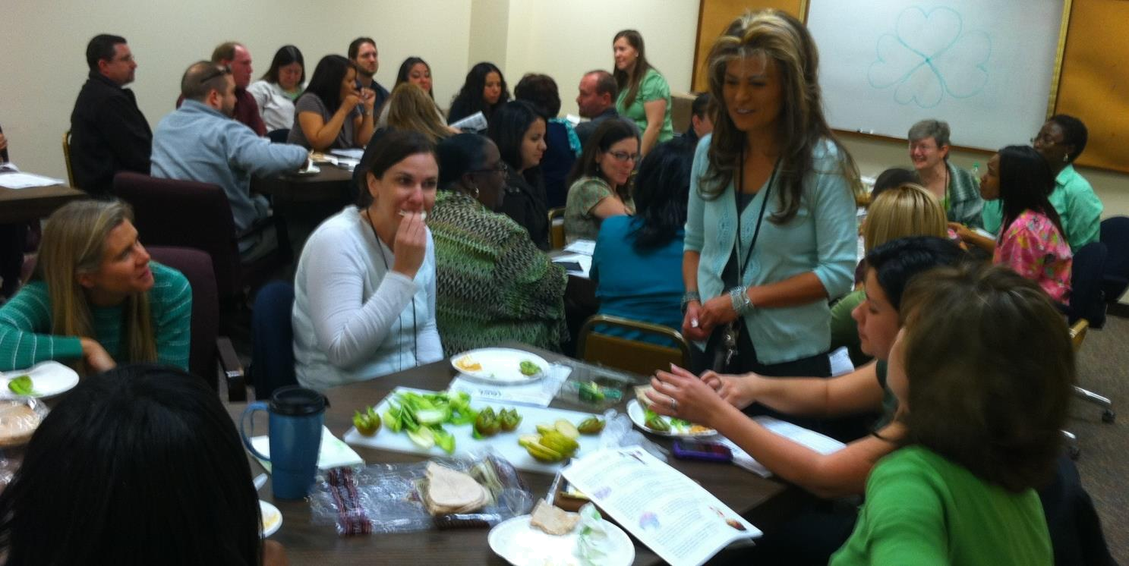

 HEALTHY MEETINGS TOOLKIT



Table of Contents

- Introduction Letter……………………………………………………………………………………………………………..….Page 1

- Physical Activity ………………………………………………………………………………………………………………...…Page 2

- Meals/Snacks/Beverages………………………………………………………………………………………….…………….…Page 7

- Catering...…………………………………………….……………………………………………………………………....……..Page 18

- Potlucks ...…………………………………………….……………………………………………………………………………..Page 20

- Recipes and Shopping Tips……………………………………………………………………………………..………….……..Page 24

- Allergens …….………………………………………………………………………………………………………….….….……Page 30

- Food Safety/Sanitary……………………………………………………………………………………………………….…...…Page 32

- Planning/Purchasing for Large Groups…………………………………………………………………………………………Page 36


A Note to Tri-County Employees and our Community Partners in Health,

The Healthy Meetings Toolkit has been developed by Tri-County Health Department Registered Dietitians in response to requests from our own staff members as well as local employers for guidance on how to support healthy eating and physical activity during the workday.

Some may wonder, “Does it matter if I serve healthy snacks at a meeting? The answer to that question is “Yes!”

- By providing a refreshing snack and an opportunity to be physically active during meetings, you will help keep participants alert and feeling good, resulting in a more focused and productive meeting.

- There is a strong body of research that shows healthy eating and physical activity play a critical role in reducing risk for obesity and chronic illness, including diabetes and heart diseases.

- Since so many of us spend the majority of our waking hours at work, the worksite culture can play a key role in either supporting or undermining an individual’s efforts to practice a healthy lifestyle.

On behalf of Tri-County Health Department, I wish to thank you for contributing to the health of our community by supporting a culture of wellness at your worksite. I hope you find the toolkit useful and we welcome your feedback to help us improve it.

In Good Health,

John M. Douglas, Jr., MD
Executive Director
Tri-County Health Department 1
Serving Adams, Arapahoe and Douglas Counties
PHYSICAL ACTIVITY

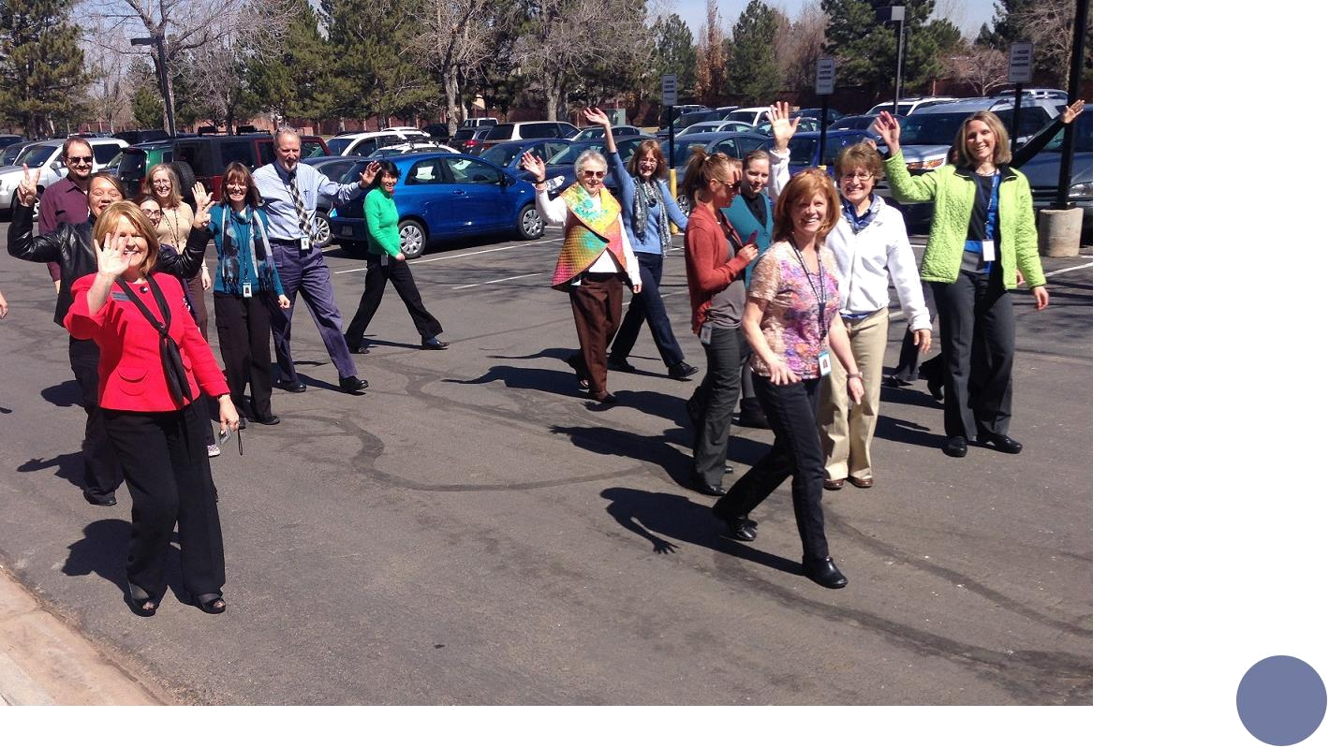

2

PHYSICAL ACTIVITY AND MEETINGS

Guidelines and Safety Considerations

- Participation in physical activity during the workday should be conveyed as optional and voluntary. Be sure to
‘invite’ and not pressure individuals to participate.

- Encourage individuals to work at their own pace and to take responsibility for monitoring themselves.

- Because a typical meeting activity break is short (2-10 minutes), there is not sufficient time to warm up the cardiovascular system. For this reason, it is important to choose activities that do not cause a sudden increase in heart rate. Walking or marching in place is a great option. Running in place is not.

- Avoid high impact activities (jumping jacks); activities that involve excessive trunk flexion (touching toes); or exercises that twist the spine.

3

Mid-Meeting Breaks

When coordinating a meeting that will be an hour or more, add a voluntary physical activity break to the agenda. The break can be as simple as walking 2 laps around the room or marching in place for two minutes (or in chair if participants prefer). You may also wish to add upper body stretches or exercises from the examples on pages 25-26.

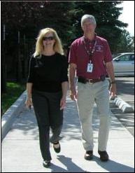

Walking Meetings

When weather permits, try a walking meeting. These are most effective for short meetings of 4 or less people. They are also great for breakout brainstorming sessions during larger meetings. Remind participants to come prepared with jackets and walking shoes. Allow people to opt out without pressuring them to participate (they may have personal reasons).

Reducing Sitting Time

Try incorporating 5 minutes of standing time into a meeting. Then, expand it to 7 or 10 minutes at your next meeting. Convey to participants that standing is an option not a requirement.

4

○

○

○

○

Stretching Guidelines | PHYSICAL ACTIVITY – STRETCHES

Avoid stretching areas of the body that are injured or symptomatic.

Stretch only to the point of comfortable tension, then relax and hold

If you feel any pain, stop immediately and relax

Do not bounce while stretching

- Remember to breathe and keep abdominal muscles taught to protect back
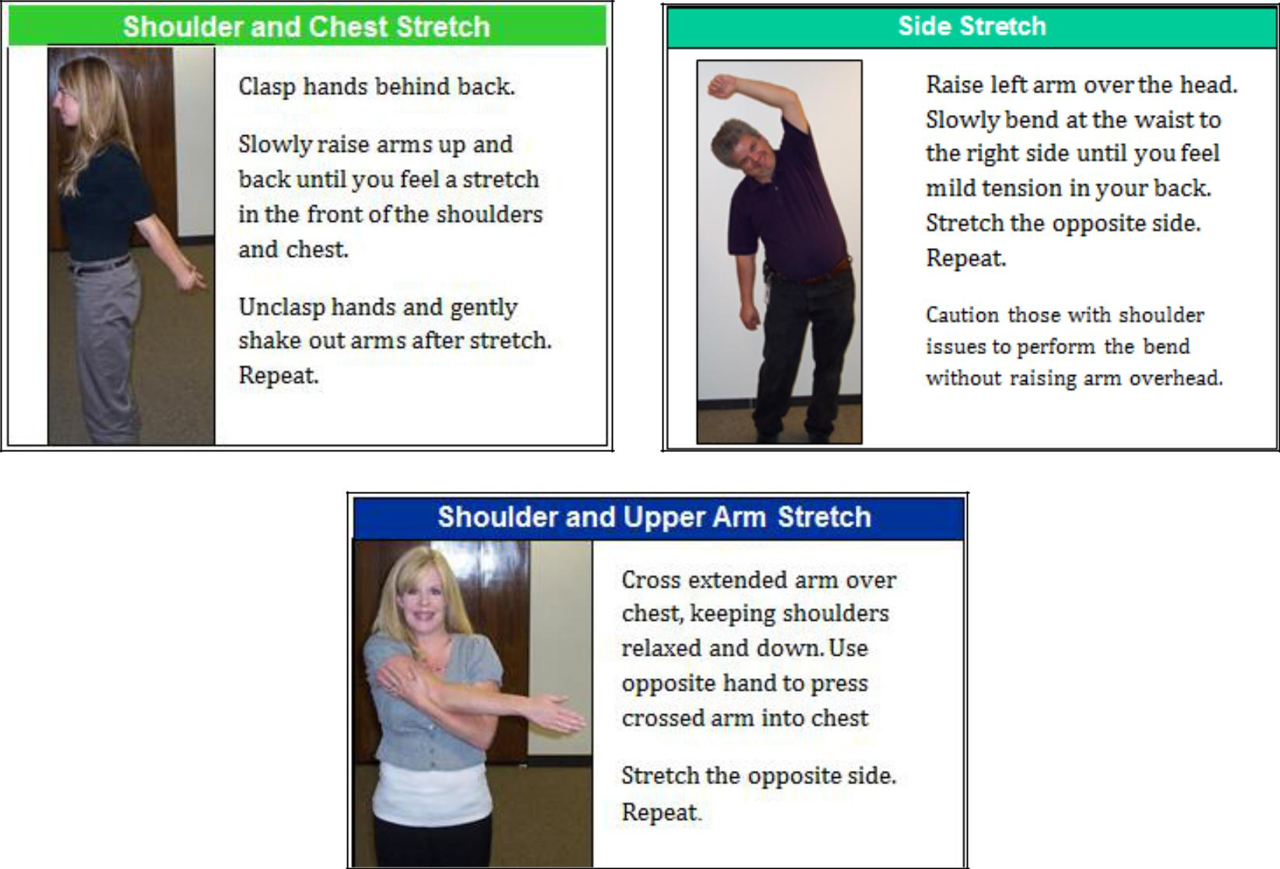

5

Exercise Guidelines | PHYSICAL ACTIVITY – EXERCISES

- Avoid performing exercises that may aggravate a chronic condition or injury

- If you feel any pain, stop immediately and relax

- Remember to breathe

- Keep abdominal muscles taut during movement to protect back from injury

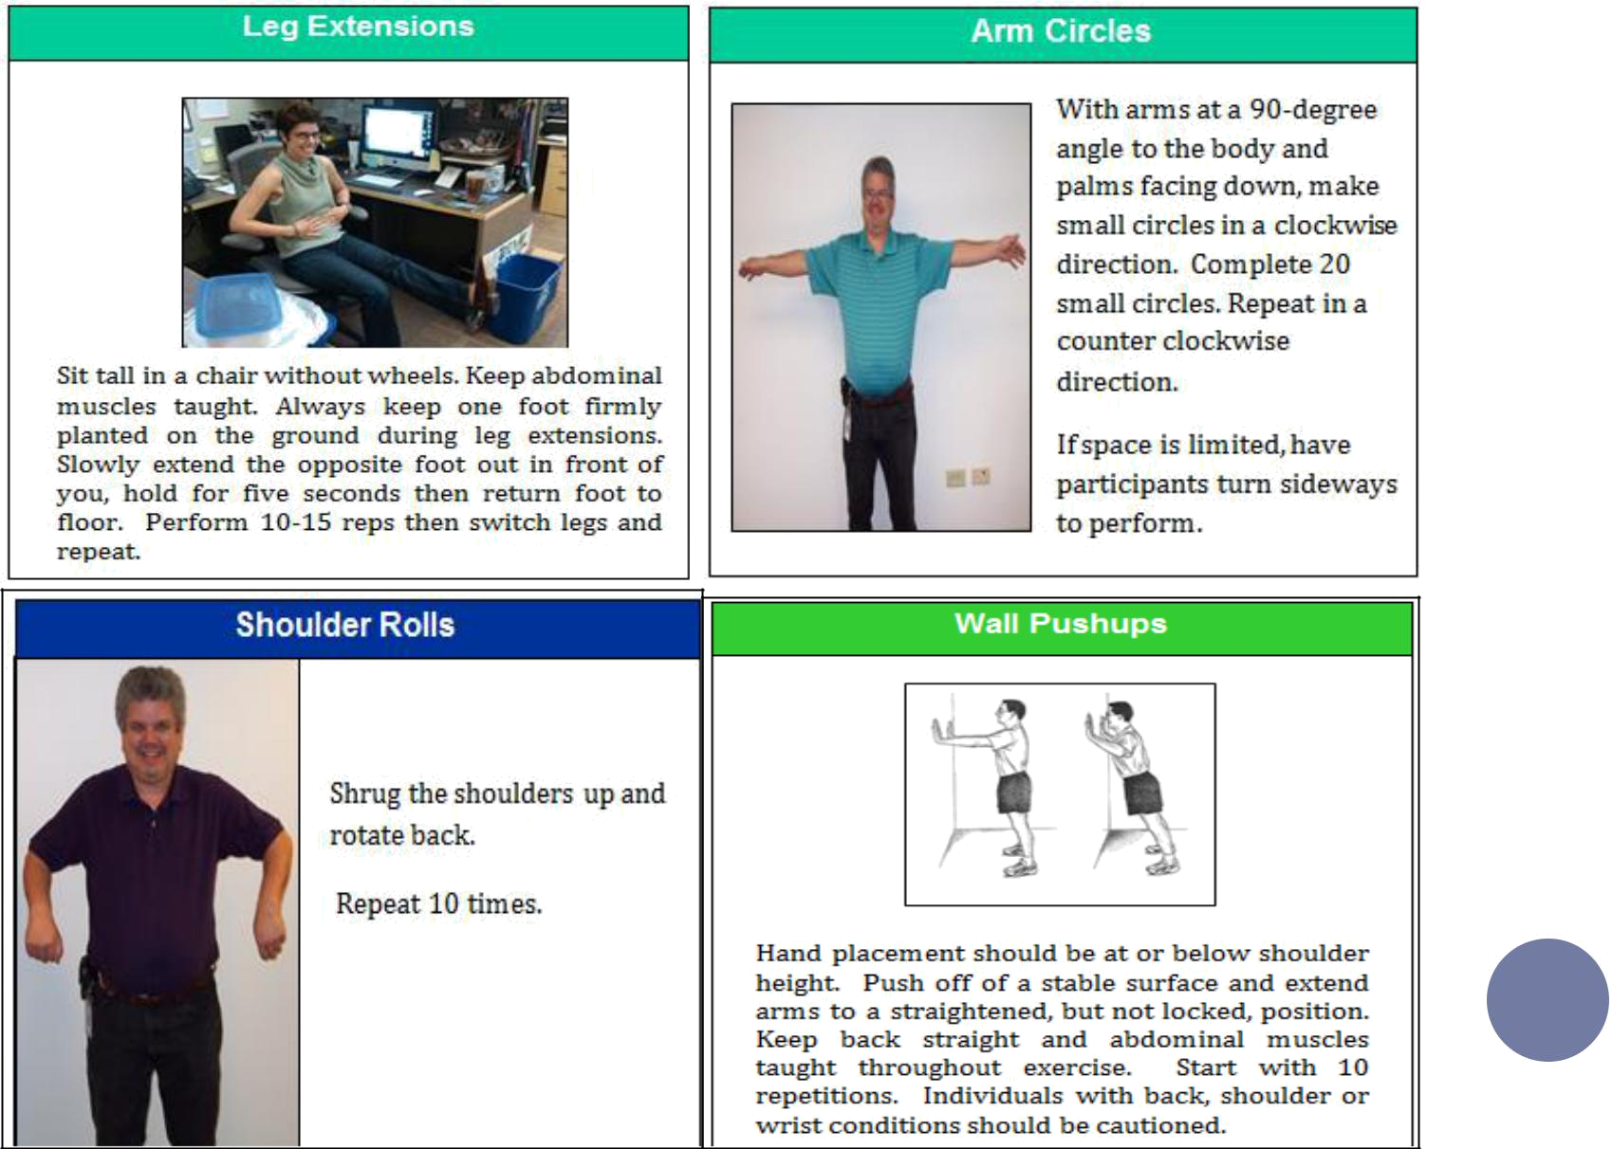

6

MEAL/SNACK/BEVERAGES

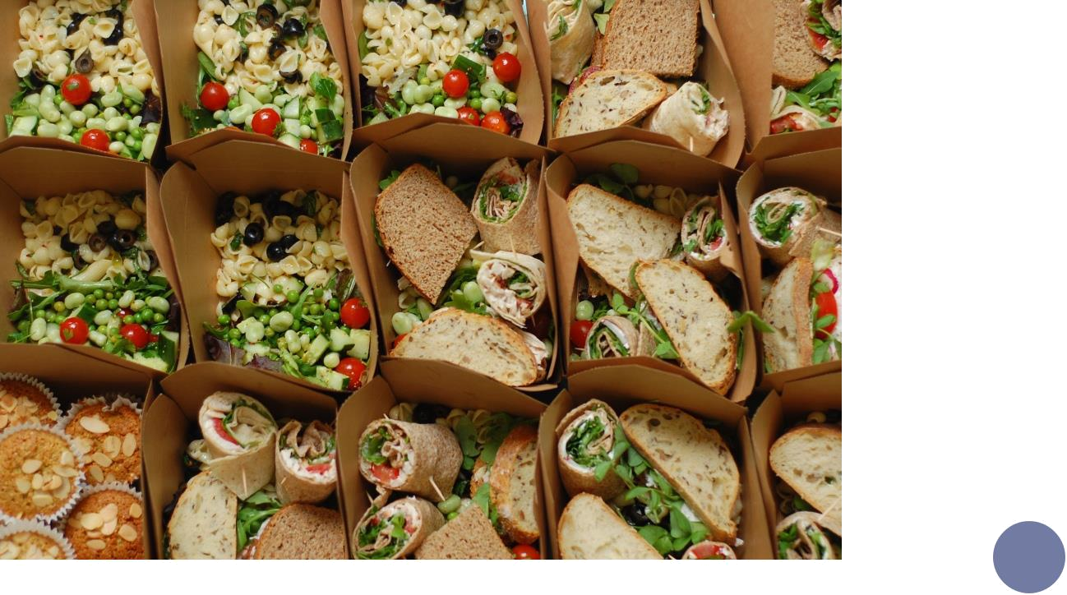

7

BREAKFAST

Below are ideas for breakfast options. Links to recipe ideas can be found in the “Recipe Ideas” section.

Grain Options

- Oatmeal or Quinoa– This breakfast item can be made in the crock pot to help make a larger amount with ease! Top with items such as:
    - Fresh or dried fruit (Bananas, apples, peaches, blueberries, raisins, etc.)
    - Nuts (chopped walnuts, almonds, pecans, etc.)
    - A small amount of honey or brown sugar to add sweetness

- Bagels – This breakfast item can be much larger than the portion most people need. Consider purchasing mini bagels or cut the bagels in half to make the portion more appropriate. Also try to purchase whole-grain bagels for extra nutrition benefits.
  - For toppings, consider items such as:
    - Peanut or other nut butters
    - Low-fat cream cheese
    - Nonfat/low-fat yogurt
    - Fruit

- Various whole-grain breakfast cereals/cereal bars - If purchasing cereals, be sure to watch the sugar content and only purchase cereals with “whole grain” as the first ingredient.

- Granola bars/nut bars – Watch the sugar content of these items and look for whole-grain items

- Whole-wheat bread for toast

- Muffins – For recipes, please see Recipe Section.

  - Avoid store bought muffins – most store bought muffins have more than one serving per muffin and are loaded with calories and fat
  - If purchasing muffins choose the mini-sized muffins

8

BREAKFAST

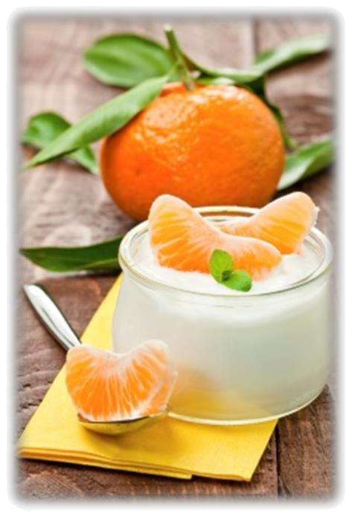

Dairy Options

- Greek or other non-fat/low-fat yogurt.
  - Top with items such as:
    - Berries
    - Dried fruit
    - Nuts (almonds, walnuts, etc.)
    - Granola

- Cottage cheese – Look for low-fat options.

- Skim or low-fat milk – Soy or almond milk can be offered as a calcium and protein rich alternative to coffee creamer.

Protein Options

- Hard cooked eggs

- Egg Casserole

- Peanut butter or other nut butters
  - Add to bread or fruit

Fruits and Vegetables

- Fresh fruit

  - Strawberries, blueberries, raspberries, grapes, cantaloupe, bananas, oranges, pineapple, apples, clementine’s, tangerines, etc.
  - Try adding spinach, mushrooms, tomatoes, onions, peppers or avocado to scrambled eggs or egg sandwiches

- Applesauce

- Smoothie

With any grain, dairy, or protein breakfast items, include a fruit or vegetable to make a balanced breakfast! | 9

MID-MORNING SNACKS

Similar to breakfast options, here are some ideas for morning snacks:

- Yogurt, fruit (berries, bananas), granola

- Assorted fruit yogurts - Choose one that does not contain a lot of added sugar

- String Cheese

- Trail Mix

  - Dried cereal

  - Dried fruits (pineapple, mango, raisins, banana, etc.)

  - Unsalted nuts (almonds, peanuts, cashews, walnuts, etc.)

- Fruit tray (any combination or any of these fruits separately)

  - Strawberries, blackberries, blueberries, raspberries, watermelon, cantaloupe, honeydew, grapes, bananas
(cut in half with peel on), oranges, apples, peaches, pineapple, clementine’s, etc.

- Granola Bars - Choose one that has protein and does not contain a lot of added sugar.

- Apples with Peanut Butter

- Mini muffins

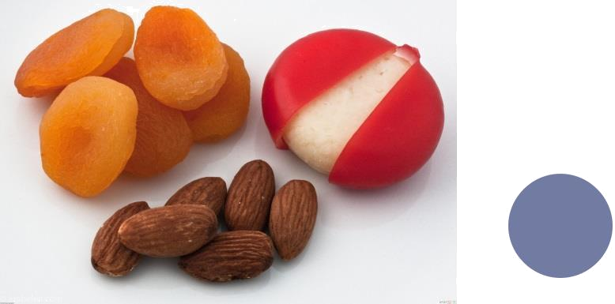

10

LUNCH

General tips to remember when creating healthy lunches:

- Offer fruits and/or vegetables as a component of every meal.

  - Apple slices, clementines, grapes, bananas and berries are a few options that are easy to prepare

  - Lettuce or other dark leafy greens, tomatoes, and roasted peppers could be offered as sandwich toppings

- Choose leans meats like chicken, fish, or seafood over red meat whenever possible.

- Bake, broil, or steam meats or vegetables instead of frying or sautéing to decrease the amount of saturated fat.

- Provide a veggie tray with lots of different options at meetings or lunches.

  - Carrots, broccoli, bell peppers, celery, olives, snap peas, and cherry tomatoes are easy to prepare

- Always try to offer a vegetarian protein source.

  - Some ideas include offering beans, quinoa, tofu, hummus, cheese, hard-boiled eggs or nut butters

- Offer any salad dressings on the side and choose dressings that are lower in saturated fat. Some examples of healthier dressings include:

  - Oil and vinegar

  - Lemon juice

  - Lime juice

  - Vinaigrettes

  - Low-fat dressings

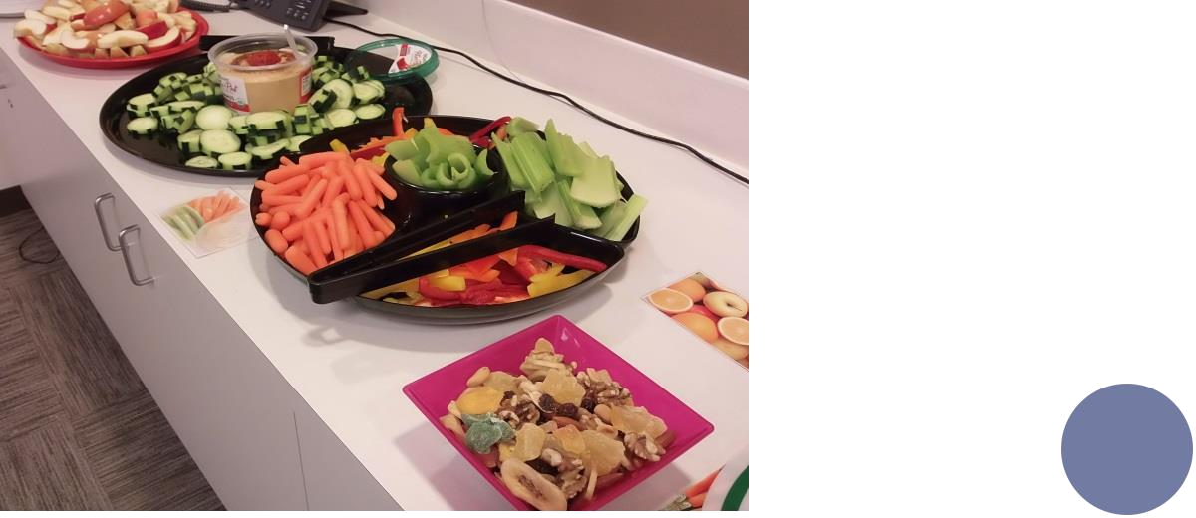

11

LUNCH

Healthy lunch meal ideas:

- Baked potatoes with low-fat or vegetable toppings instead or butter, sour cream, cheese and bacon.

  - Try using broccoli, tomatoes, and chives

  - Choose reduced-fat cheese and light sour cream

- Offer broth-based soups with lots of vegetables instead of cream-based soups that can be high in calories and fat.

  - Try using skim milk of vegetable puree to make soups thicker and creamier

- Offer sandwiches served on whole grain bread instead of white bread.

  - Provide lots of health sandwich toppings like lettuce, tomato slices, cucumber slices, onions, and grated carrots

  - Try using avocado instead of mayonnaise.

  - Offer whole grain bagels or rolls instead of white bagels, rolls or croissants.

    - Offer mini bagels or sandwich thins instead of the regular size

  - For dessert offer items that are lower in fat and calories. Some examples include:

    - Low fat frozen yogurt, sherbet or sorbet instead of ice cream

    - Fresh fruit instead of pie, cheesecake, cream puffs or cookies

    - Angel food cake with fruit topping instead of regular cake with frosting

    - Oatmeal cookies with dried fruit instead of regular cookies.

    - Whole grain fruit muffins instead of cupcakes

    - Greek yogurt with sliced strawberries, honey, and cinnamon

12

AFTERNOON SNACKS

- Vegetable Tray with Dip

  - Carrots, cherry tomatoes, broccoli, cauliflower, bell peppers, cucumbers, celery, jicama, etc.

  - Some healthy dip options include: hummus, white bean dip, or low-fat ranch.

- Trail Mix

  - Unsalted nuts (almonds, peanuts, cashews, walnuts, sunflower seeds, etc.)

  - Mini Pretzels

  - Raisins

  - Chocolate Chips or Candy coated chocolate (M&Ms)

  - Popcorn

  - Cereal with whole grains, such as Oatmeal Squares or Wheat Chex

  - Dried fruit

- Granola Bars

  - Choose one that has protein and does not contain a lot of added sugar.

- Popcorn

  - Make your own air-popped popcorn and season it yourself for a more healthy option! See the “Recipe Ideas” section

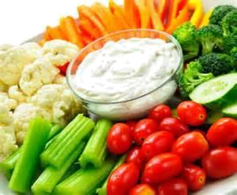

○

○

○

○

○

Reduced-fat string cheese

Cheese and crackers

Hummus with veggies and crackers

Celery with peanut butter

Apples with peanut butter

- Assorted nuts

  Salsa and tortilla chips |  | 13
 | Guacamole and tortilla chips | 13
○ | Guacamole and tortilla chips
○ | Fruit tray with assorted fruits


DESSERT

- Frozen Yogurt bar with assorted toppings

  - Fruit is a great choice!

- Angel Food Cake with strawberries or other fruit

- Sherbet/Sorbet

- Small portions of cakes/cookies

  - Oatmeal cookies with dried fruit may be a good option

  - Whole grain fruit muffins instead of cupcakes

- Fresh fruit pie in place of cheesecake or cream puffs

- Fruit and graham crackers with a sweet dip

  - For an easy sweet dip recipe, go to the “Recipe Ideas” section for the recipe for a Nutella Yogurt Fruit Dip.

- Fruit Popsicles

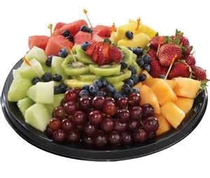

14


BEVERAGES

- Spa water – Add fruit to water to add a little extra flavor without all the sugar. Below are some great options. For a pdf with tips go to (copy/paste to web browser):

  - Orange and lime slices

  - Strawberries

  - Lemon and cucumber slices

  - Lemon and lime slices

  - Lemon and orange slices

  - Orange slices and cranberries

  - Apple slices, cinnamon, orange slices, and cranberries (heat this one when you are preparing to increase the flavor)

- For people who really enjoy carbonated beverages, add a little fruit or 100% fruit juice to sparkling water. This cuts down on calories and added sugars.

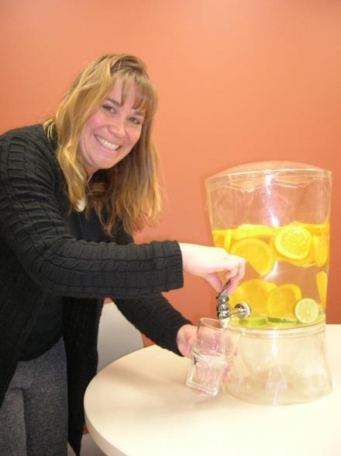

○

○

○

○

Low-fat (1%) or nonfat milk

Try alternative milk products like rice milk, soy milk, or almond milk. Coffee or tea

100% fruit or vegetable juices

15

CATERING

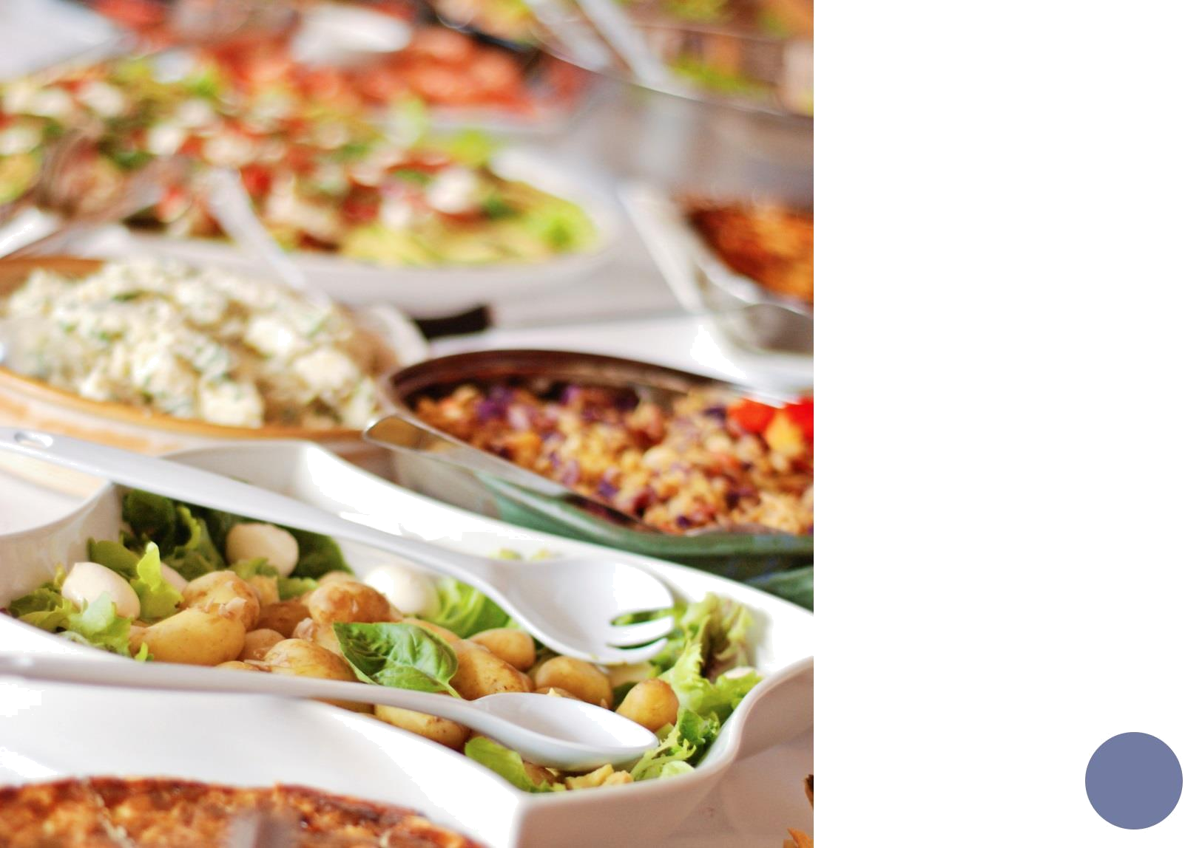

16

CATERING

A resource for locating healthier meal items for pick-up or delivery is the Healthy Dining Finder tool, available at:

Other steps you can take to make catered or delivered meals healthier:

- Ask for items that have been prepared using lower-fat or fat-free preparation methods, such as baked, broiled, steamed, sautéed or grilled.

- Ask for dressings or condiments to be served on the side.

- Select whole grains when possible. This includes choosing whole-wheat bread, bagels, and English muffins instead of enriched varieties (i.e. white bread), brown rice instead of white rice, and corn or whole-wheat tortillas instead of white flour tortillas.

- When possible, ask the caterer to display the number of calories and fat grams in entrees. If your meal is delivered from a restaurant, check their website for nutrition information prior to ordering.

- Ask for fresh fruit such as apples, bananas, or a fruit salad to be served with the meal.

- Include at least one vegetable: raw or cooked, made without added butter or cream sauces.

- Choose lower-fat or lower-calorie desserts. (see page 17 for ideas).

- If ordering boxed lunches, request fruit, green salads, and/or baked chips as sides rather than the typical chips and cookies in each box.

Health inspection information for restaurants can be obtained on TCHD’s website to help inform your selection of
caterers: |  | 17
POTLUCKS

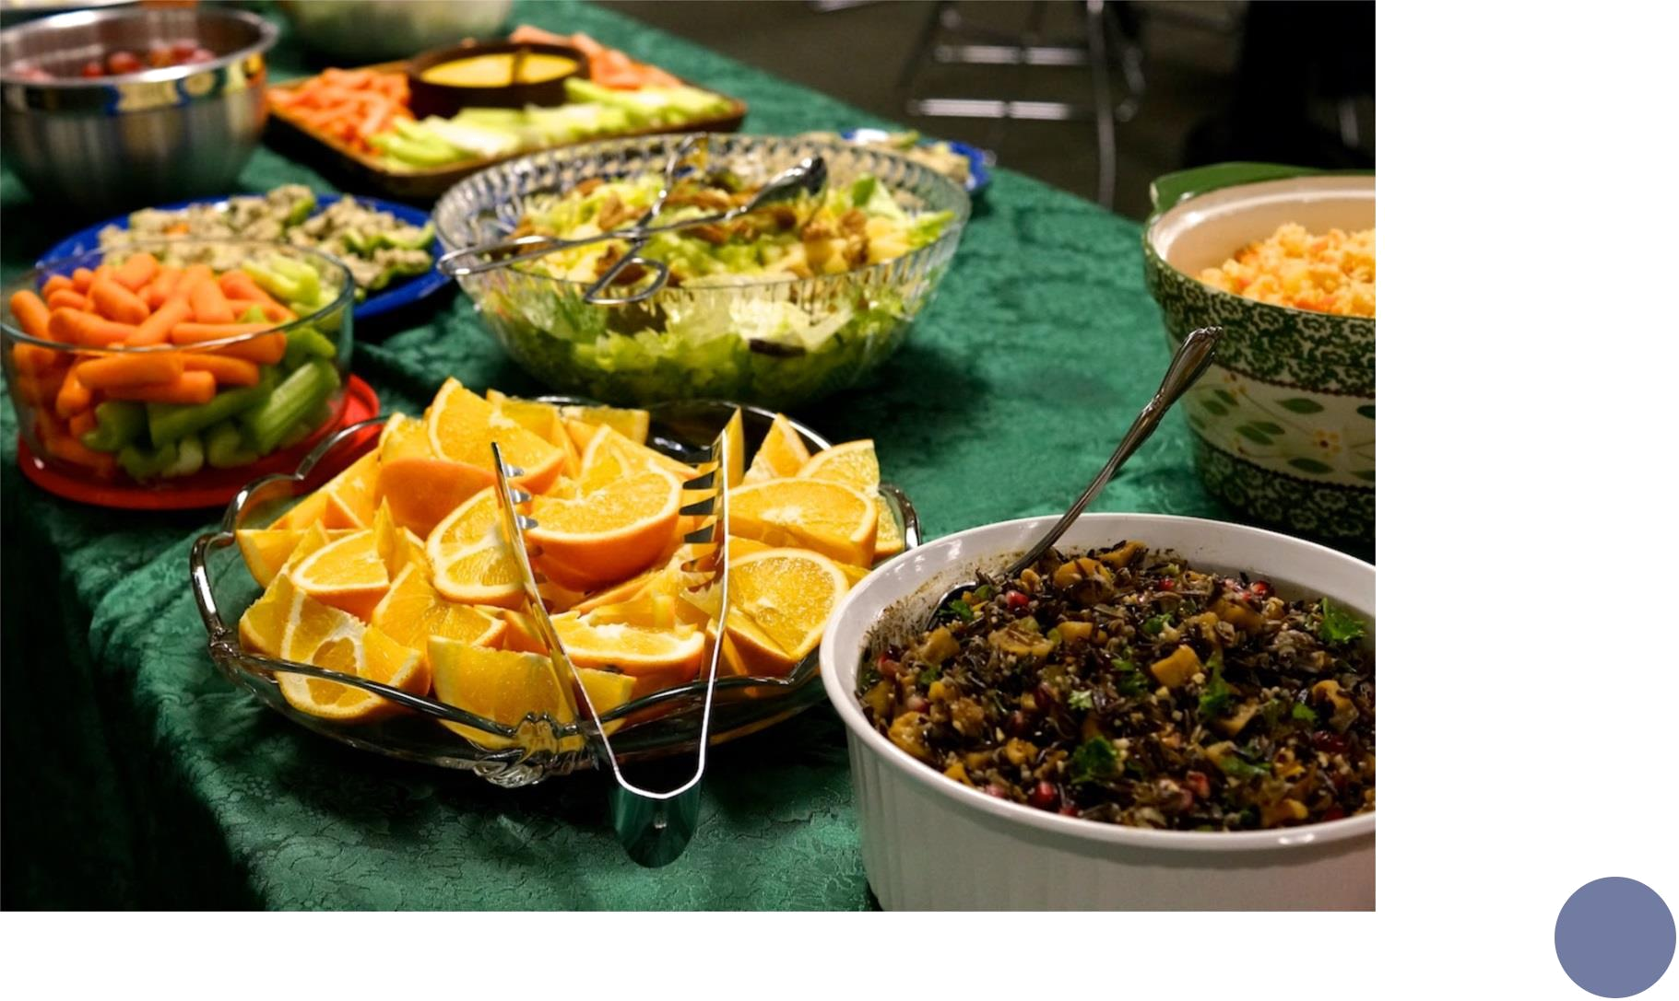

18

POTLUCKS

Potlucks are a simple and inexpensive way to provide nutritious food during meetings and employee luncheons. Some ideas include breakfast potlucks, smoothie potlucks and salad potlucks. Examples of sign-up sheets are provided below and on the following pages.


Breakfast Potluck

Date:

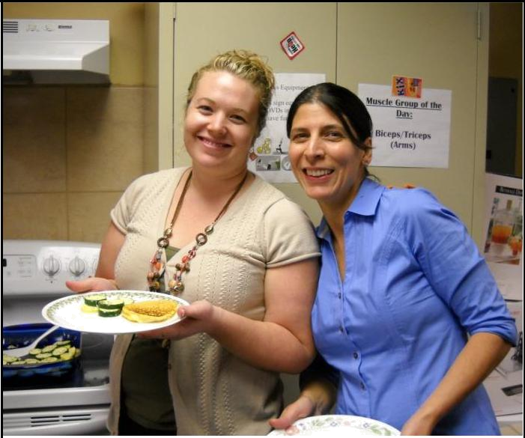
Time:

Name | Item - Choose or write-in something else
 | Yogurt and Milk
 | Yogurt - 16 oz container - Plain
 | Yogurt - 16 oz container - Flavored
 | Dairy free yogurt
 | Lowfat Milk
 | Soy Milk
 | Fruit
 | Berries
 | Bananas
 | Pineapple
 | Oranges
 | Cereal, Bread and Spreads
 | Granola or Other Whole Grain Cereal
 | Whole Grain Cereal
 | Flax seeds
 | Nuts, seeds, etc.
 | Whole Grain Bread or English Muffins | 19
 | Almond Butter
 | Peanut Butter
POTLUCKS

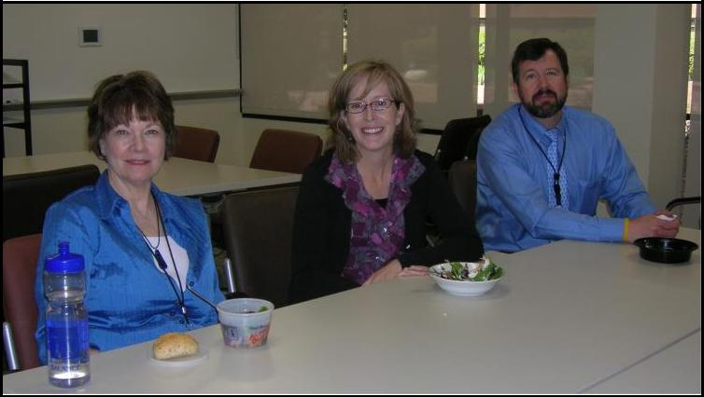

Sign-up Sheet Example:


Salad Potluck

Date:

Time:

Name | Item - Choose or write-in something else
 | Bag of greens
 | Bag of greens
 | Hard cooked eggs
 | Cherry tomatoes
 | Cucumbers
 | Snap peas
 | Spinach
 | Garbanzo beans
 | Shredded cheese
 | Lean cooked meat or poultry
 | Shredded Cabbage
 | Unsalted Nuts (walnuts, almonds)
 | Mushrooms
 | Mandarin oranges
 | Berries
 | Beets
 | Cottage cheese
 | Black & green olives
 | Black Beans | 20
 | Whole grain bread or rolls
 | Butter or nontransfat substitute

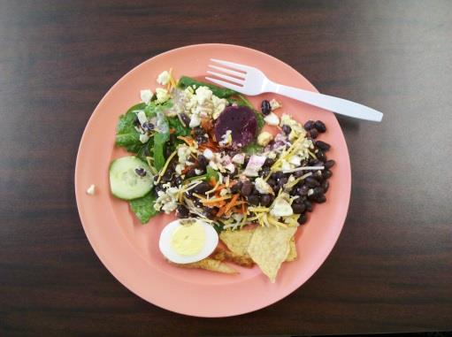
POTLUCKS

Sign-up Sheet Example:


Smoothie Potluck

Date:
Time:
Name | Item - Choose or write-in something else
 | Essentials:
 | Blender
 | Blender
 | Ice
 | Yogurt (Lowfat 16 oz. container):
 | Plain
 | Flavored
 | Fruit and Vegies (fresh or frozen)
 | Frozen or fresh berries
 | Apples
 | Peaches
 | Bananas
 | Carrots
 | Spinach
 | Liquids:
 | Apple Juice
 | Lowfat milk
 | Soy milk
 | Chocolate Almond Milk
 | Other Ingredients
 | Flax Seeds | 21
 | Honey

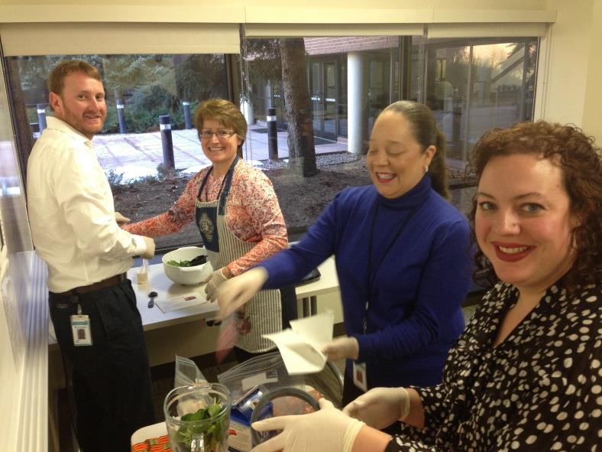
RECIPES AND SHOPPING TIPS

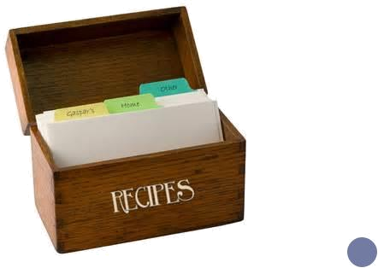

22


Refer to Tri-County’s Pinterest Page for more great recipes
RECIPES

Egg Casserole:

- Recipezaar (copy/paste to web browser)

Ingredients:

- 16 ounces frozen hash brown potatoes

- ½ pound cooked ham, cubed

- ½ onion, chopped

- ½ green bell pepper, chopped

- ½ tablespoon olive oil

- ¾ cup cheddar cheese, shredded

- 6 eggs

- ½ cup milk

- ¼ teaspoon salt

- ¼ teaspoon pepper

Directions:

1.

2.

3.

4.

5.

6.

7.

Spray inside of a slow cooker with nonstick spray.

In a small skillet, cook onion and green pepper in olive oil until crisp tender. Let cool about 10 minutes.

Place frozen hash browns in the slow cooker.

Add ham, onion, green pepper and cheese. Repeat layers, ending with the cheese.

In a large bowl, beat the eggs, milk and seasonings until well mixed.
Pour over the ingredients in the slow cooker, cover and turn on low. ₂₃ Cook for 5-6 hours, until casserole is set and eggs are thoroughly cooked.

RECIPES
Directions:

Banana Muffin – Made with Applesauce:

(Copy/paste to web browser)

Ingredients:

- 1 ¾ cups flour

- ½ cup sugar

- 1 teaspoon baking powder

- ½ teaspoon baking soda

- ½ teaspoon cinnamon

- ½ teaspoon nutmeg

- ½ teaspoon salt

- 2 eggs

- 1 cup banana, mashed

- ½ cup applesauce

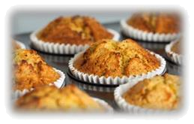

- Preheat oven to 350 degrees.

- Spray a 12-cup muffin pan with non-stick cooking spray.

- Combine the dry ingredients and mix well. In a separate bowl, mix all the wet ingredients. Add together and mix well.

- Pour into muffin tin.

- Bake for 15-20 minutes.

24

RECIPES

Slow Cooker Oatmeal

Ingredients:

- 1 cup steel cut or regular oats (NOT quick oats)

- 2 cups skim milk or soy milk

- 3 cups water

Directions:

- Coat the slow cooker bowl with nonstick cooking spray.

- Combine oats, milk, and water in the bowl.

- Cover and cook for 4 ½ to 5 hours on low (longer if using steel cut oats).

- Makes 5 servings. Recipe can be doubled.

Tip: Don’t want to wake up in the

Middle of the night to start your slow cooker? Plug it into an on/off light timer and set it to turn on later.

Popcorn:

Ingredients:

- 1/3 cup popcorn kernels

Directions:

- Add kernels to a microwave-safe bowl. Place a vented lid on top.

- Microwave for 3-4 minutes, until 1-2 seconds between pops.

Nutella Yogurt Fruit Dip:

Ingredients:

 | 1 cup plain, nonfat Greek yogurt
 | ½ cup Nutella
Directions: |  | 25

- Mix the yogurt and Nutella together in a small bowl until completely combined.

- Refrigerate until ready to use

3. Makes 10 servings. | References are available upon request.

RECIPES

Easy Black Bean Salsa Dip:

Ingredients:

- 1 can (16 oz.) black beans, drained and rinsed

- 1 cup salsa

Directions:

- Combine black beans and salsa in blender or food processor.

- Blend until smooth and transfer to serving dish. Garnish with fresh cilantro if desired.

- Refrigerate until ready to use. Serve with fresh vegetables or crackers. Makes 12-16 servings.

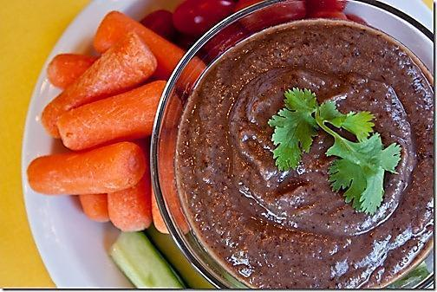

26


SHOPPING TIPS – PRODUCE

- Purchase fresh fruits and vegetables in season. This can be a great money saver.

  - Don’t be afraid to ask a grocery store employee to help make your selections!

- Read the labels!

  - Select frozen and canned products that say “packed in own juices”, “packed in water”, “unsweetened”, “no added sugars”, “no salt added”, or “reduced sodium”.

- Compare prices. Pre-cut and pre-portioned foods are convenient but are often more costly.

Should I buy fresh, frozen or canned? Let’s think through the pros and cons!

Fresh Frozen

o

o

o

o

May spoil quickly • Picked and processed at their peak flavor

Buy in season when prices are cheaper • Often pre-chopped for fast preparation

Heat and light may destroy some nutrients • Look out for added sauces, salt, and sugar

No need to worry about added salts or sugars

Canned - Rinse fruit or vegetable under cool water in a strainer before cooking to remove sodium/sugar

○ Portable and quick •Make sure cans have no bulges or leaks

○ Refrigerate after opening • Watch for added sodium and sugar

Here are some helpful links when it comes to choosing fruits and vegetables: (copy/paste to web browser)

- List of what’s in season with nutrition information and storage tips:
27
  Smart Shopping for Veggies and Fruit 10 Tips for Affordable Vegetables and Fruit:

ALLERGENS

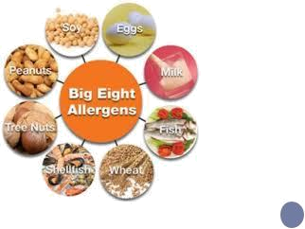

28

ALLERGIES AND OTHER DIETARY CONSIDERATIONS

- Gluten-free options

  - Use quinoa or rice instead of wheat pasta in pasta salad dishes. You can also buy gluten-free pasta, such as quinoa pasta or rice pasta.

  - Choose corn tortillas instead of wheat flour tortillas.

  - Offer baked goods that substitute rice flour for wheat flour.

  - Fruits, vegetables, and many dairy and protein foods are naturally gluten-free

- Milk allergy or Lactose Intolerance

  - Offer soy milk, rice milk, almond milk, coconut milk, or hemp milk.

  - Offer vinaigrettes, oil-based dressings, or lemon juice instead of ranch, Caesar or blue cheese dressings.

  - Offer broth-based soups instead of cream-based soups.

  - Offer hummus dip or guacamole instead of ranch dressing for veggies.

- Nut Allergies

  - Offer SunButter instead of peanut butter.

  - If any products contain nuts, be sure to clearly identify these for meeting attendees.

- Vegetarian

  - Meat alternatives include:

    - Beans, tofu, hummus, cheese, hard-boiled eggs, or nut butters

- Vegan

  - Offer plenty of fruits, vegetables, nuts, beans, tofu, hummus, and whole grains.

If possible, ask meeting attendees in advance if they have and special dietary requirements. The Registered Dietitians in your office can help with questions about foods to meet different dietary needs.

29


FOOD SAFETY AND SANITATION

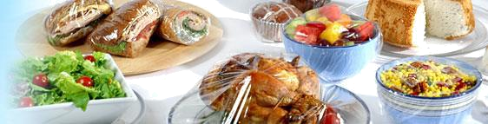

30

FOOD SAFETY

- Shopping
  - Shop for refrigerated and frozen foods last.
  - Check containers for dents, bulges, leaks, etc.
  - Check “sell by” and “best if used by” dates.
    - Sell by - Tells the store how long to display the product for sale; purchase before the date listed.
    - Best if used by-this is the “freshness date” or the date that is recommended for best flavor or quality.

    - Use by-“last date recommended for the use of the product” while at peak quality; this date is determined by the manufacturer of the product.

- Storage
  - Refrigerate or freeze perishable items promptly.
  - Store frozen foods in airtight containers.
  - Keep freezer temperatures at or below 0°F.
  - Keep refrigerator temperatures at or below 40°F.
  - For potentially hazardous cold foods, keep on ice to help maintain temperature.

- Preparation
  - Wash hands and surfaces often.

  - Keep containers, cutting boards and utensils clean; wash dishes in hot, soapy water and then sanitize either in the dishwasher or with a bleach solution.

    - Bleach solution: 1/4 tsp. bleach and 2 cups water in a spray bottle.
      - Wear rubber gloves when using.
  - Use different cutting boards for raw meats and produce.
  - Wash and sanitize the cutting board in between items.

- Hand-Washing
  - Wash your hands before handling any food.
  - Hand-washing basics
    - Use warm running water and soap.
    - Rub your hands together for at least 20 seconds.
    - Scrub the backs, fronts, fingernails and between fingers.
    - Rinse and dry.
○ | Use a paper towel to open doors after hand-washing. | 31
   When to wash your hands during food preparation:
  Before, during and after you prepare food.
○ | Before you eat.

FOOD SAFETY

- Cooking

  - Use a food thermometer to make sure food is safe to eat.

  - Place the thermometer in the thickest part of the food, away from bones.

  - Wash the food thermometer with hot, soapy water after each use.

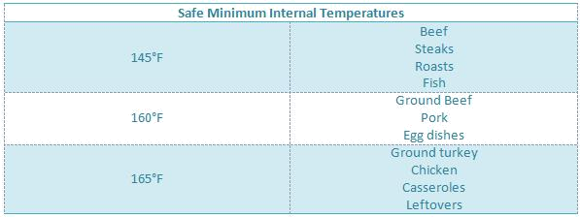

- Knife Safety

  - Tuck your fingers toward the palm of the hand that his using the knife.

  - Lead with the tip of the knife.

  - Cut through the food with one motion—do not saw.

  - Cut round foods in half first so they have a flat surface to lie on.

  - Don’t move while cutting.

32
FOOD SAFETY

- Using Leftovers

  - Buy ingredients that can be included in a variety of meals and snacks.

  - Plan to use leftovers as part of another meal within a day or two.

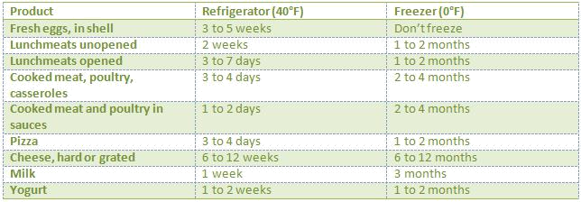

- Freeze leftovers if you plan to use them much later

  - Freeze foods into an individual portion.

  - Label the package with the date.

  - Keep the freezer at 0° or lower to protect food quality.

- Thaw foods safely

  - In the refrigerator: Place food on the lowest shelf until it is no longer frozen; it will keep for 2 to 3 days.

  - Cold water: Submerge the food, packed in an air tight container in cold water. Change the water every 30 minutes so that the frozen item continues to thaw.

  - Cook foods defrosted in the microwave immediately after thawing because some of the food may start to cook in the
defrosting process. | 33

PLANNING/PURCHASING FOR LARGE GROUPS

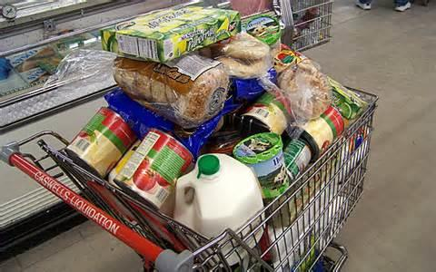

34

PLANNING/PURCHASING FOR LARGE GROUPS

Use this chart to determine the amount of food you may need to purchase to plan for your group.

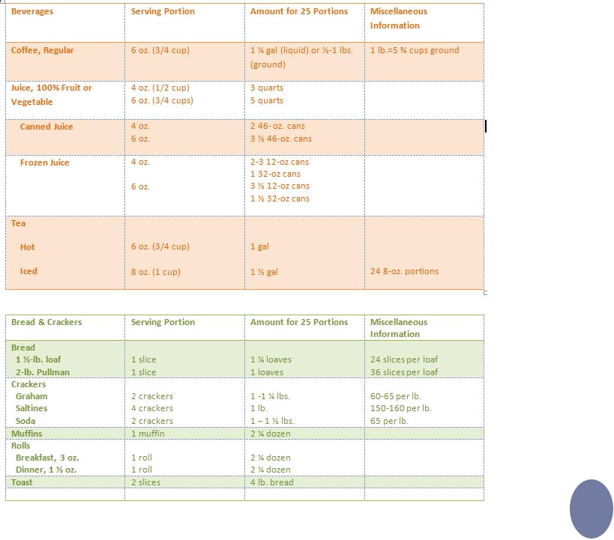

35

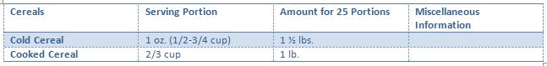

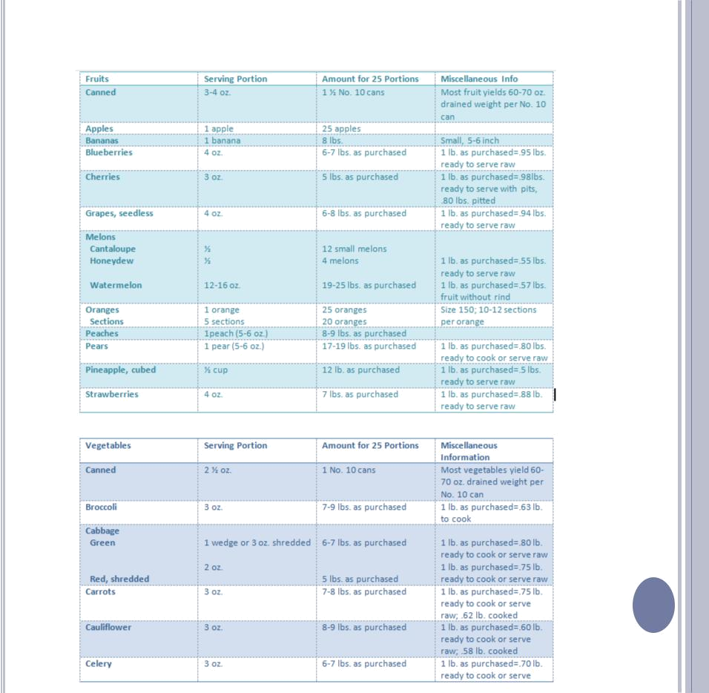

36
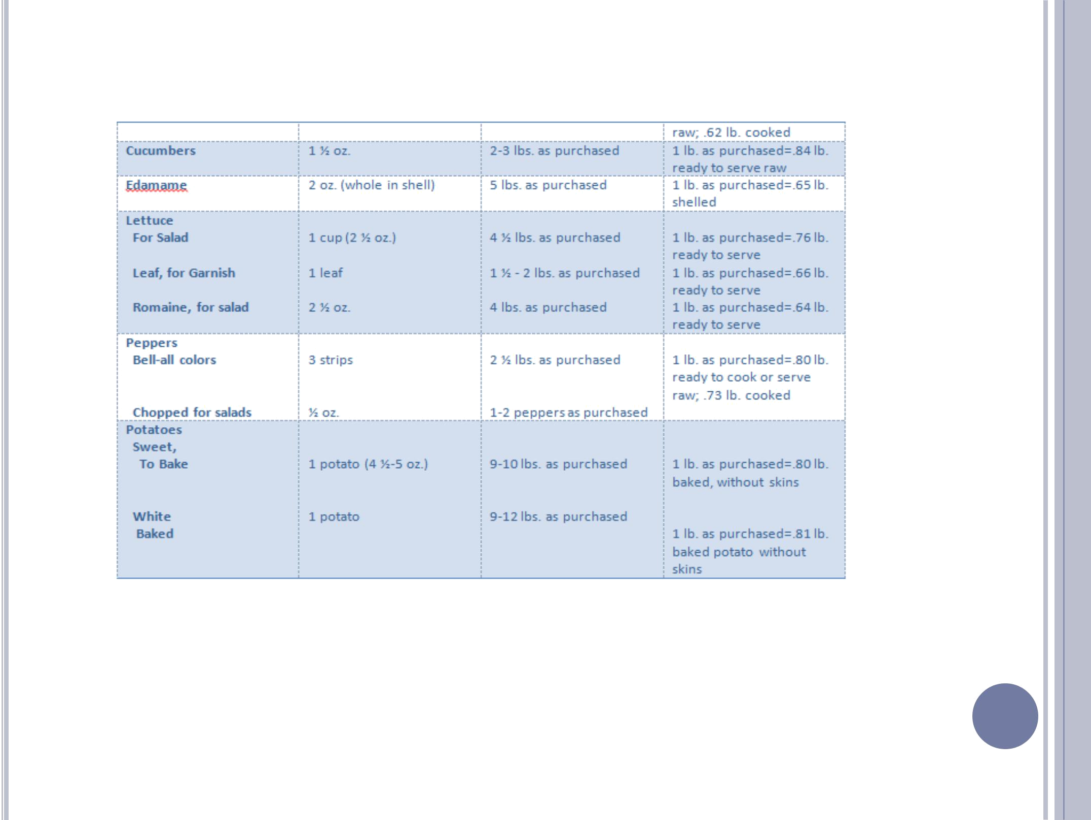

37
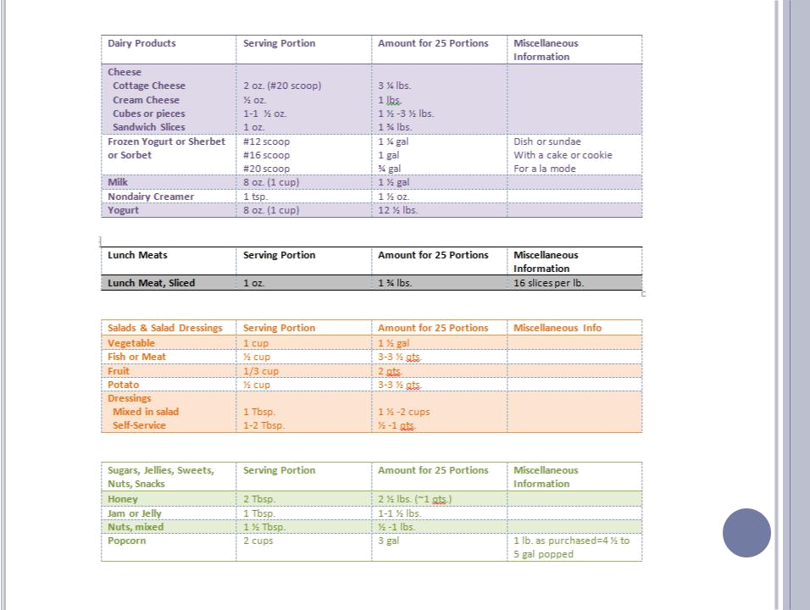

38

Source: Molt, M., Food for Fifty, 13th edition, 2011, Prentice Hall

