Today is

Subject |  |  | Level  1-5 | Assignment | Done | Teacher Comments
Reading 9:15-10:15  (Mrs. |  | )
Specials
10:15-11:15
Math  11:15-12:00  (Ms. |  | )
Spelling 12:00-12:20  (Mrs. |  | )
Lunch 12:30
Language 1:00-1:35  Ms. |  | )
1:35-2:00  Math ( | )
2:00 Recess
2:30-3:00
Writing/Science/Social Studies
(Mrs. )
3:00-3:30
Study Hall/AR Read/Finish Work
(Social Skills Wed.)

Parent signature

Parent comments: Date:

- should mark what level she is at in each area according to her number scale with 1 being doing well and 5 requiring teacher intervention.

Name:

My Day at School…
Date:

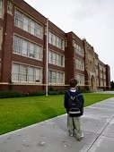

Room 4
Morning Work: | 1 | 2 | 3 | 4 | 5
Exercise: | 1 | 2 | 3 | 4 | 5
Sensory/Study Hall: | 1 | 2 | 3 | 4 | 5
O.T./P.T./Speech: | 1 | 2 | 3 | 4 | 5
General Education
Spelling: | 1 | 2 | 3 | 4 | 5
Reading: | 1 | 2 | 3 | 4 | 5
Recess: | 1 | 2 | 3 | 4 | 5
Math: | 1 | 2 | 3 | 4 | 5
Science: | 1 | 2 | 3 | 4 | 5

Lunch: I ate…  Great!  Most of my food.  I wasn’t hungry.

Specials

Art: | 1 | 2 | 3 | 4 | 5
P.E.: | 1 | 2 | 3 | 4 | 5
Music: | 1 | 2 | 3 | 4 | 5
Library/Tech: | 1 | 2 | 3 | 4 | 5

To make my day better, these are the things that I need:

  - Pull-ups  Wipes  Kleenex

Daily News Log

Day

My favorite Center today
Was:

Special
Activity

Behavior/Mood: | happy calm | quiet | silly cooperative
 | talkative | sad | non compliant

Bathroom
News:

Comments:

Teacher

    - Today I attempted to participate to circletime activities—such as body movement, imitation of YES SOMETIMES NO
    - I preferred to play alone today. I played well with others. YES/NO

    - During activity time/work station time I…

    - Today I enjoyed…

Teacher/Parent Positive Comments or Concerns:
16

Please initial each day so we know you have read this. Thanks!

Daily
Notes: Week of

Behaviors | Monday | Tuesday | Wednesday | Thursday | Friday
Crying
Tantrums
Bathroom
Eat Lunch

Monday:
Best Thing of the Day:

Challenge of the Day:

Tuesday:
Best Thing of the Day:

Challenge of the Day:

Wednesday;
Best Thing of the Day:

Challenge of the Day:

Thursday:
Best Thing of the Day:

Challenge of the Day:

Friday:
Best Thing of the Day:

Challenge of the Day:

Good Morning The date is

The day is: Monday Tuesday Wednesday Thursday Friday Special: Media C. Media C. PE Art Music
Points
Today’s Assignments |  | Check if  completed |  | Points  0 or 2
Clinic
Assignment 3
Assignment 4
Lunch with your class
Recess with your class
Specials with your class
Assignment 1
Assignment 2
SSR (20 Minutes)
Today’s Needs | Check if used |  | Points 1
9:15 restroom
10:40 restroom
11:50 restroom
12:50 restroom
2:00 restroom
snack/water | 1 2 3 4 5 |  | NA

Yesterday | Today | Total

With points, you can earn these privileges:

      - book buddies
      - study trips (there is a trip on Oct. 11)
      - variety of break activities
      - invite a pal to lunch or recess in room 24
      - peer totor
      - time with Mr. Maniakas
      - ?????? what would you like to add? 8) 9)

Your IEP allows these accommodations:
- small group testing
- preferential seating
- extended time
- access to food and drinks at all times
- flexible schedule for test and assignments
- choices
- breaks (paper/pencil drawing, reading, or rest)

You are responsible for:
- all 4th grade academic class work, assignments, and tests
- using acceptable strategies to manage stress, frustration, and anger
- passing ISTEP and earning passing grades (Needed to go to 5th grade)

Name:

Today is Monday,

Time/Location/Teacher |  | Activity | Comments
8:00 | Rm 53 | A.M. Procedures Morning Work
8:30  Mrs. Brown | Rm 24 | Math
9:15  Miss Brinson | Rm 24 | Language Arts
10:25-10:50  Mrs. Brown | Rm 23 | Reading
10:50 | Café | Lunch
11:25  4th Grade Teachers/ Mrs. Brown | Outside | Recess
12:00  Mrs. Brown |  | Media Center
1:00  Mrs. Brown | Rm 24 | Work
1:40  Miss Brinson/Mrs. Green | Rm 53 | Teacher Read Aloud, SSR  End of Day Procedures
 |  |  |  | Bus to JCC

Restroom:

Today I also had: Speech OT PT

Comments:

The best thing about today was: My day was a 5 4 3 2 1

Today is Monday

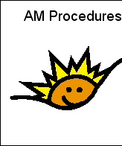 | 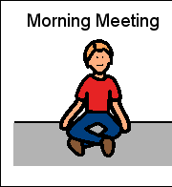 | 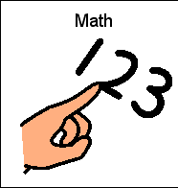
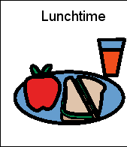 | 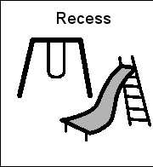 | 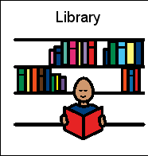 | 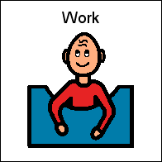
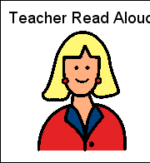 | 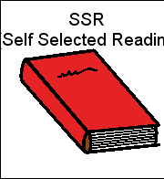 | 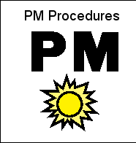 | 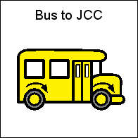

Restroom:

The best thing about today was:

My day was a 5 4 3 2 1

Day Month Date
Subject Assignments Date Due
Test Day


Reading
English/
Language Arts

Spelling

Math

Science

Social Studies


Things To Take Home Things To Bring To School

1.
2.
3.
4.
5.
1.
2.
Messages

↑ Students are given green (great), Yellow (ok), or red (needs improvement) days.

Student The week of

Monday | Today I was super at . I need to work on . Today I had a day because . I had Music, PE, Art, Library, Adaptive PE, OT, Speech, PT.
Tuesday | Today I was super at . I need to work on . Today I had a day because . I had Music, PE, Art, Library, Adaptive PE, OT, Speech, PT.
Wednesday | Today I was super at . I need to work on . Today I had a day because . I had Music, PE, Art, Library, Adaptive PE, OT, Speech, PT.

Behavior Checklist
Student:

↑Record the date and time of the observed behavior.
Write the location or activity during which the behavior was observed. Write a checkmark in the correct column.

Date & Time  Observed | Location and/or  Activity | Followed Directions | Kept Hands to Self | Did Work | Stayed in Seat

What I did at school today!
Name:

Date:

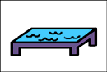
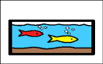
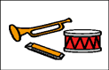
Books
Blocks
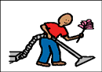
Housekeeping
Art
Sensory
Science
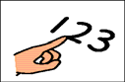 Math
Music
Computer
Other
Playground | Classroom | Gym |  | Gross Motor
My day was:  Good |  |  | Okay |  | Rough

Date

What I Did at School Today
Morning Work on own with prompts

Calendar on own with prompts

Morning Groups on own with prompts (check work in book bag)

Lunch ate well with prompts Recess
Story Time and Quiet Time quiet nap

Afternoon Group on own with prompts (check work in book bag)

Small Groups on own with prompts (language, fine motor, social)

Centers on own with prompts

Art Music PE Library Speech OT PT

Name: | Date:
During circle time we:  - Listened to a story  - Sang circle time songs  - Worked on vocabulary/or a concept with  Sally the Camel | Therapy:  - Speech with Miss Evers  - OT with Miss Amy  - PT with Miss Mary Beth  - VI with Miss Kelly
Today I had:  White Chocolate Strawberry | Bathroom:  - I went to the bathroom by myself.  - I went through the motions and sat on potty.  - My diaper/pull-up was dry/wet/BM.
Info:
Name: | Date:
During circle time we:  - Listened to a story  - Sang circle time songs  - Worked on vocabulary/or a concept with  Sally the Camel | Therapy:  - Speech with Miss Evers  - OT with Miss Amy  - PT with Miss Mary Beth  - VI with Miss Kelly
Today I had:  White Chocolate Strawberry | Bathroom:  - I went to the bathroom by myself.  - I went through the motions and sat on potty.  - My diaper/pull-up was dry/wet/BM.
Info:

