Daily Report

Name: Date:

Today I did a great job at:

I may need some help with:

Other comments:

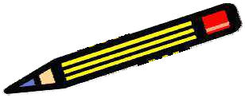Friday Folder

Date:
Teacher comments:

Parent comments:

Date:
Teacher comments:

Parent comments:

Date:
Teacher comments:

Parent comments:

Date:
Teacher comments:

Parent comments:

Behavior Report for Date

Times of Day | Followed Directions | Listened to Directions | Raised Hand before  Talking | Did not Argue with  Adults
Morning
Afternoon
Specials

Great = Fair = Unacceptable = Teacher Comment

Parent Comment

Parent Signature

Weekly Behavior Chart

Week of

 | Sat Correctly in Chair | Followed Directions | ↑ Listened with “5” While Others  Spoke | Participated | Earned Bonus  Points | Parent Initials
Monday
A.M.
P.M.
Specials
Total Points
Comments:
Tuesday
A.M.
P.M.
Specials
Total Points
Comments:
Wednesday
A.M.
P.M.
Specials
Total Points
Comments:
Thursday
A.M.
P.M.
Specials
Total Points
Comments:
Friday
A.M.
P.M.
Specials
Total Points
Comments:
Points for Week

Name
Date

Homework: Behavior:

Spelling Great (0-3 warnings) Reading Good (4-6 warnings) Math Fair (7-9 warnings) Science Poor (10+ warnings)
5

Social Studies

Comments:

English

Other
Wfiles/secretary share/cathy/handouts 6-2009

Parent Signature

(teacher initials)
(date)
- Brought assignment log & books to room 28
- Respected other people’s property
- Raised hand in order to participate
- Stayed in seat
- Kept hands to self
X = No
 = YES!

Date:

Did I… A.M. P.M.
Follow Directions
Complete My Work w/Good Work
Habits
Use My Manners
Respect My Friends
Have Good Restroom Breaks
Have Good Cafeteria Behavior
Do a Good Job in Specials

My color for today was:
GREEN | Reason:
YELLOW | Reason:
RED | Reason:

Positive Points:

Homework:

SIGN & RETURN

Comments:

Homework Check List Week:
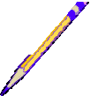Fill-in your assignments below. Check them off as they are completed.

Math | Reading
Mon.  | Mon. 
Tues.  Wed.  Thurs.  Fri.  | Tues.  Wed.  Thurs.  Fri. 
Science | Writing
Mon.  | Mon. 
Tues.  Wed.  Thurs.  Fri.  | Tues.  Wed.  Thurs.  Fri. 
Social Studies | Other
Mon.  | Mon. 
Tues.  Wed.  Thurs.  Fri.  | Tues.  Wed.  Thurs.  Fri. 

Positive Behaviors
Name:

Date:

Goal or Rule  (List Below) |  | ☺ | ☹
 | A.M.
 | P.M.
 | A.M.
 | P.M.
 | A.M.
 | P.M.
 | A.M.
 | P.M.
 | A.M.
 | P.M.
Totals for the Day: Student Comments:

Today is
Day Month Date

Subject | Assignment | Due
Reading |  | - Complete
Math |  | - Complete
SSR |  | - Complete
Language |  | - Complete
Social Studies |  | - Complete
Science |  | - Complete
Spelling |  | - Complete

Behavior Marks:
Teacher Messages: | Parent Messages/Signature:

Schedule: |  |  |  | Color System:
9:10-10:10 | Specials | 12:45-1:30 | Language | Green = Great | Blue = Call home
10:15-11:00 | Reading | 1:35-1:55 | Recess | Yellow = Warning | Red = Room 25/TO
11:00-11:45 | Math | 2:00-2:45 | Social Studies | Brown = 5 min. off recess | Black = Principal
11:45-12:05 | SSR | 2:50-3:35 | Science | Pink = 10 min. off recess
12:05-12:40 | Lunch | 3:35-3:45 | Pack up/Dismissal | Orange = Missed recess

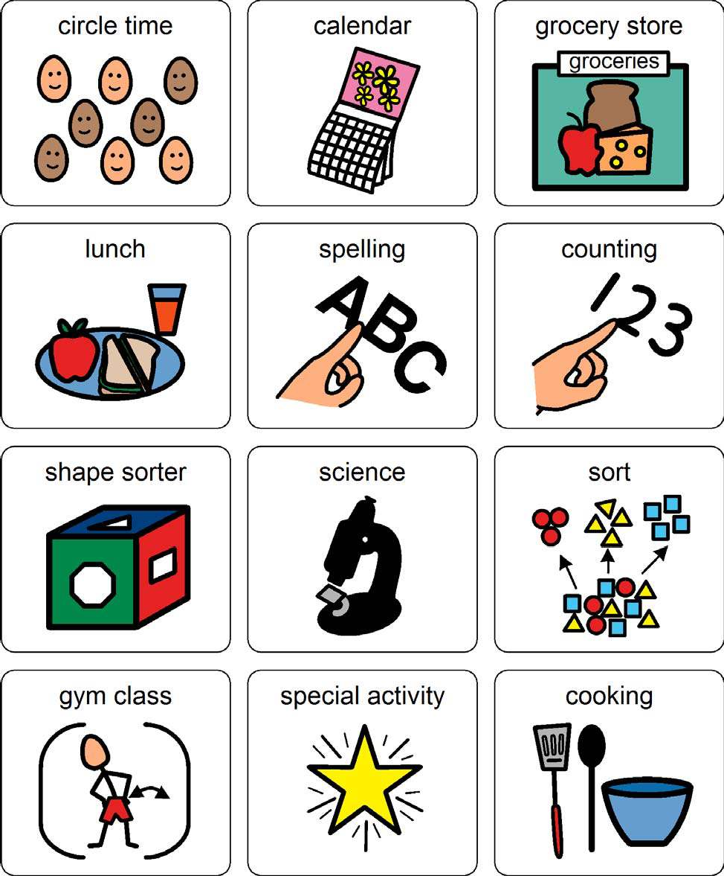
Today at School

Travel Card

Student Name:

Date

Key | + = Yes | 0 = No | NA = Not Applicable

 | Did student  follow class rules? | Did student participate in  class? | Did student  complete assignments? | Did student  turn in homework? | Teacher’s initials
Reading
Science
Social Studies
Study Skills
English
Spanish

Bonus Points |  |  | Has assignment  book?

Total | + | 0

Teacher Comments/Suggestions/Announcements:

