

Surgeon

**JOHN** DOE

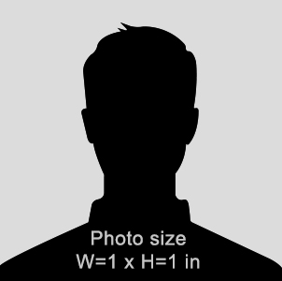

**CODE**

0892536437

01-12-1989

**DATE OF BIRTH**

02-15-2019

**EXP DATE**



44 Shirley Ave. West Chicago, IL 60185

**COMPANY NAME**

