T-shirt Order Form

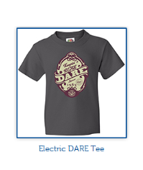
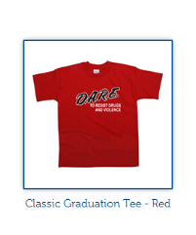
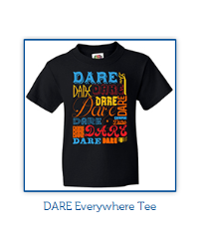

Adult Sizes $7 $8.50

DARE Everywhere: Small ____ Medium _____ Large _____ X-Large ____ 2XL ______ 3XL ______

Classic Graduation: Small ____ Medium _____ Large _____ X-Large ____ 2XL ______ 3XL ______

Electric DARE: Small ____ Medium _____ Large _____ X-Large ____ 2XL ______ 3XL ______

(Please indicate number of each size)
Prices include shipping and handling.

Total Enclosed $________________

HORRELL
STROUP/LAMB
___________________________________________ _____________________________
Student Name DARE Class Period #

Make checks payable to: LMTSD/Murray
Send orders to your student’s Social Studies teacher.
The sale ends Thursday, November 7th.

On a related note: You are invited to attend DARE Graduation, tentatively scheduled for Thursday, December 19, 2013 at 8:30 a.m. in the Murray Avenue School Cafeteria.

