School T-Shirt Order Form
Show your school spirit! Shirts are available in children and adult sizes.
Policy for wearing during school: Okay to wear instead of polo, but no layering, not able to wear on concert or field trip dates, and NWIS will occasionally announce spirit dates to encourage use of shirt.
$7 per shirt (50/50 Cotton/Poly Shrink Resistant)
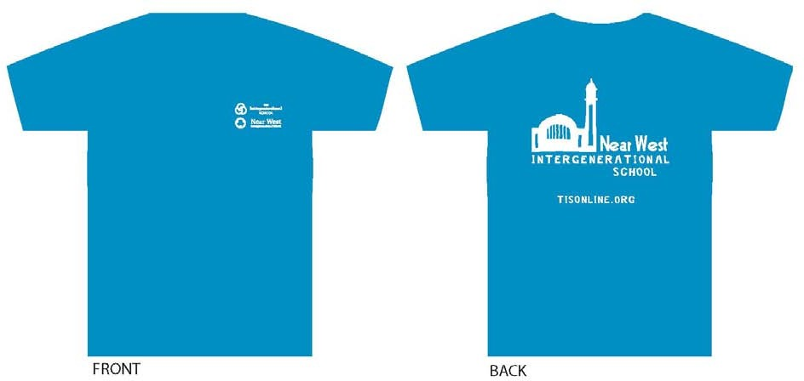
*Color will be Sapphire (more blue toned than seen here) *Design by Nancy Szilagyi, NWIS Teacher

Student Name

Homeroom *if more than 1 student, just use 1 form with oldest students name

Total Number of Shirts * $7 per shirt = $ Total Cost Due to Main Office

Size Selection (if more than 1 shirt, please put number of each size needed in blank):

CHILD SIZES: Extra Small Small Medium Large Extra Large

ADULT SIZES: Small Medium Large Extra Large 2XL 3XL

Parent Name/Signature

Please include payment in envelope for main office. Shirts will be ordered when full payment received. Order Dates: December 20th (ready after break) & January 10th (ready by end of January) Interested in an Intergenerational School (Eastside Campus) t-shirt? Contact Mr. McGarvey for order form.

