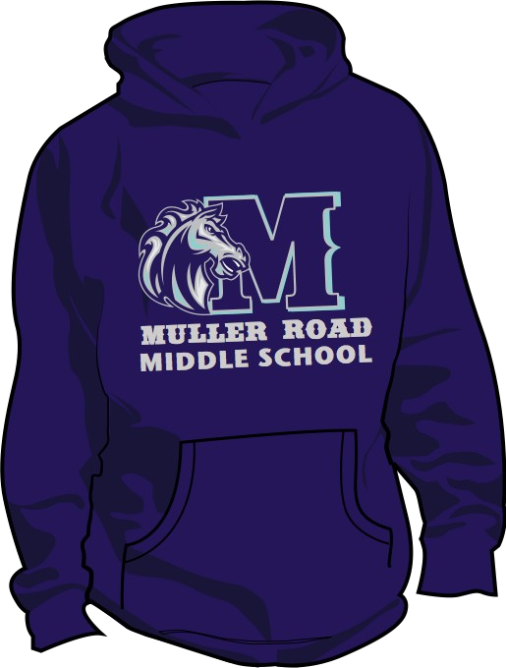T-Shirt Order Form

Student Name:

Homeroom Teacher/Room Number:

Parent name & email address: Contact Phone Numbers: Check #:

Note: All shirts have the same logo as the hoodie

Short Sleeve T-Shirt: $10 QTY: Please Circle Preference (Adult sizes only)

Pink | S | M | L | XL | 2XL
Navy | S | M | L | XL | 2XL

Hoodless Sweatshirt: $18 _{QTY:} Please Circle Preference (Adult sizes only)

Pink | S | M | L | XL | 2XL
Navy | S | M | L | XL | 2XL

Hoodie Sweatshirt: $20 _{QTY:} Please Circle Preference (Adult sizes only)
Navy S M L XL 2X

