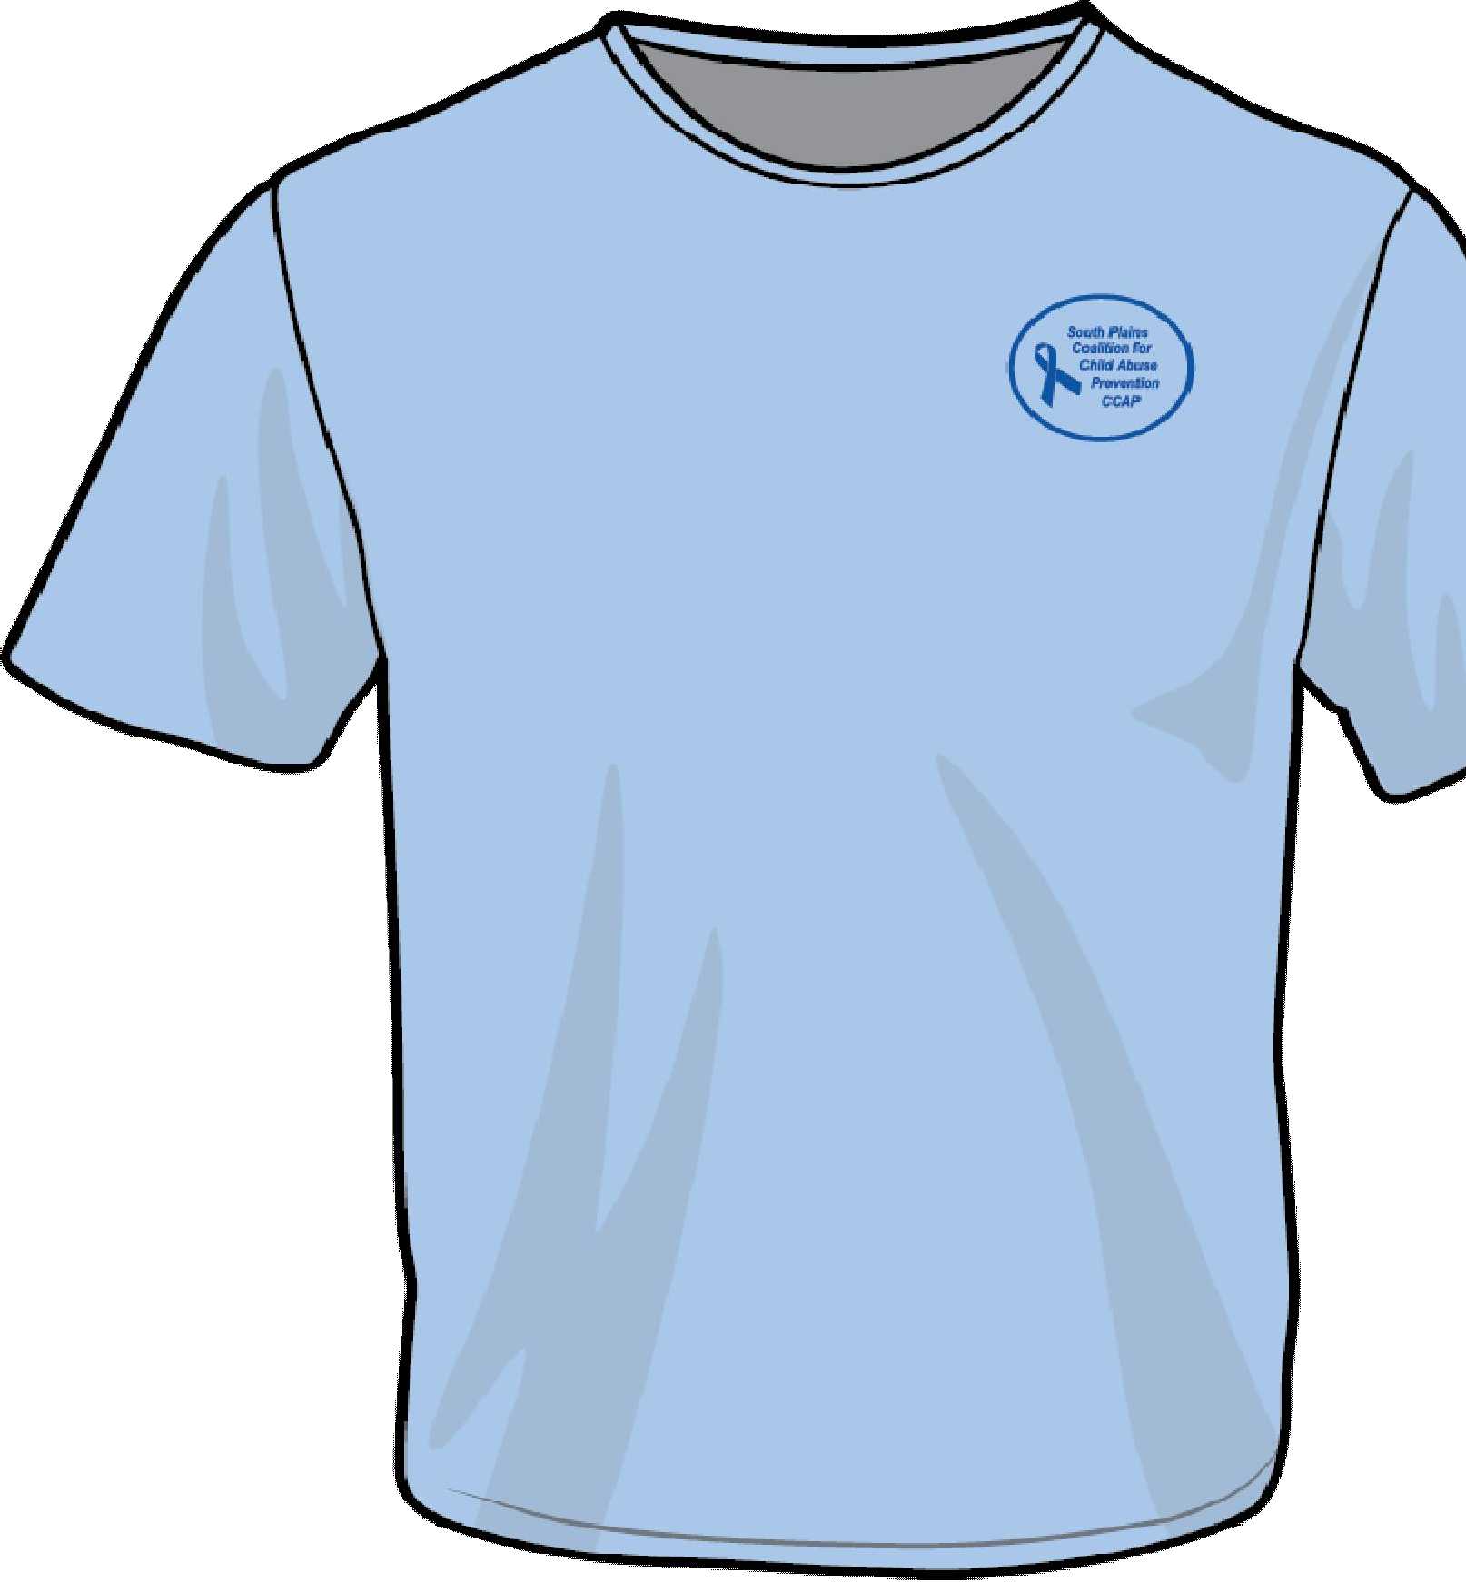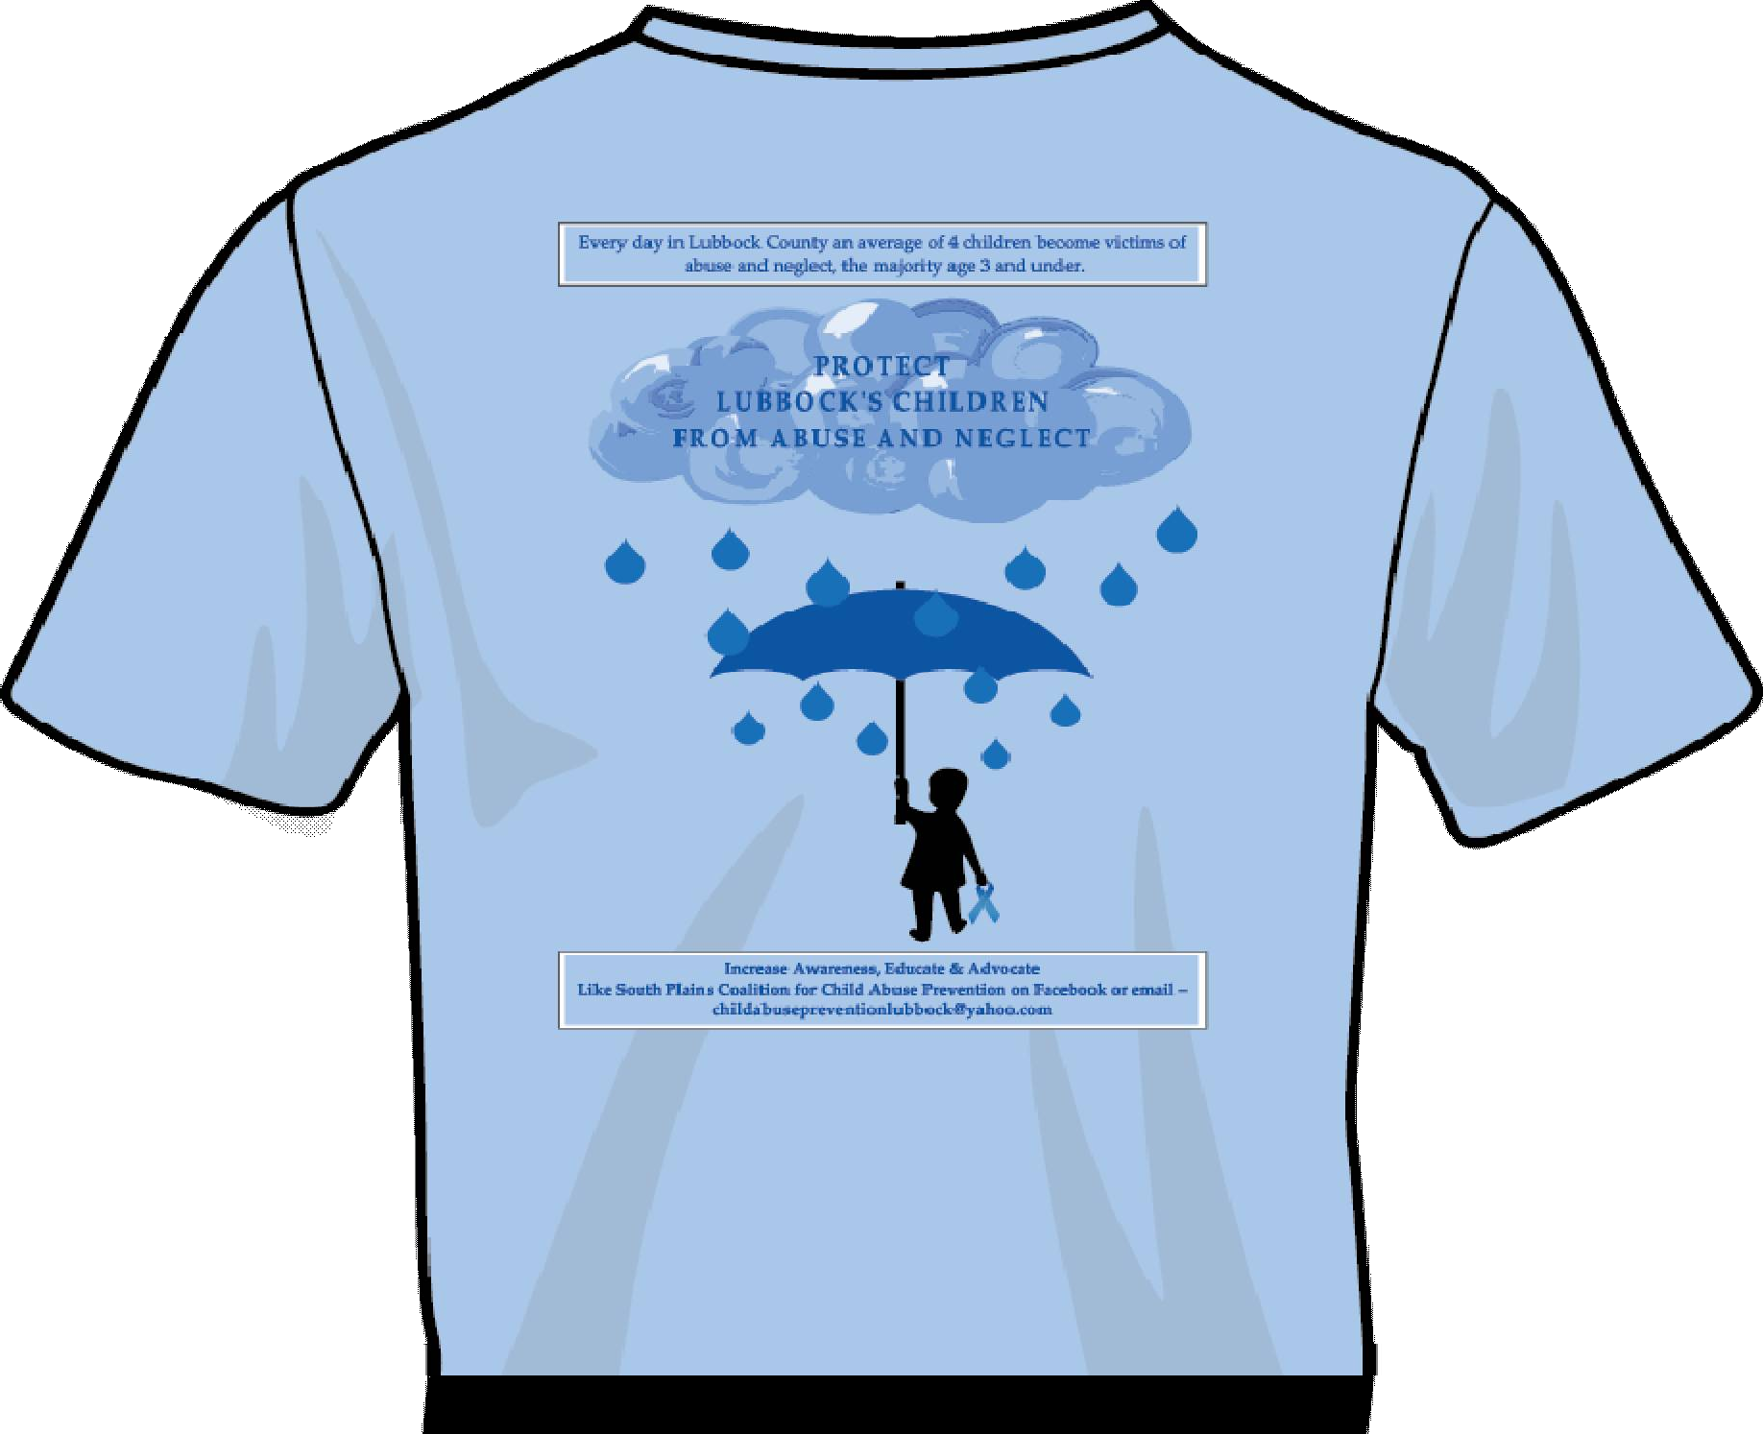 T-shirts Order Form
Youth Shirts

Deadline to order is March 20 ^{th} for shirts to be picked up at United Way on March 26 ^{th} .
Deadline to order is April 6 ^{th} for shirts to be picked up on April 9 ^{th} at United Way.

Date: Name: Company: Address:

Phone Number:

Email Address:

Payment Method: (circle one) Cash, MC, Visa, AMEX, Check, Cash

****If the shirts are paid for by individuals, then you will have to pay sales tax.****

*****Minimum order of 6 shirts per group*****
Adult Shirts
 | Small | Medium | Large | XL | 2XL | 3XL | Total # of Shirts
Cost per shirt NOT  including Sales Tax | $6.64 | $6.64 | $6.64 | $6.64 | $8.64 | $9.64 | $
 | Total Adult Cost

 | Medium | Large | Total # of shirts
Cost per shirt NOT including Sales  Tax | $6.64 $6.64 |  | $
 | Total Youth Cost

