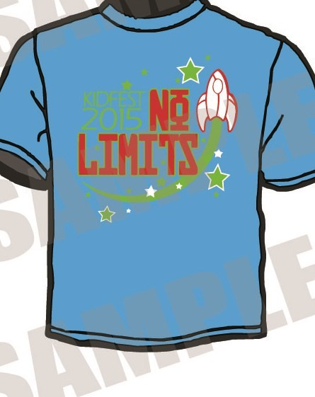Shirt Pre-Order Form

$10.00 each 2xl & 3xl — $12.00
Kidfest Location Attending:

Church Name:

Group Leader:

Phone: Email:

T-shirts: YXS YS YM YL AS AM AL AXL A2XL A3XL

Total Quantity T-Shirts: Payment Enclosed:

All pre-orders must be sent in to the Kidfest Office along with payment in order to be held.

