T-shirt Information and Team Pre-Order Form

- This year we would again prefer to collect the orders by team. This will make the sorting and distribution of the shirts easier and faster and we can ensure that all swimmers are able to get a shirt in their preferred size.
- Please submit one order per team with the number of shirts in each size.
- Individual checks are fine; however one team check is preferred. All checks should be made out to “Marlin Meet Management”.
- If you send a list of names and sizes, we will then provide the list back to you for easy distribution to the swimmers.
- T-Shirts are $22 each and are short sleeve. The shirt color will be Honey (a dusty sort of yellow) for all adult sizes and Gold (sort of golden rod colored) for the Youth sizes
- Mail order form with number of shirts in each size, swimmers names and checks to Terri Marlin, 3212 Allness Ln, Herndon, VA 20171
- All orders due by Sunday January 20 at 5:00. Email orders will be accepted as long as check immediately follows in the mail ☺

Depending on demand a second order may be placed after the meet; we do not guarantee that a second order will be placed. We strongly recommending ordering the shirts prior to the meet to ensure each swimmers receives one.

T-Shirt Order Form

Team Name: Coach on Deck: Email & Phone # of coach:

SHORT SLEEVE ($22 each)
Total # Youth Large Total # Adult Small
Total # Adult Medium Total # Adult Large Total # Adult X-Large Total # Adult XX-Large Total # Short Sleeve: # shirts X $22 = $

In addition if you send a list of names w/sizes, I will return the list with the shirts for easy distribution at the meet.

Order due to Terri Marlin by: 5:00 on Sunday June 20, 2019
You can mail individual checks or one check from the team. Each short sleeve shirt is $20, make checks payable to Marlin Meet Management and mail to Terri Marlin, 3212 Allness Ln, Herndon, VA 20171.

FRONT
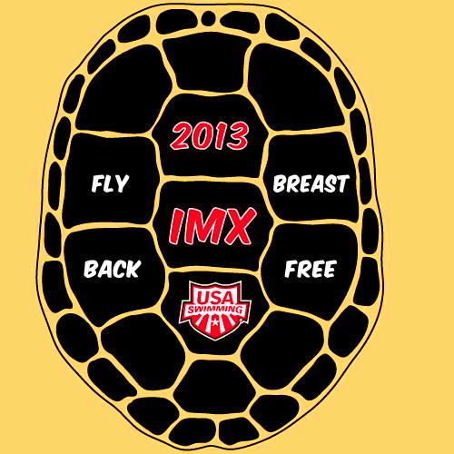

BACK

