T-Shirt Order Form

All shirts will have “Good grief!” (As shown below) in black on the front of the shirt and a small production logo on the sleeve in black. All shirts are available in white or yellow. The basic t-shirt is more of a yellow-gold color and the ladies styles are more of a canary yellow.
To order, just enter the number of shirts/items on the coordinating blank and total below.

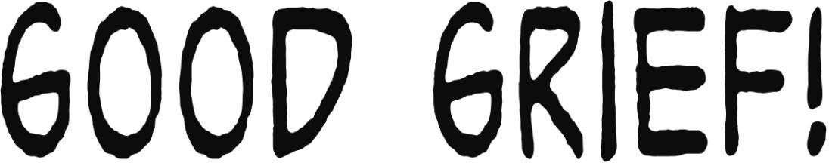
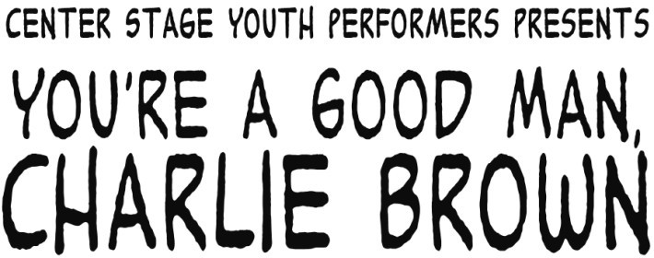
Large, in black, on the front: Small, in black, on the sleeve:

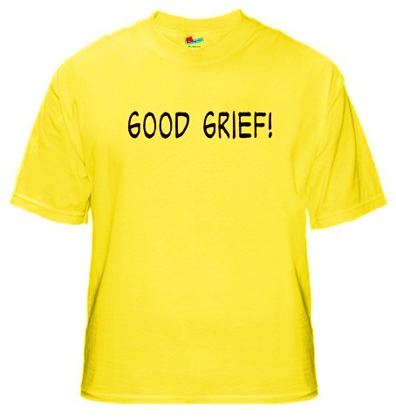
Basic T-Shirt (SHORT SLEEVE) — Cost $8.00 Please choose one: □ YELLOW □ WHITE

Adult S Adult M Adult L Adult XL Adult 2 XL
Youth XS Youth S Youth M Youth L Youth XL
(2-4) (6-8) (10-12) (14-16) (18-20)

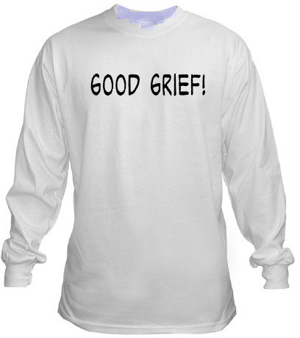
Basic T-Shirt (LONG SLEEVE) — Youth sizes cost $10.00, Adult sizes cost $12.00 Please choose one: □ YELLOW □ WHITE

Adult S Adult M Adult L Adult XL Adult 2 XL
Youth S Youth M Youth L Youth XL
(6-8) (10-12) (14-16) (18-20)

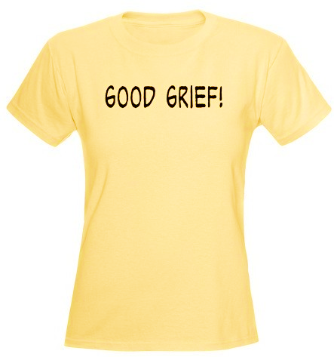
Ladies Fitted Shirt (SHORT SLEEVE) — Cost $10.00
This is a form fitting shirt. We recommend buying a size larger than you usually wear.
Please choose one: □ YELLOW □ WHITE

Adult S Adult M Adult L Adult XL Adult 2 XL
Youth S Youth M Youth L
(6-8) (10-12) (14-16)

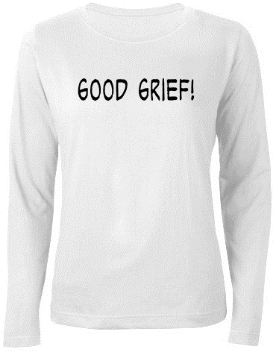
Ladies Fitted Shirt (LONG SLEEVE) — Cost $12.00
Sorry—only available in white and adult sizes. This is a form fitting shirt. We recommend buying a size larger than you usually wear.

Adult S Adult M Adult L Adult XL Adult 2 XL

Name: Phone #:
Total quantity ordered Total cost $
Please make checks payable to Pleasant Grove City. DUE FEB. 4.

