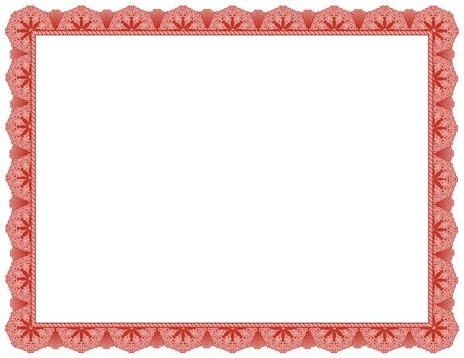

This certifies that on _________________

A very special teddy bear was born and adopted by:

___________________

Name given to bear: __________

Signed: ________

**Certificate of Adoption**