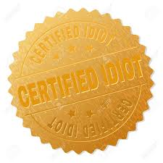

Organized under the laws of the state of
Insert Name of State

Insert Name of Corporation

This Certifies that [insert owner's name here] is the holder of [Insert # of shares owned] Shares of the [insert total # of shares issued] shares of the total stock issued by the above named Corporation.

This evidences [insert percentage of shares issued that you own here]% of the total shares of stock issued by the corporation.

In Witness Whereof, the said Corporation has caused this Certificate to be signed by the duly authorized officer this [insert date] day of [insert month] A.D. [insert year].

