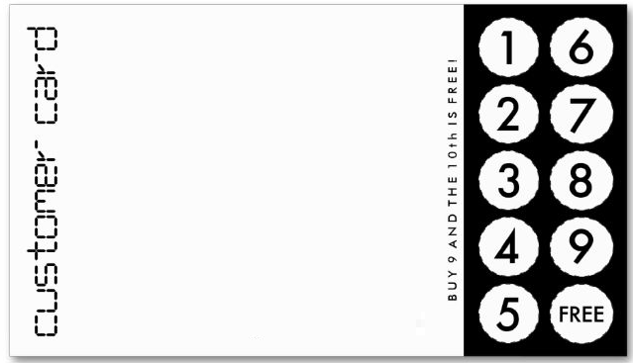

Phone

Address

Company Name

Insert Logo