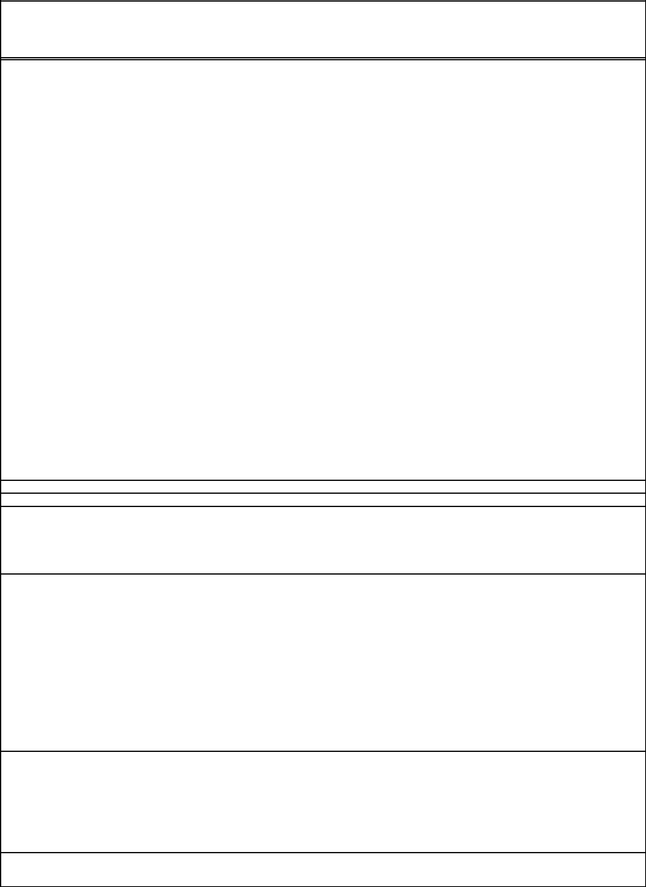
Community Service Completion Form

Complete section below and return to the Office of Financial Aid no more than two weeks after Community Service work is complete.
 | Student Name
 | Student WPI ID |  |  |  |  |  |  |  |  |  | Year: (ex 2019)
 | Company Name:
 | Company Address
 | Company Address
 | City, State Zip
 | Name of Supervisor
 | Title: |  |  |  |  | Phone ( |  | ) |  | -
 | Date(s) & Hours | Date | Date | Date | Date |  | Date | Date | Date |  | Date | Date | Date | Date | Date
 | Communtity Service
 | work was performed

Signature of Community Service Supervisor:

By signing this form you are indicating that the student listed above worked the hours listed at your

General description of work that was performed

By signing this form I understand that I will only be paid for a maximum of 15 hours of community service (unless I'm employed in a year long position designated by the SAO office). Any hours worked in community service beyond the 15 hours will be considered my own personal volunteer time given to the organization.

I also understand that if the completion form is not turned in within 2 weeks of the date of the work hours listed above I will not be paid for these hours and they will not be counted toward my 15 hours of community service. All hours must be completed by 5:00 pm est. on the last day of D term. Any hours completed after this will not be paid or count towards your required 15 hours of service. I also acknowledge that this form cannot be used to submit hours for the Relay for Life event there is a separate time sheet form specifically for that event. These forms must be submitted at the event ! Any forms turned in after the event will not be accepted and the hours will not count toward my CSWS requirement.

 | Signature of Student: |  |  | Date:
 | DO NOT WRITE BELOW THIS LINE - TO BE COMPLETED BY WPI OFFICE OF FINANCIAL AID
 | Approval Decision |  | Approved | Denied: (if denied provide a brief description for reason)

Signature of FA Official: Date:

