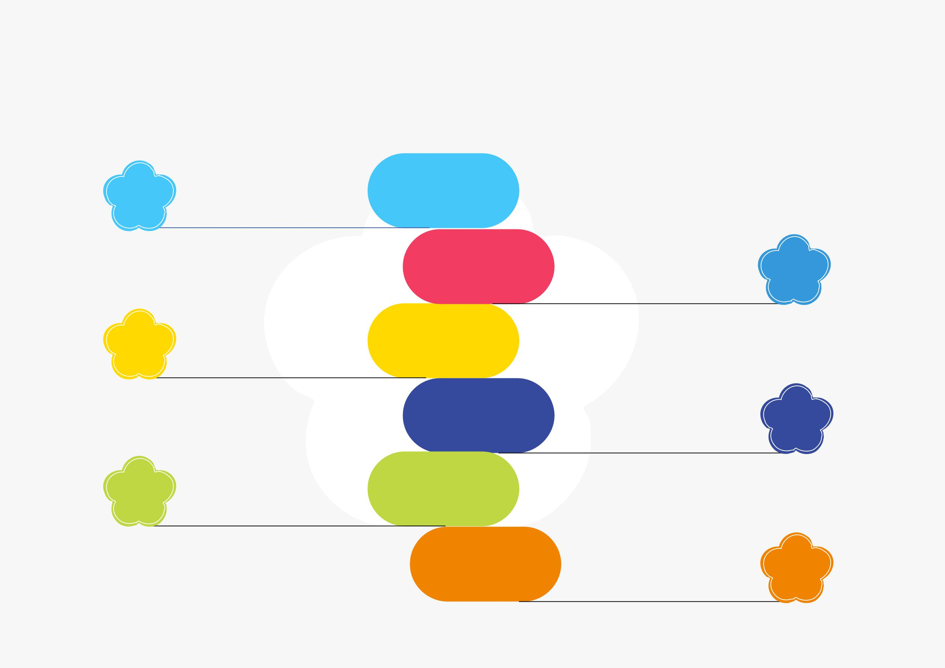
Insert your title here

Title

Title

Title

Use the float button to change the basic setting of circular chart.

Use the float button to change the basic setting of circular chart.

Use the float button to change the basic setting of circular chart.

2020

2019

2018

z

2017

2016

2015

Use the float button to change the basic setting of circular chart.

Use the float button to change the basic setting of circular chart.

Use the float button to change the basic setting of circular chart.

Title

Title

Title

