Rule Timeline

2008

2009

2010

2011

2012

2013

2014

2015

2016

2017

 |  |  |  |  |  |  |  | 2018
Mike |  |  |  |  |  |  | 9/1-15/2008: Hurricane Ike
 |  |  |  |  |  |  | 9/15/2008: Hurricane Ike Data Call
Geeslin,
 |  | 81st
2/1/2011-6/2005
 |  |  |  |  |  | 9/1/2009: |  | HB 4409 takes e ect,
5/27/2013-8/15/2011 | Kitzman,Eleanor |  |  |  |  |  | implements TWIA assessments
 |  | 82nd
 |  |  |  |  |  |  | 7/21/2011: NRRA takes e ect,
5/27/20131/21/2015- |  |  |  |  |  |  | prompts Ch. 15 rule change
 | Rathgeber,Julia | 83rd
 |  |  |  |  |  |  | 2013: Initial TDI surplus lines
 |  |  |  |  |  |  | rule hearing, TIC 981 clean-up
 |  |  |  |  |  |  | 2013: SLSOT issues bulletin
 |  |  |  |  |  |  | requiring zip code for highest limit
 |  | 84th |  |  |  |  |  | 2019
 |  |  |  |  |  |  | 5/2016: SLTX initiates working group
 |  |  |  |  |  |  | with the Big I and TSLA counsel
 |  |  |  |  |  |  | 6/2016: SLTX counsel provides
David |  |  |  |  |  |  | Board Chairman legislative reviews
 |  |  |  |  |  |  | 7/2016: Informal surplus lines
Mattax, |  |  |  |  |  |  | rules published by TDI
 |  |  |  |  |  | 7/22/2016: |  | SLTX issues Board brief,
4/13/2017-1/21/2015 |  |  |  |  |  |  | bulletin, and press release Re: rules
 |  |  |  |  |  | 8/19/2016: |  | SLTX shares rules
 |  |  |  |  |  |  | comments with Board
 |  |  |  |  |  |  | 8/19/2016: SLTX shares rules
 |  |  |  |  |  |  | comments with TSLA and Big I
 |  |  |  |  |  |  | 8/22/2016: SLTX shares rule comments
 |  |  |  |  |  |  | with NAPSLO
 |  |  |  |  |  |  | 8/22/2016: SLTX submits comments to
 |  |  |  |  |  |  | TDI
 |  |  |  |  |  |  | 8/17/2017: Hurricane Harvey
 |  | 85th |  |  |  |  | 9/1/2017: Industrial Insured e ective
 |  |  |  |  |  |  | 9/21/2017: Hurricane Harvey
 |  |  |  |  |  |  | Data Call

KentSullivan,
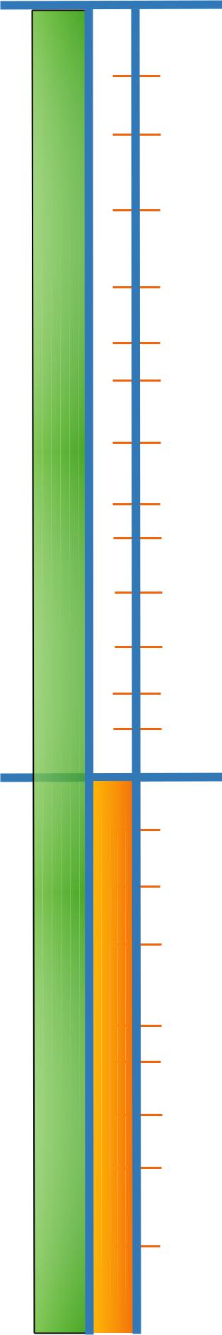
9/21/2018 Present-

86th

6/5/2018: TDI files

proposed Ch. 15 rules

6/2018: SLTX shares rule comments

with TSLA, Big I, WSIA,

PCI, and third-party filers

7/2018: SLTX receives support

letters from PCI, WSIA, TSLA,

and third-party filers

7/6/2018: SLTX submits

comments to TDI

7/10/2018: TDI holds public hearing

8/2018: TDI sends proposed

rule to Governor’s o ce

10/12/2018: SLTX announced PG and limit rule

changes before US and TSLA counsel

12/10/2018: TDI files adopted rule

12/2018: SLTX reached out to

IT developers

12/14/2018: SLTX Sends briefing to Board and

external market place

12/17/2018: SLTX in private discussion with TDI

to discuss the e ective date

12/21/2018: Adopted rule published by TDI

12/30/2018: Adopted rules take e ect

1/2-14/2019: SLTX conducts

Automated Filers Survey

1/11/2019: SLTX implements

short-term policy upload portal feature

1/28/2019: TSLA request meeting with TDI

to include SLTX

2/1/2019: Flood Export Bill filed

2/4/2019-present: SLTX in private discussion

with TDI on compliance and retroactive dates

2/4/2019: SLTX initiates IT vendor and

compliance interviews to amend instruction

2/12/2019: TSLA Board meeting with request

to SLTX for ”permanent discretion for

voluntary compliance”

2/20/2019: SLTX Special Board meeting, no

support for permanent noncompliance

however, working group to be established

