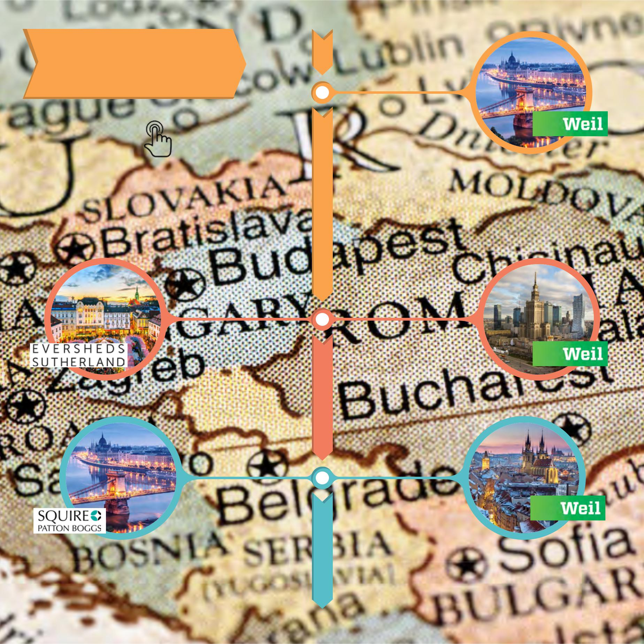
CEE TIMELINE

2018-19

Click on pictures for full story...

February 2018
Weil Gotshal &
Manges closes

Budapest office

December 2018
Eversheds Sutherland
announces merger
with Czech and
Slovak Republic firm

December 2018

Weil Gotshal &
Manges reviewing

Warsaw office

January 2019
Squire Patton
Boggs closes
Budapest office

January 2019
Weil Gotshal &
Manges closes
Prague office

