1997

Network Medical established by Phil Weston Neck Ear Throat Work Medical

1998
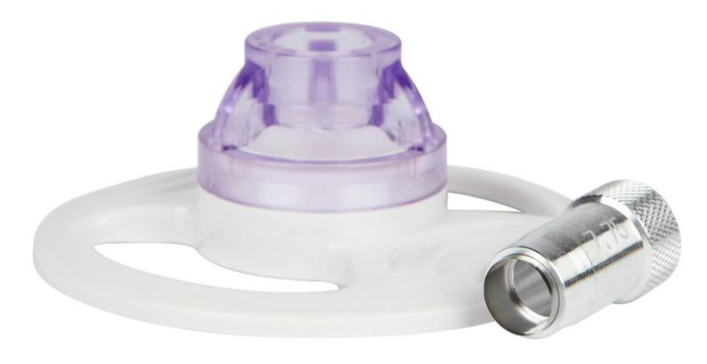

Ophthalmic division launched with introduction of CORONET™ standard trephines

1999

Government SMART award for development of trephine technology

2000
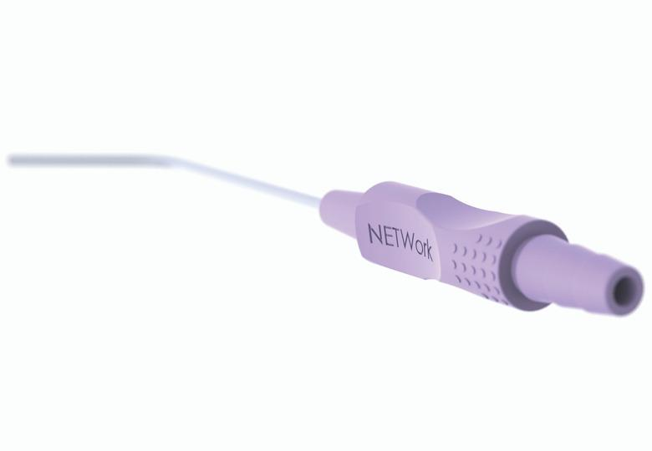

CORONET™ Recipient Vacuum Trephine and Donor Punch launched (Patent Protected)

2003

Launched NETCELL™ Series 5000™ PVA Nasal Packs (Patent Protected)

2004

Network ENT™ Suction Tubes with unique

ergonomic handle launched

2005

CORONET™ Artificial Anterior Chamber launched

2006

Precision LASIK Blades launched
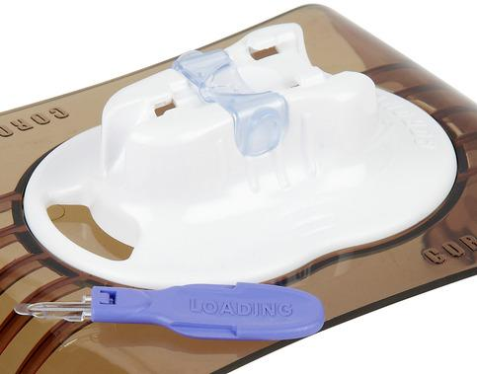

2007

CORONET™ Orbital Implants launched

2009

CORONET™ EndoGlide™ developed and launched in collaboration with Prof Don Tan (Patent Protected)

2011
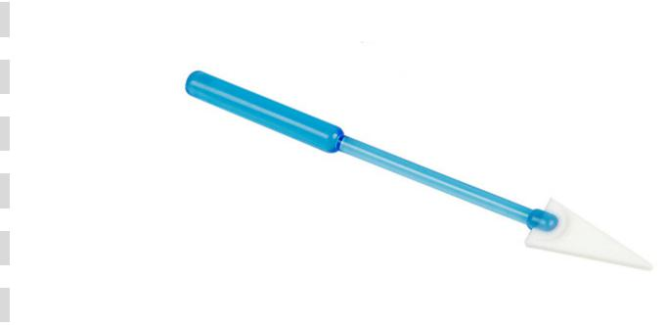

Moved into new purpose built head office and manufacturing site in Yorkshire UK

2013

Dedicated PVA production site opened in

Connecticut USA

2015

Satellite sales office CORONET Medical

Technologies set up in Philadelphia USA

2016

Network Medical re-brand and expansion of UK manfuacturing facility

CORONET™ Clear-Vue™ Launched
2017 (Patent Protected)

Celebration of 20 years of business with

distribution across 72 countries

