Project Charter

General Information

Project Title |  |  |  | Date
Enterprise Service Management Reporting |  |  | 7/3/2012
Project Manager | Phone |  |  | Email
Jodi Muller | 415.476.2821 |  |  | Jodi.Muller@ucsf.edu
Executive Sponsor | Phone |  |  | Email
Opinder Bawa | 415.502.4004 |  |  | BawaO@medsch.ucsf.edu
Document Version |  | Updated Date
1.0 |  | 7/32012
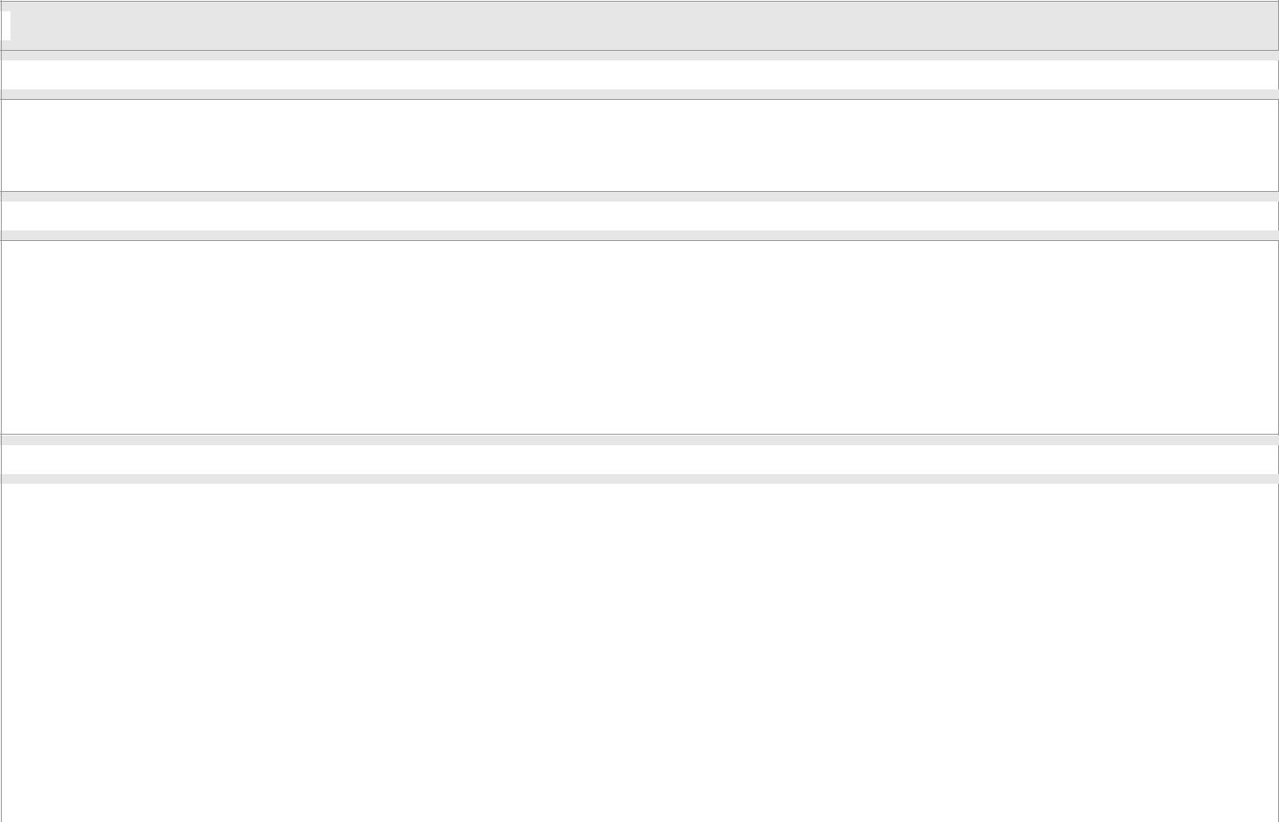
Project Scope
Situation / Problem / Opportunity

Current reporting functionality in ServiceNow is very limited, not user friendly and accessible only to ITIL users.
Project Goals

The Enterprise Service Management Reporting project intends to plan, design, construct and implement a structured data warehouse environment that will include data from ServiceNow. The data warehouse will support various areas of data from ServiceNow. The automated collection of data from ServiceNow will be available to create a wide range of reports and dashboards depending on the customer need.

The vision of the project is to improve efficiency and service levels of ITS services and support.
In Scope / Out of Scope

In Scope:
- Incident and Change related tables will be loaded into the data warehouse

- Predefined Incident Management reporting will be available

- Predefined Change Management reporting will be available

- Ad-hoc reporting for Incident and Change Management will be available

Out of Scope:
- Service Catalog tables will not be loaded into the data warehouse during this phase

- Service Request reporting will not be available during this phase

UCSF ITS Product and Project Management Office
Project Charter 1.0 | 1

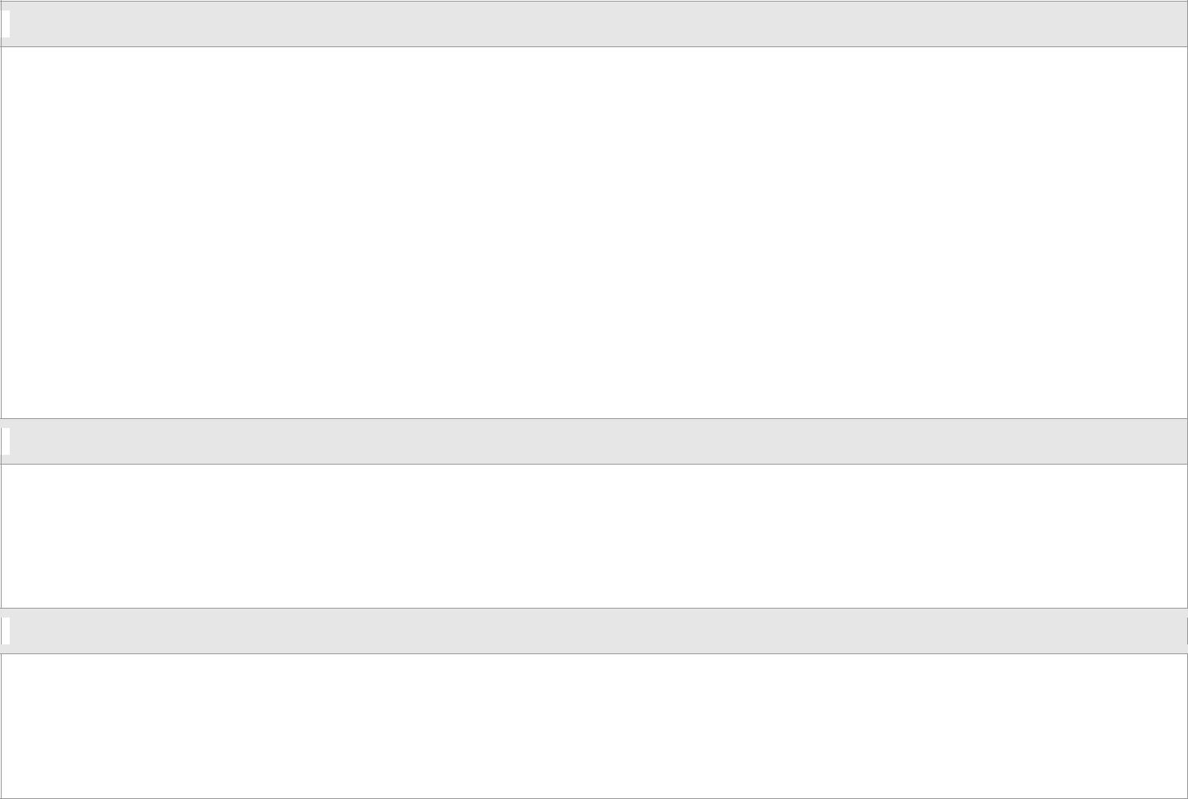
Objectives / Deliverables (if known)

- A data inventory that includes Incident and Change related tables.

- A data warehouse that can expand to include Service Catalog tables and other ServiceNow tables for future release(s).

- Cognos will be available to identified users to view and run reports.

- Provide Executives and Management with predefined reports for the following areas:

o Productivity Metrics

o Quality Metrics

o Operational Metrics

  - Trending Metrics
- Provide ability for IT Managers to generate Ad-Hoc Reports.

Project Assumptions

- Preparation and development of the data warehouse will be completed by the Business Intelligence group.

- ServiceNow Developer will be made available for questions to the Business Intelligence group.

- Only IT Directors and Managers will have access to Cognos.

Risks and Dependencies

- Lack of resources or resource availability.

- Scope creep for additional ‘predefined’ reports.

  - Select number of Managers to review and approve requirements.

  - ServiceNow Subject Matter Expert (SME) is critical to Business Intelligence group.

UCSF ITS Product and Project Management Office
Project Charter 1.0 | 2

Resource Requirements
- People:

 | o | Executive Sponsor
 | o | IT Directors
 | o | IT Managers
 | o | ITSM Product Manager
 | o | Project Manager
 | o Business Intelligence Senior Manager
 | o DW/ETL & Business Intelligence Developer
 | o | ServiceNow Developer
 | o | Business Analyst
 | o | ServiceNow Administrator
▪ | Time:
 | o The initial estimate for the Enterprise Service Management Reporting Project duration is
 |  | approximately 6 months with an implementation occurring at the end of 2nd quarter for fiscal year
 |  | 2013. (December 2012)
▪ | Dollars:
 | o The approved budget for the Enterprise Service Management Reporting Project is $50,000.
 |  | • Actual Budget will be estimated after finalizing the requirements.

  - The license cost for Cognos is TBD based on the type (Consumer vs Adhoc) and number of users.

- Other:

o The Cognos software will be available to identified users for viewing and running reports

High-Level Milestones and Timeline

- Project Charter Approved: July 9, 2012

- Kickoff Meeting: July 23, 2012

- Identify and Document High Level Requirements: July 31, 2012

- Finalize Requirements: August 17, 2012

- Design and Development Completed: TBD

- Unit Testing Completed: TBD

- UAT Completed: TBD

- Training Completed: TBD

- Go-Live: January 2013

Note: Dates and milestones are subject to change pending final requirements and resource availability.

UCSF ITS Product and Project Management Office
Project Charter 1.0 | 3

Project Team Roles and Responsibilities

Team Member | Roles | Responsibilities
Rebecca Nguyen | ITSM Product Manager | The Product Manager is the
 |  | liaison to the Project Sponsor
 |  | and Project Stakeholders, and is
 |  | responsible for facilitating and
 |  | organizing the project roadmap,
 |  | managing the team work
 |  | activities, and resolving issues
 |  | raised by the Project Manager.
Jodi Muller | Project Manager | The Project Manager develops
 |  | and maintains the project plan
 |  | (resourcing, implementation,
 |  | work plans, etc.), monitor project
 |  | progress, and ensures projects
 |  | are completed on time and within
 |  | budget.
Stakeholders | IT Directors and Managers | The Stakeholders will work with
 |  | the Product Manager in voicing
 |  | concerns or issues impacting the
 |  | success of the projects.
Ramesh Doraivelu (PD) | Senior Manager, Business | The Business Intelligence Senior
 | Intelligence | Manager oversees the Business
 |  | Intelligence Developers, ensures
 |  | optimal, accurate, and timely
 |  | technical solutions to
 |  | requirements and requests. In
 |  | addition, is a technical liaison
 |  | with other departments,
 |  | coordinating information systems
 |  | across the Enterprise.
Terrie Coleman | Business Analyst | Business Analysts analyze,
 |  | interpret, and document
 |  | business rules and requirements
 |  | for technical systems. In
 |  | addition, they assist in
 |  | integration and user acceptance
 |  | testing, support the development
 |  | of training material, participate in
 |  | the implementation of systems,
 |  | and provide post-implementation
 |  | support.
Jason Lin | ServiceNow Developer | The ServiceNow Developers will
 |  | ensure technical quality of the
 |  | systems and products, control
 |  | system development and
 |  | operation during implementation,
 |  | provide input into the project
 |  | plans for work completed status,
 |  | produce all technical project
 |  | deliverables, documentation and
 |  | design specifications, and
 |  | ensure technical issues are
 |  | resolved.

UCSF ITS Product and Project Management Office
Project Charter 1.0 | 4

George Meng and TBH | Programmer/Developer – | The Business Intelligence
 | Business Intelligence | Developers will ensure technical
 |  | quality of the systems and
 |  | products, control system
 |  | development and operation
 |  | during implementation, provide
 |  | input into the project plans for
 |  | work completed status, produce
 |  | all technical project deliverables,
 |  | documentation and design
 |  | specifications, and ensure
 |  | technical issues are resolved.
Shawn Hall | ServiceNow Administrator | Administrators maintain
 |  | knowledge of how the system
 |  | operates and are responsible for
 |  | establishing processes and
 |  | enforcing policies such as user
 |  | access (accounts). In addition to
 |  | monitoring and supporting the
 |  | system, they contribute to user
 |  | training, communication,
 |  | troubleshooting, and enhancing
 |  | the overall user experience.

UCSF ITS Product and Project Management Office
Project Charter 1.0 | 5

Communication Strategy

 | What? |  |  | Who? |  | When? |  |  |  | How?
 | Description/Title |  | Provider |  | Recipient | Frequency |  |  | Format |  | Medium/Distributi
 |  |  |  |  |  |  |  |  |  |  | on Method
 | Kickoff Meeting |  | Project |  | Project | One Time Only |  | Meeting |  |  | Face to Face
 |  |  | Manager |  | Team |  |  |  |  |  | Conference Call
 | Project Team |  | Project |  | Project | Weekly |  | Meeting |  |  | Face to Face
 | Meetings |  | Manager |  | Team, |  |  |  |  |  | Conference Call
 |  |  |  |  | Invitees
 | Meeting Minutes |  | Project |  | Distributio | 2 days after |  | MS Word file on |  |  | Email
 |  |  | Manager |  | n List | Meeting by |  | Shared Drive
 |  |  |  |  |  | COB
 | Action Items |  | Project |  | Project | TBD |  | MS Excel file on |  |  | Face to Face
 |  |  | Team |  | Team |  |  | Shared Drive |  |  | Conference Call
 | Status Reports |  | Project |  | Executive | Bi-Weekly |  | PDF on Shared |  |  | Email
 |  |  | Manager |  | Sponsor |  |  | Drive
 | Technical |  | Project |  | Technical | TBD |  | Meeting |  |  | Face to Face
 | Design/Development |  | Manager |  | Staff |  |  |  |  |  | Conference Call
 | Meetings
 |  |  | Developers
 | ServiceNow |  | Project |  | Project | As Needed |  | Email |  |  | Email
 | Updates/Announceme |  | Manager |  | Sponsor
 | nts |  | Product |  | IT
 |  |  | Manager |  | Directors
 |  |  |  |  | Project
 |  |  |  |  | Team
 | Charter will be reviewed and signed by the sponsors and manager
 | Executive Sponsor |  |  | ITSM Product Manager |  |  |  |  | Senior Manager, Business
 |  |  |  |  |  |  |  |  | Intelligence
 | Reviewed By |  | Date | Reviewed By |  |  | Date |  | Reviewed By |  |  |  | Date

UCSF ITS Product and Project Management Office
Project Charter 1.0 | 6

