PACKING SLIP Please enclose this form so we can let you know your package was received!

 |  |  |  | Card Triage Checklist:
 | Name
 |  |  |  | No glitter or handwritten sentiments
 | Organization (if any) |  |  | Card size A2 (4.25x5.5)
 |  |  | Updated info
 | Address |  |  | Dark cards lined with light paper
 |  |  |  | Cards stamped or labeled on back with
 | City | State | ZIP | “Operation Write Home”
 |  |  |  | Cards are properly tucked. Watch tucking
 | E-mail
 |  |  |  | video: operationwritehome.org/prepare
Enclosed: |  |  |  | Sorted by theme, and no packing peanuts
 | # cards ______________________ | # AnyHero cards _______________________
 | Donation $_ __________________ Your generosity help us better serve our heroes.
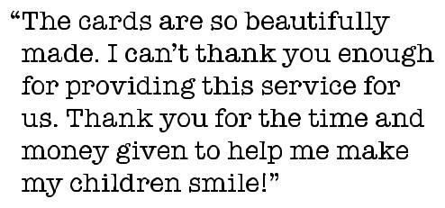
Notes___________________________________________________

______________________________________________________

______________________________________________________
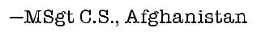

PACKING SLIP Please enclose this form so we can let you know your package was received!

 |  |  |  | Card Triage Checklist:
 | Name
 |  |  |  | No glitter or handwritten sentiments
 | Organization (if any) |  |  | Card size A2 (4.25x5.5)
 |  |  | Updated info
 | Address |  |  | Dark cards lined with light paper
 |  |  |  | Cards stamped or labeled on back with
 | City | State | ZIP | “Operation Write Home”
 |  |  |  | Cards are properly tucked. Watch tucking
 | E-mail
 |  |  |  | video: operationwritehome.org/prepare
Enclosed: |  |  |  | Sorted by theme, and no packing peanuts
 | # cards ______________________ | # AnyHero cards _______________________
 | Donation $_ __________________ Your generosity help us better serve our heroes.
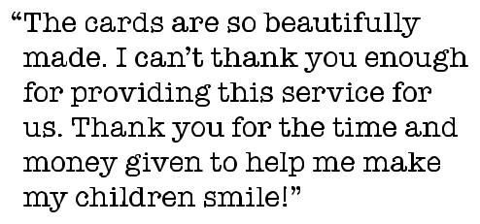
Notes___________________________________________________

______________________________________________________

______________________________________________________

