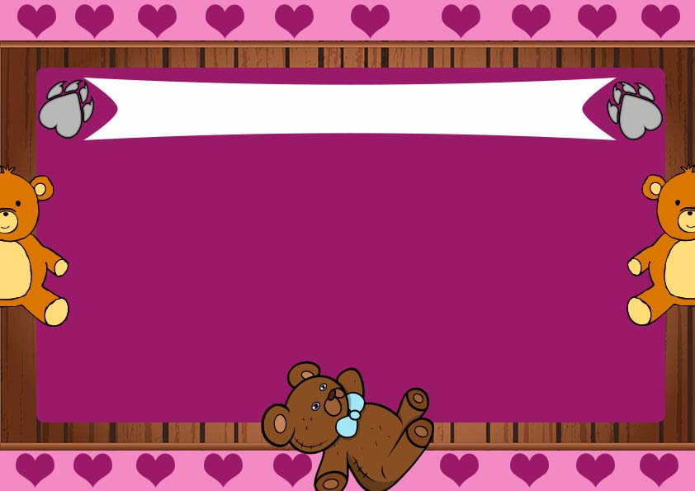

**__________________**

**Date**

**__________________**

**Signature**

**This certifies that ______________**

**Has adopted ____________**

**I promise to love and take care of my new pet!**

**Certificate of Adoption**