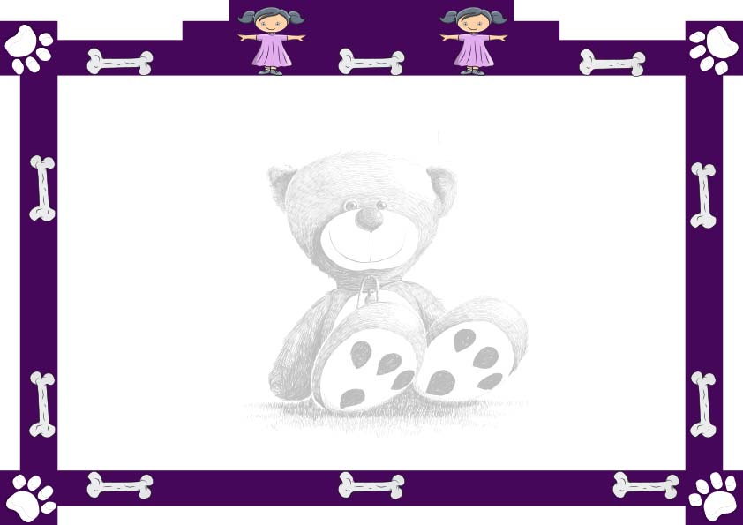

This certifies that

_____________________

Has been formally adopted into the ________________

By __________

On this ____Day of _____

**________________**

**Signed**

**__________________**

**Signed**

**Adoption Certificate**