1.1—Develop Your REAP —
Records Emergency Action Plan
Complete the initial steps in developing your Records Emergency Action Plan (REAP), including:
- Identifying the disaster plans relevant to your state agency, city, or county, with a special focus on how this guidance addresses records-related preparedness and response
- Identifying the existing emergency or Continuity of Operations (COOP) teams authorized within your agency or chain of command
- Determining the scope of your REAP and beginning to identify the records emergency planning that needs to be completed
Complete the Developing a REAP—First Steps table by doing the following:
- Identify the disaster plans relevant to your state, county, city, and/or agency and record the information in Section I. Disaster Plans.
- Suggested resources for locating these documents include the following:
- For state-wide information, start with your state page in the IPER Resource Center.
- For county and municipality information, consult your Emergency Management Office. Specific state or local government agencies may also have in place their own plans, which should be available through the Agency Director or the agency’s Emergency Management Officer.
- Identify the existing emergency or COOP teams authorized within your agency or chain of command and record the information in Section II. Emergency or COOP Teams.
- Determine the scope of your REAP; identify the records emergency planning that needs to be completed for your REAP and record the information in Section III. Scope and Planning.

Name(s):
Agency:
Table 1: Developing a REAP—First Steps, Part I: Disaster Plans
Disaster Plans Relevant to My State, County, City, and/or Agency | Document Version/ Date | Source of the Plan (Originating Agency, etc.) | Location Where the Plan Can Found | Brief Description of the Disaster Plan | Does the plan address records? If so, how?

Table 2: Developing a REAP—First Steps, Part II: Emergency or COOP Teams

Emergency or COOP Teams Authorized Within My Agency or Chain of Command | Contact Name(s) | Contact Information

Table 3: Developing a REAP—First Steps, Part III: Scope and Planning

Scope of My REAP | Records Emergency Planning That Needs To Be Completed

2.1—Emergency Contact Directory Template

Emergency Contact Directory

STAFF CONTACT INFORMATION
Name | Title
Address | Email (work)
Email (home) | Phone (work)
Phone (home) | Phone (mobile)
Emergency Contact (Name & Number) | Distance from home to work

Name | Title
Address | Email (work)
Email (home) | Phone (work)
Phone (home) | Phone (mobile)
Emergency Contact (Name & Number) | Distance from home to work

Name | Title
Address | Email (work)
Email (home) | Phone (work)
Phone (home) | Phone (mobile)
Emergency Contact (Name & Number) | Distance from home to work

Name | Title
Address | Email (work)
Email (home) | Phone (work)
Phone (home) | Phone (mobile)
Emergency Contact (Name & Number) | Distance from home to work

ELECTRONIC DISTRIBUTION LISTS
Type | Title/Recipients | Posting Address
Email
Text messaging

OTHER EMERGENCY CONTACTS
FIRST RESPONDERS
Service/Position | Name | Company/Org. | Phone Number
Police Chief

Nearest Police Station

Fire Chief

Nearest Fire Station

Sheriff

Nearest Hospital

Local Emergency Management Agency

State Emergency Management Agency

FEMA Regional Office

Local Red Cross

Public Health Dept

OTHER

PUBLIC/MUNICIPAL CONTACTS
Position | Name | Company/Org. | Phone Number
Mayor/
Town Administrator/
Town Manager, etc.
County Commissioner

Town/City/County Clerk

County Manager

Chief Operations Officer

Chief Financial Officer

OTHER

OTHER

MAINTENANCE/UTILITIES
Service/Position | Name | Company/Org | Phone Number
Gas

Electric

Water Utility

Fire Detection and Suppression

HVAC

Plumber

Electrician

Telephone Provider

Internet Provider

Locksmith

Janitorial Services

Pest Control

Architect

Legal Counsel

Security

OTHER

VENDORS, CONTRACTORS, RECOVERY SPECIALISTS
Service/Position | Name | Company/Org | Phone Number
Document Recovery Services

Building Recovery Services

Local Freezer Space

Out-of-area Freezer Space (in case of a larger/regional disaster)

Trucking/Transport

Conservator/
Preservation Expert
Mycologist

OTHER

INSURANCE
Service/Position | Name | Company/Org | Phone Number
Risk Manager

Insurance Company

OTHER CONTACTS
Service/Position | Name | Phone Number
State Archives

State Historical Records Advisory Board (SHRAB)
Local Disaster Networks

Regional Preservation Services

Govt. Records Organization
State/Regional Archival Organization

NARA Regional Office

2.2—Essential Records
NOTE: The left-hand column below indicates salvage priorities for essential records based on how quickly access will be required following an emergency.
Priority for Salvage | Essential records are  records that: | Examples include:
Priority 1: First 1–12 hours | Are necessary for emergency response | - Copy of emergency and/or Continuity of Operations (COOP) Plan  - Infrastructure and utility plans  - Maps and building plans  - Emergency contact information
Could be either Priority 1 or Priority 2 | Are necessary to resume or continue operations | - Delegations of authority  - Contracts and leases  - Payroll  - Prison, jail, and parole records  - Insurance records
Priority 2: First 12–72 hours | Protect the health, safety, property, and rights of residents | - Deeds, mortgages, land records  - Birth and marriage records  - Medical records  - Active court proceedings  - Education and military service records  - Voting records  - Professional licenses
Priority 2 or Priority 3 | Would require massive resources to reconstruct | - Geographic information systems data  - Tax records
Priority 3: After first 72 hours | Document the history of communities and families | - Historical documents  - Photographs  - Identity records
- Only a small percentage (typically, less than five percent) of all Government records are essential  - Value during an emergency makes a  record essential  - As disruption time increases, more records  become essential  - “Records” can be in many different formats,  including paper or electronic |  | 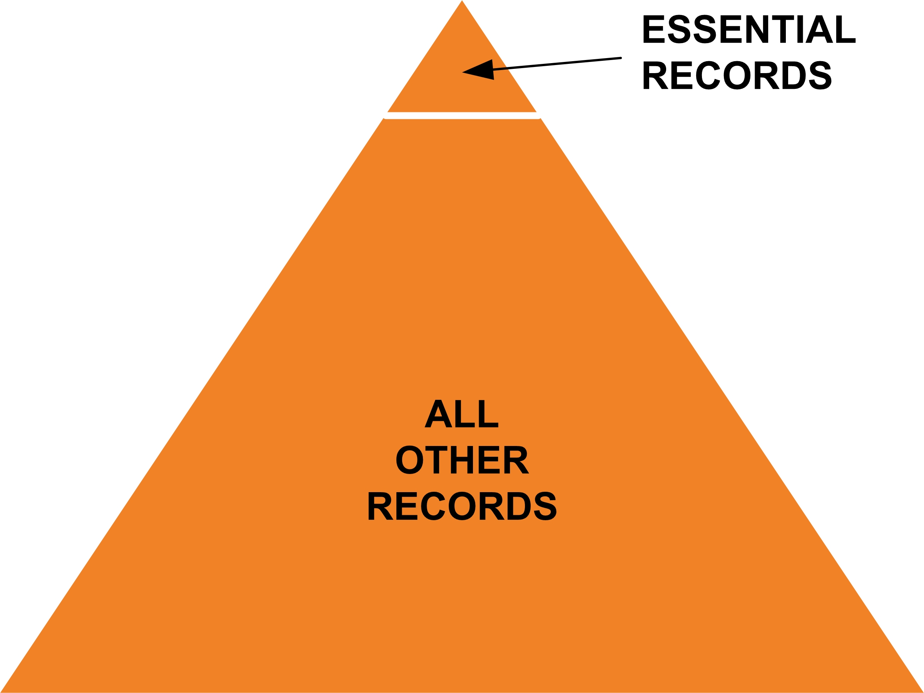

2.3—Sample Records Priorities List
Priority | Record Series | Schedule Item | Retention Period | Location
First Priority | Program Correspondence Files | 101a | PERM | Director’s Office Main Cabinet Drawer 1
First Priority | Advisory Commissions | 202 | PERM | Assistant Admin Office Cabinet 3 Drawer 2
First Priority | Erosion Control Study System database (tapes) | 306 | TEMP—20 yrs | Environmental Research Staff
First Priority | Site Containment Photographs |  | Unscheduled | Assistant Admin for Recreation
Second Priority | Analytical Compilations | 305 | TEMP—20 yrs | Resources Evaluation Cabinet 5 Drawer 3
Second Priority | Site Containment Maps |  | Unscheduled | Assistant Admin for Recreation
Third Priority | Subject Files | 103 | TEMP—3 yrs | Admin Area Cabinet 1
Third Priority | Tracking Files | 106 | TEMP—No longer needed | Admin Area Cabinet 1

2.4—Supplies and Equipment List

Note: Use the following to create your own checklist of supplies and equipment tailored to the risks faced in your agency or geographic region. Having such a list is important when conducting periodic checks of preparedness. Take into consideration what you will need for an immediate response as well as what you might need for records that require special treatment, such as air drying or freezing for stabilization.
Table 1: In-House Stash of Supplies for Immediate Response
Needed for Immediate Response | Needed for Air Drying | Needed for Freezing for Stabilization | Disaster Response Supplies and Equipment
X |  |  | 33-gallon plastic trash can with wheels and lid (to store supplies)
X |  |  | 1 roll 10' x 100' 2 mil plastic sheeting
X |  |  | 1 roll masking/duct tape (to use with sheeting)
X |  |  | 1 spool packing string (to hang sheeting)
X |  |  | 10 large plastic trash bags (to fit can)
X |  |  | 1 large sponge
X |  |  | 1–5-gallon bucket
X |  |  | 1 box disposable gloves
X |  |  | 1 roll “Do not enter” barricade tape
X |  |  | 2 rolls paper towels
X |  |  | 1 pair scissors
X |  |  | 1 dozen pencils (mechanical or sharpened)
X |  |  | 2 black permanent marking pens
X |  |  | Lined paper pad
X |  |  | Flashlight (self-standing, extra batteries)
X |  |  | 10 dust masks

Table 2: Documentation
Needed for Immediate Response | Needed for Air Drying | Needed for Freezing for Stabilization | Disaster Response Supplies and Equipment
X | X | X | Camera, memory cards (in case a digital camera is not available, keep a disposable camera in emergency supply stash)
X | X | X | Video camera, memory cards
X | X | X | Laptop computer
X | X | X | Waterproof pens/markers
X | X | X | Pencils (mechanical or sharpened)
X | X | X | Clipboards
X | X | X | Paper pads/logs

Table 3: Personal Safety and Protection
Needed for Immediate Response | Needed for Air Drying | Needed for Freezing for Stabilization | Disaster Response Supplies and Equipment
X | X | X | First Aid kit  (keep in mind treatment of paper cuts, staple pokes)
X | X | X | Gloves (disposable, work)
X | X | X | Hard hats (size adjustable)
X | X | X | Masks and respirators (dust, mold)
X | X | X | Rubber boots (non-skid), many sizes
X | X | X | Safety goggles
X | X | X | Eyewash kits
X | X | X | Aprons (plastic, disposable)
X | X | X | Overalls, jumpsuits
X | X | X | Vest (or jacket) with pockets
X | X | X | Antimicrobial soap/alcohol hand wash
X | X | X | Drinking water
X | X | X | Portable toilet
X | X | X | Identification badges
Table 4: Packing Supplies
Needed for Immediate Response | Needed for Air Drying | Needed for Freezing for Stabilization | Disaster Response Supplies and Equipment
X |  | X | Self-adhesive labels, color-coded adhesive dots
X |  | X | Hand trucks, dollies, book carts
X | X | X | Plastic bags (garbage, zipper lock, assorted sizes)
X |  | X | Corrugated cardboard boxes
X |  | X | Tape (masking, packing, duct), tape dispensers
X |  | X | Scissors, utility knives (extra blades)
X |  | X | Plastic crates
X |  | X | Rescubes® (see description on p. 4 of this handout)
X |  | X | Pallets
Table 5: Communication
Needed for Immediate Response | Needed for Air Drying | Needed for Freezing for Stabilization | Disaster Response Supplies and Equipment
X |  |  | Hand radio sets/Walkie-talkies
X |  |  | Portable radios
X |  |  | Cellular phones (with emergency numbers)
X |  |  | Ham radios
X |  |  | Megaphone
Table 6: Environmental Monitoring and Moisture Control
Needed for Immediate Response | Needed for Air Drying | Needed for Freezing for Stabilization | Disaster Response Supplies and Equipment
X |  |  | Air conditioners (portable)
X | X |  | Dehumidifiers
X | X |  | Fans
X | X |  | Monitors (temperature, humidity)

Table 7: Other Supplies and Equipment
Needed for Immediate Response | Needed for Air Drying | Needed for Freezing for Stabilization | Disaster Response Supplies and Equipment
X |  |  | Acrylic sheets (Plexiglas™)
 | X |  | Blotting paper (white)
X | X | X | Brooms, dustpans, shovels, mops, buckets
X | X | X | Bubble pack
X |  |  | Cleaning products, disinfectant
X | X |  | Cloths: cotton rags, dust cloths, lint-free cloths, nonwoven polyester web, cheesecloth
X | X |  | Clothesline, rope, string (heavy packing on spool)
 | X |  | Clothespins (rust proof)
 | X |  | Dish-drying racks (plastic-covered)
X |  |  | Dry ice
X | X | X | Flashlights (self-standing), headlamps, extra batteries, chemical light sticks
X | X | X | Generator (portable, fuel supply)
X |  | X | Ladders and kick stands
X | X |  | Mat board
X | X |  | Moisture meter
X | X |  | Newsprint (un-inked, blank), butcher paper
X | X | X | Office supplies (paper pads, pencils, waterproof pens/markers, flipcharts, large self-adhesive labels)
X | X |  | Photo Flo, wetting agent (Kodak)
X | X |  | Plastic clips/clothespins
X | X | X | Plastic garbage cans, washtubs
X |  |  | Plastic sheeting (polyethylene) rolls
X |  |  | Plywood or masonite board

Table 8: Other Supplies and Equipment (cont’d.)
Needed for Immediate Response | Needed for Air Drying | Needed for Freezing for Stabilization | Disaster Response Supplies and Equipment
X | X |  | Polyester film (Mylar), 3 to 5 mil
 | X | X | Polyester, spunbond (Reemay, Hollytex)
X |  |  | Pump (portable)
X | X |  | Screen (nylon), screen or bakery drying racks
 |  | X | Shrink wrap
X | X |  | Signs: “Caution Wet Floor”
 | X | X | Silicone release paper
X | X |  | Sponges (cellulose, chemical)
X | X |  | Surge protectors, extension cords (50+ ft., heavy-duty, grounded)
X | X | X | Tables (portable, folding)
X | X | X | Tool kit (crowbar, hammer, wrenches, pliers, screwdriver)
X | X |  | Towels (absorbent cloth, paper)
X | X |  | Trays (deep, for rinsing)
X |  |  | Water hoses, adjustable spray nozzles
X |  |  | Wet vacuum (10-gallon industrial)

Other Equipment and Supplies to Consider:
Water Diverter: For protection from overhead leaks. An industrial vinyl plastic tarpaulin carried by ProText, Inc.; stocked in sizes from 3' × 6' to 6' × 10'; can also be ordered in custom sizes. There are grommets at the edges to facilitate hanging over a collection, and a standard garden-hose fitting makes it easy to lead water away. The diverter, which is reusable, would be a good thing to have if your institution suffers from persistent roof leaks.
Corrugated Cardboard Boxes: Not ideal for soaking-wet materials, but it is good to have flattened boxes in the emergency supplies. They take up relatively little space and are inexpensive compared to plastic crates. They can be lined with large plastic bags before wet records go in.
Rescubes®: One-piece folding boxes made of corrugated polyethylene. They are reusable and can be stored flat and set up as needed. They do not absorb water from wet records and do not need to be lined. They have several ventilation openings. Records can be sent to freeze-drying facilities in Rescubes®. Available from ProText, Inc., Gaylord, University Products, and other conservation suppliers.
React•Paks (ProText): The kit consists of a Rescube® (described above) filled with basic supplies and equipment. Boxes measure about 1.5 cubic ft, take up little space, and can be stored in multiple locations. React•Paks can be bought instead of or in addition to an immediate response kit. Available from ProText, Inc., and other conservation suppliers.
Collection Protection Emergency Kit (Gaylord): Contains materials to cover and protect collections quickly, contain or divert water, and clean up, stored in a 6-gallon plastic bucket. Like the ReactPak, these can be purchased instead of or in addition to an immediate response kit. Available from Gaylord University Products and other conservation suppliers.
Note: This list is adapted with permission from one developed by WESTPAS, the Western States
2.5—Initial Damage Assessment and Response Checklist
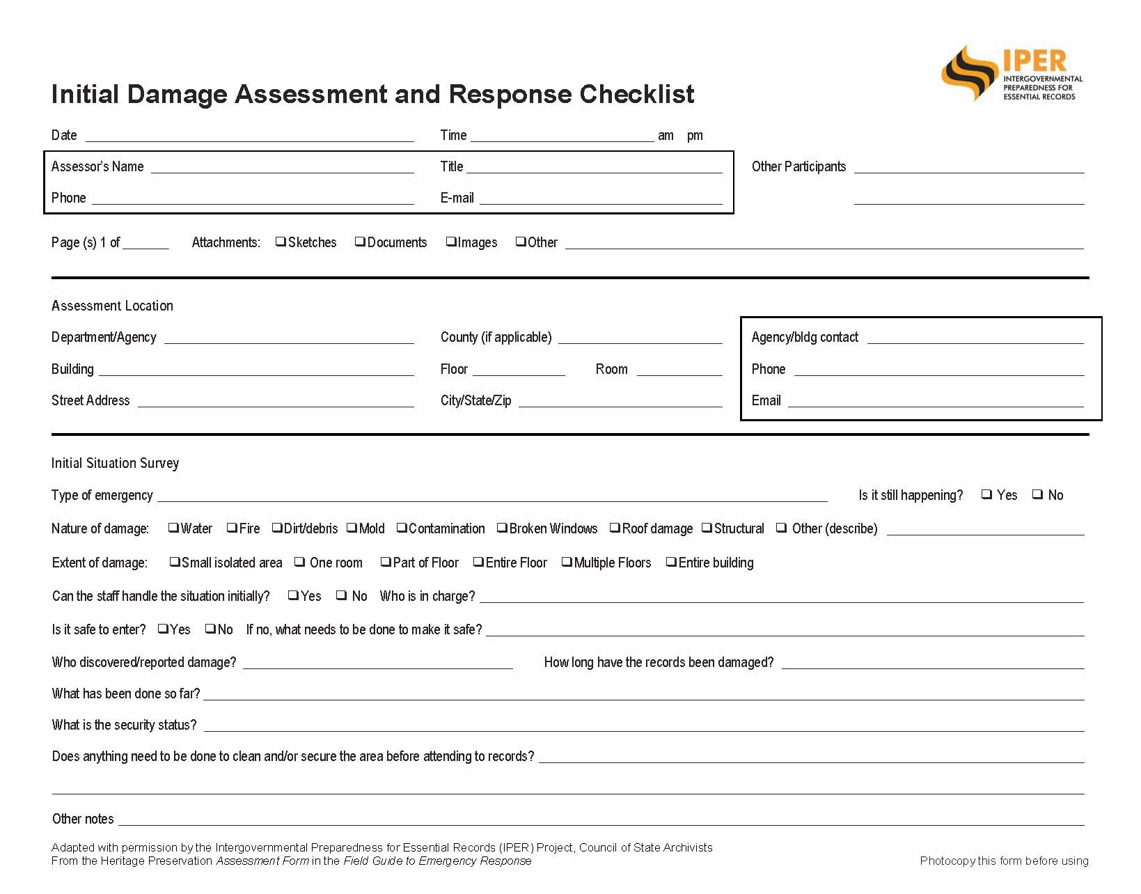
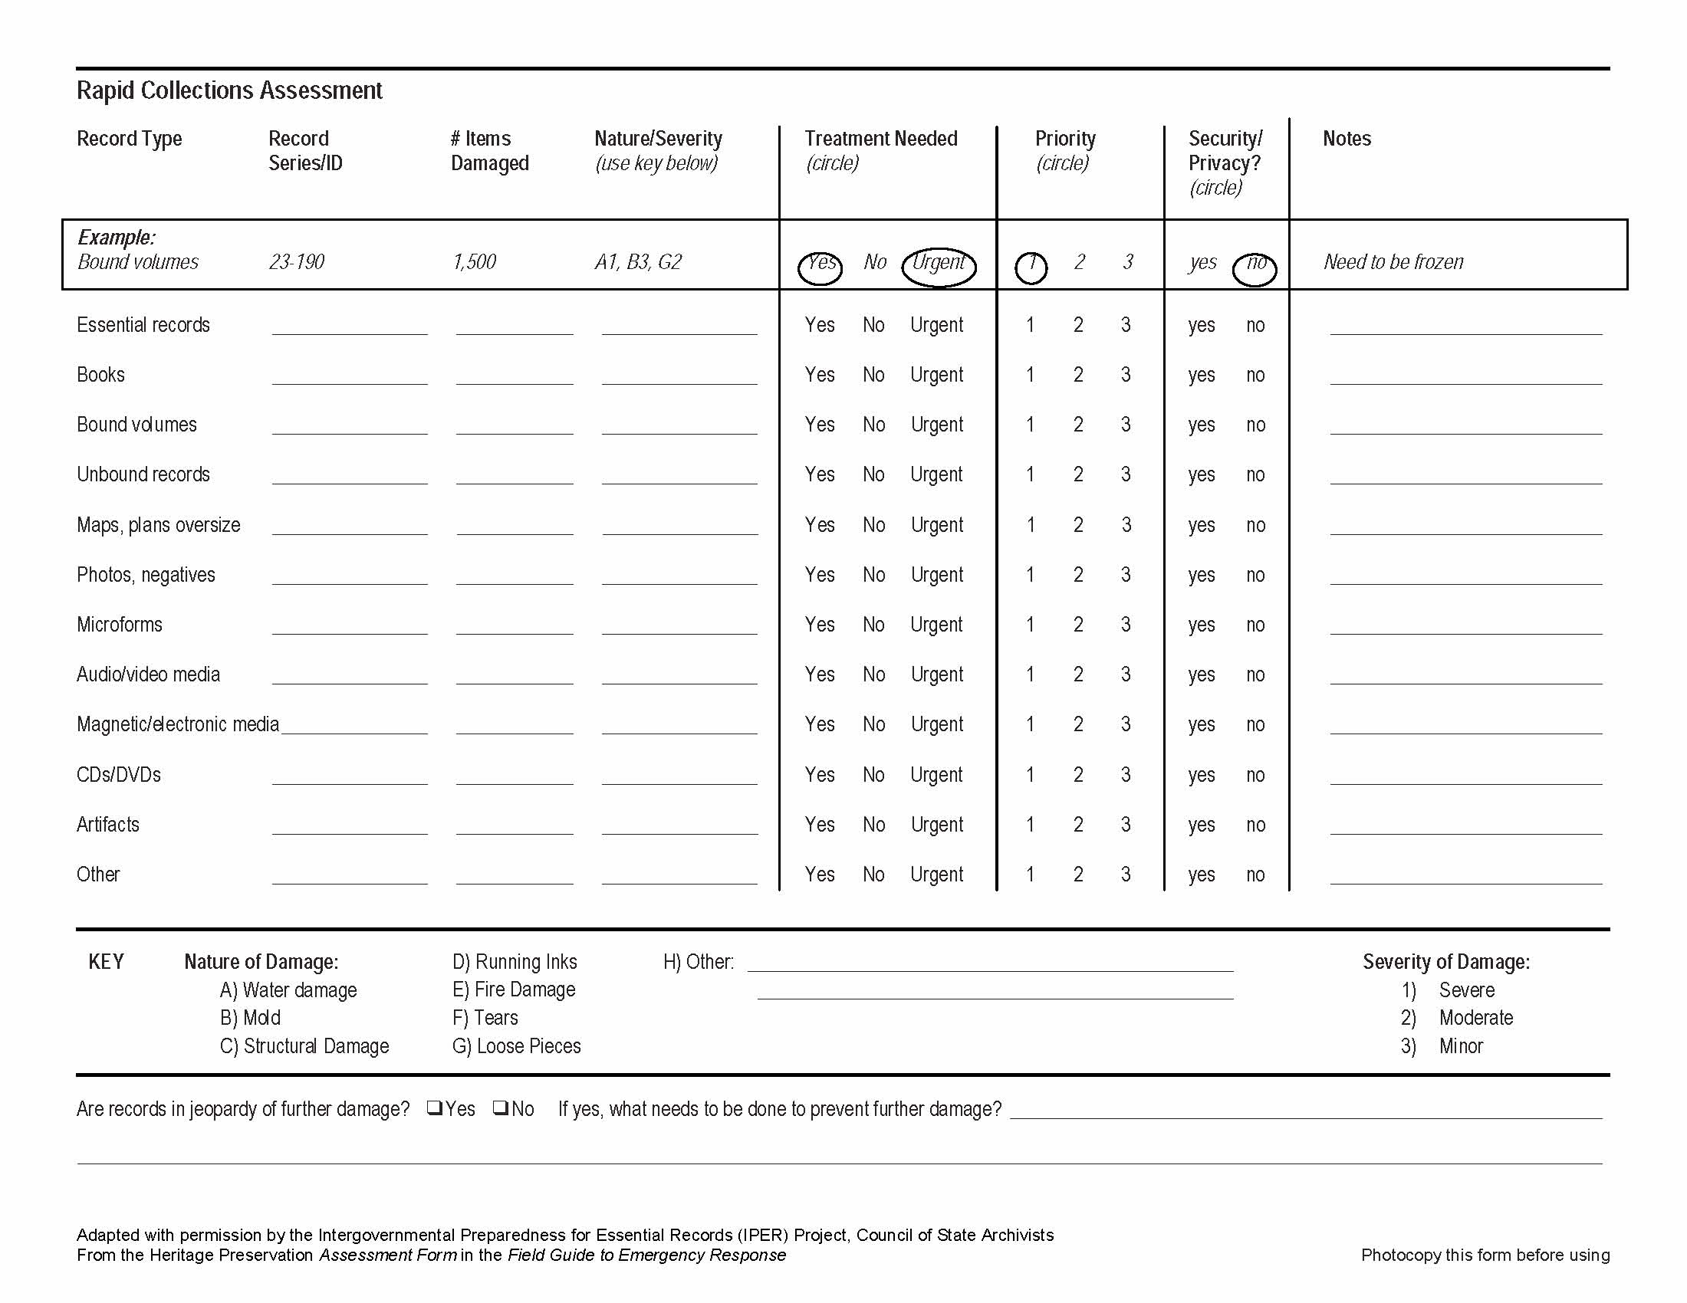
NOTE: A copy of this form is available at the IPER Resource Center so it can be downloaded and duplicated easily.
2.6—Components of a REAP

A Records Emergency Action Plan (REAP) provides direction for reducing the risk to records and information from natural and human hazards. No two REAPs will be the same, because every agency has its own risks, protection strategies, resources, policies, etc. However, there are several common components that should be part of every REAP.
If you have already completed a Pocket Response Plan, it will provide a good start for completing several of these components.
Use the table below to help you think through the components of your REAP.
- What will you include?
- Where will you find the information related to that component?
- Are some of the components already covered in your overall agency emergency plan or Continuity of Operations (COOP) Plan?
- Which components should receive special attention?

Table 1: Components of a REAP
Component | Description/Contents | Notes for Your REAP
Introduction | The briefest part of the REAP. It should state the purpose of the REAP and the entire preparedness program. It should also include information about how to use and revise the document.
Policy Statement | Include a clear policy statement or directive from the most senior officer in the agency, approving the Plan and identifying it as an official agency policy. The policy statement should clearly mandate the preparation and implementation of the REAP in order to secure the necessary cooperation among departments, have the authority to examine business processes and functions, and assign the organizational resources needed to prepare and implement the REAP.
Responsibilities and Authorities | Provide information about delegation of authority, chain of command, and roles and responsibilities for various activities, including REAP Team assignments, response/recovery manager duties, phone trees, media contacts, and offers of assistance (volunteer labor, supplies, cash donations, etc.).
Communication Plan | Identify multiple communications strategies to be used during an emergency at both the primary site and an alternate site, if required. Consider call-in voice recordings and information relaying systems.  Establish a Phone Tree to disseminate information in an orderly way but not overburden one individual with the responsibility.  Create an emergency contact directory that lists (as appropriate) telephone numbers (office, home, cell), email addresses, and physical locations of key contacts, including agency staff, emergency responders, contractors and suppliers, and others whom you will need to reach in an emergency.  Identifying communications strategies is usually a major component of the larger COOP Plan, but also a critical part of your REAP.
Locations of Essential Records | Include the essential records inventory, including title, location, retention period, container identification, format and media, volume, and location of master copy (if one exists).
Salvage Priorities | Organize this section in a list that makes it clear which records will require attention first and which ones can wait.  Include the record series under each priority category; item numbers from records schedules, retention period, and the physical location of the records.
Supplies  (should be included as an appendix) | Include a list of supplies you may need in the event of an emergency, including all supplies needed to prevent further damage to records, to aid in packing out records for further recovery, and information on how to purchase the supplies. See Handout 2.4—Sample Supplies and Equipment List.
Financial or Funding Information | Plan and document how you will obtain funds that may be required to purchase any necessary equipment and supplies you may not have on hand.  Finance and accounting personnel will need to track expenses associated with an emergency. Establish special codes for labor, equipment, and supplies to ensure proper accounting of expenses.
Vendors and Suppliers  (should be included as an appendix) | Include a list of vendors and suppliers of emergency services and supplies in your REAP. Consider developing standing contracts for professional service providers and temporary storage facilities, if possible.
Contractor Statement of Work | Include a generic draft Statement of Work (SOW) ready to use to obtain needed services in the event that an emergency befalls your records. Obtain this draft SOW from your Procurement Office.  Include any signed contracts or Memorandums of Understanding (MOUs) with individual contractors for specific services. However, if they contain confidential or private information, access to them should be restricted. Make sure to include in your REAP the procedures for activating the contract or MOU.  Include the names, addresses, and phone numbers of the contractors with which you have established contracts for response and recovery.
Facility Information  (should be included as an appendix) | Include all relevant facility information, especially evacuation plans and provisions for employees and visitors with disabilities; locations and operating instructions for equipment, mechanical systems, and emergency supplies; locations of master keys, floor plans, hazardous materials, doorways, stairways, and windows.
Staging Space | Contact the proprietors of your building(s) about the availability of space and make arrangements for use of the space in the event of an emergency. Document these arrangements in your REAP.  Spell out agreements and procedures, and keep contact and all other information up-to-date in your REAP.  Also, outline the procedures you will use to transfer or obtain office equipment and supplies and the services you will need, such as electricity, water, communications, and computers.
Preparedness, Response, and Recovery Procedures | The Preparedness, Response, and Recovery Procedures section will comprise the largest and most detailed section of your Plan. As explained earlier, your REAP must address specific emergencies and how to handle them, as identified in your risk assessment. It must provide for both major and minor emergencies and should include both site-specific and community-wide events.
Training, Testing, and Updating | Document the goals, objectives, and schedules for training all employees, plus testing the REAP and updating it periodically. Specific training programs for responders and specialized teams should also be developed and documented in the REAP.
Appendixes | The final section of the REAP provides information which is needed for the effective execution of the Plan, but which should be kept separate from the main narrative of the Plan. You can place these items in the Plan as an appendix. They should include a Phone Tree; a supplies, equipment, and space list; forms for assessing damage and tracking records (pack-out tracking log); reduced floor plans with locations of emergency equipment and utility boxes; and your essential records inventory and plan.

