4th of July

Potluck

Healthy Food Guideline Checklist:
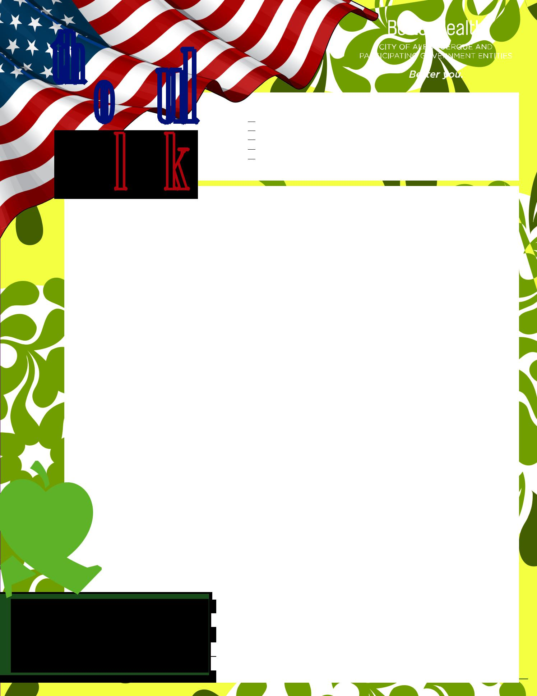
Make half of all food offerings colorful fruits and vegetables*
Offer smaller portions of foods
Offer foods low in solid fats, added sugars, and sodium
Offer whole-grain foods
Make water more available
*For information and tips about filling half your plate with fruits and veggies, visit FruitsAndVeggiesMoreMatters.org.

Sign-up Sheet

APPETIZER: Fresh Veggie Tray

Jicama Sticks: ________________________________ Cherry Tomatoes:____________________________

Sliced Bell Peppers & Sugar Snap Peas:______________________________________________________

Carrott Sticks &&Sliced Cucumbers:__________________________________________________________

Hummus for Diipping::_________________________ Low Fat Ranch:______________________________

ENTREES:

4oz Grilled Turkey Burgers: ____________________________ , _________________________________

4oz Grilled Chicken Breasts: ___________________________ , _________________________________

Whole Wheat Hamburger Buns:_________________________ ,__________________________________

Grilled Turkey Hot Dogs:_______________________________ , _________________________________

Whole Wheat Hot Dog Buns: __________________________ ,__________________________________

SIDES:
Chili Beans Made with Tomatoes && Corn +⁺½ Cup Ladle: ______________________________________
Grilled Onions/Peppers/Squash:____________________________________________________________

Lettuce & Tomatoes:___________________________ Pickles & Onions:___________________________

DESSERTS: Fresh Fruit Tray or Salad

Blueberries, Raspberries, and/or Strawberries:_______________________________________________

Sliced Banana:Bananas:_______________________________________________________________________

Ripe Cut Melon (Honeydew, Cantaloupe or Watermelon):___________________________________

Cut CutOranges:Oranges:___________________________ Diced Apples:_______________________________

^{Mini}Mini^{Muffins/Cupcakes:}Muffins/Cupcakes: _____________________________________________________________

²⁰20^{Dark}Dark^{Chocolate}Chocolate^{Covered}CoveredStrawberries:_______________________________________________

“Eating and drinking colorful fruits and veggies provides a natural variety of vitamins, minerals, phytonutrients, and fiber that allow you to be your best everyday.”

Fruits & Veggies—More Matters®

Produce for Better Health Foundation

- Gallons Water– Plain&&^{with}with^{Fruit:}Fruit:_ ____________________________

Paper Plates:_______________________________________________

Bowls: _ ___________________________________________________

Utensils: __________________________________________________

⁴4⁻-⁶6OunceCups:____________________________________________
Napkins: __________________________________________________

