



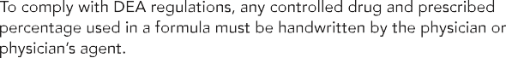

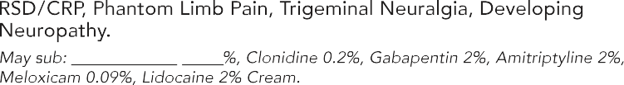

**Neuropathic Pain Creams**

**ANTI-INFLAMMATORY PLAN CREAMS**

|  |  |
| --- | --- |
|  | |
|  |  |
|  |  |
|  |  |

|  |  |  |
| --- | --- | --- |
|  |  |  |

