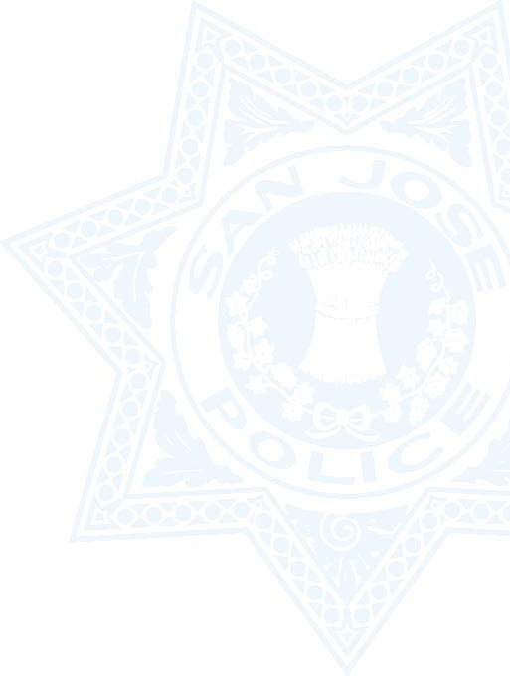
POLICE REPORT REQUEST FORM
Accident Reports Fees ……… Please make your check payable to “City of San Jose”
Crime Report Fees (Fees will be calculated based on the number of pages in the report.)
Include a Copy of your Photo I.D. AND your Check made out to:
“Visit the link below for instructions describing how to make out your check.”

Please complete all four sections below and sign: ONLY one report per request form. Please provide as much information as possible. This form may be delivered in person or mailed to the police department.
Please include a self-addressed stamped envelope to ensure prompt delivery.
(Type out information or print out and fill in by hand.)

1. Your Name
First Name Last Name
Address: _ _ _ _
Street Number Street Name City State Zip Code
Telephone:
Include Area Code
2. Check applicable type of report:

Traffic Accident
Crime Report
Case Report Number _ _

Date of Incident

Location of Incident: _ __

Cross Street:

Other Party Involved: _ _

3. I certify that I am:

Named in the report: (Check this box to certify that you are named in the requested report.)

An Insurance Agent: _ __
(Name of Company)
A Government Agency:
(Name of Agency)
An Authorized Representative of: _ _
(Person Named in the report)
4. Please provide in complete detail your reason for requesting a copy of this report:

_ _ _ __

_ _ _ __

_ _ _ __
Signature
Date: _ _
Driver’s License Number: _
State: _ _

