

COMPANY NAME

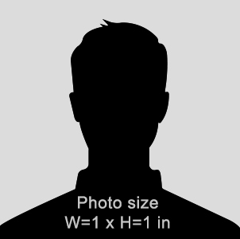

**JOHN** DOE

Graphic Designer

0892536437

**CODE**

**EXP DATE**

02-15-2019

**DATE OF BIRTH**

01-12-1989

