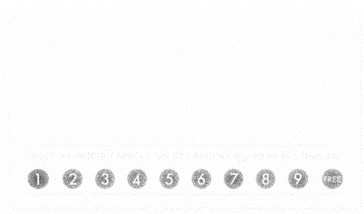

Company Name

Address: Street, City

Phone# 123456789

Product

Logo